CenturyLink

1600 7th Avenue, Room 1506

Seattle, Washington 98191

(206) 345-1568

Facsimile (206) 343-4040

Mark S. Reynolds

Director

Western Region Regulatory Affairs

May 24, 2012

Re: Advice No. WA 12-01A for CenturyTel of Washington, Inc.

David Danner
Executive Director and Secretary
1300 S. Evergreen Park Dr. S.W.
P.O. Box 47250
Olympia, Washington 98504-7250

Dear Mr. Danner:

CenturyTel of Washington, CenturyTel of Inter Island and CenturyTel of Cowiche d/b/a CenturyLink is forwarding for filing the sheets listed on Attachment A.

As described in the attached narrative (“Description of Methodology”), this filing is the first step in implementing the “Transitional Intrastate Access Service” reductions mandated by the Federal Communications Commission's November 18, 2011 Report and Order and Further Notice of Proposed Rulemaking in WC Docket Nos. 10-90, etc. (FCC 11-161). The calculations supporting these rate changes are being filed as confidential.

CenturyLink QC respectfully requests that these proposed rate changes becomes effective on July 3, 2012. If you have questions concerning this filing, please contact Gary Kepley – Regulatory Operations on (913) 345-7572.

Sincerely,

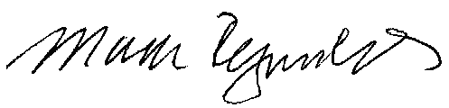

Mark Reynolds

Attachments

Attachment A
Advice No. WA 12-01A

ACCESS SERVICE
WN U-8

SECTION | SHEET | REVISION
16 | 16-7 | 2nd
17 | 17-7 | 2nd
18 | 18-7 | 2nd

