CenturyLink

1600 7th Avenue, Room 1506

Seattle, Washington 98191

(206) 345-1568

Facsimile (206) 343-4040

Mark S. Reynolds

Director

Western Region Regulatory Affairs

May 24, 2012

Advice No. 3687T

David Danner
Executive Director and Secretary
1300 S. Evergreen Park Dr. S.W.
P.O. Box 47250
Olympia, Washington 98504-7250

Dear Mr. Danner:

Qwest Corporation d/b/a CenturyLink QC is forwarding for filing the sheets listed on Attachment A.

As described in the attached narrative (“Description of Methodology”), this filing is the first step in implementing the “Transitional Intrastate Access Service” reductions mandated by the Federal Communications Commission's November 18, 2011 Report and Order and Further Notice of Proposed Rulemaking in WC Docket Nos. 10-90, etc. (FCC 11-161). The calculations supporting this rate change are being filed as confidential.

CenturyLink QC respectfully requests that this proposed rate change becomes effective on July 3, 2012. If you have questions concerning this filing, please contact Mark Brinton – Regulatory Operations on (303) 992-5832.

Sincerely,

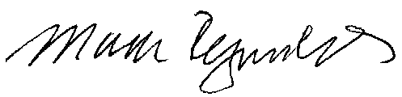

Mark Reynolds

Attachments
Attachment A
Advice No. 3687T

ACCESS SERVICE
WN U-44

SECTION | SHEET | REVISION
6 | 146 | 5th

