CenturyLink

1600 7th Avenue, Room 1506

Seattle, Washington 98191

(206) 345-1568

Facsimile (206) 343-4040

Mark S. Reynolds

Director

Western Region Regulatory Affairs

February 29, 2012

Advice No. 3685T

David Danner
Executive Director and Secretary
1300 S. Evergreen Park Dr. S.W.
P.O. Box 47250
Olympia, Washington 98504-7250

Dear Mr. Danner:

Qwest Corporation d/b/a CenturyLink QC is forwarding for filing the sheet listed on Attachment A.

This filing reduces the City of Liberty Lake, Washington’s Occupational Tax Rate from 6.0% to 3.0%. The Effective Tax Rate for billing will decrease from 6.382% to 3.092%.

In addition, this filing introduces the City of Cathlamet, Washington’s Occupational Tax Rate of 6.0%. The Effective Tax Rate for billing will be 6.382%.

The City of Cathlamet requested the Legal Effective Dates of February 28, 2012, and Liberty Lake requested the subsequent Legal Effective Date of March 1, 2012. CenturyLink QC is requesting an effective date of March 30, 2012, for this filing.

If you have questions concerning this filing please contact me.

Sincerely,

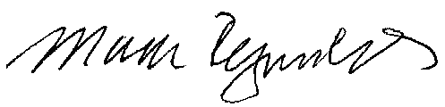
Mark Reynolds

Attachments
Attachment A
Advice No. 3685T

EXCHANGE AND NETWORK SERVICES
WN U-40

SECTION | SHEET | REVISION
2 | 68 | 9
2 | 68.1 | 5
2 | 70 | 8

