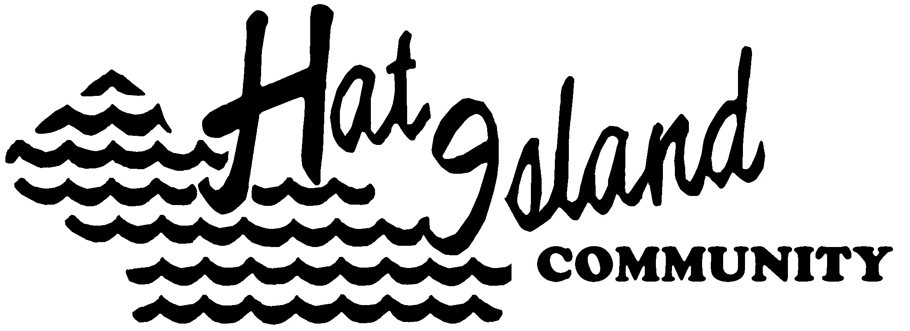

3616 Colby Ave., PMB 335 - Everett, WA 98201

Office: 360-444-6611 - FAX: 360-444-6614
www.hatisland.org

Wednesday, July 29, 2026

Washington Utilities and Transportation Commission
P.O. Box 47250
1300 S. Evergreen Park Dr. SW
Olympia, WA 98504-7250

RE: Tariff 4-11 for Hat Island Community; BC 96

Hat Island’s last rate filing with the UTC was in 2008 just a few months after purchasing our new vessel. In the three years since that purchase we have learned a great deal about owing and maintaining a vessel as large and sophisticated as Hat Express.

Attached are our requested fares and rules.

The Hat Island Ferry is unique. As a public entity we potentially serve the general public, in reality the only people who ride the vessel are Hat Island property owners and their guests

Historically the community has subsidized the ferry operation at 37%. That is the Island has historically subsidized every dollar of ticket sales with $0.37 from our general fund. After four months of 2011 our annual subsidy for this year is now estimated at 117% or $123,000 from the general fund. In order to cover all our costs the average one way fare would need to be $17.00 We realize that we must continue to subsidize our ferry operations, but we must bring the subsidy back to the 50% range.

No doubt the recent rule change by the USCG which decreased our carrying capacity by 15% will have a yet to be evaluated impact on our operations as well. Certainly much of the increases in our operating costs are fuel driven. Insurance, maintenance and staff costs are all increasing annually and while we are also experiencing steady increases in ridership, this increase does not provide sufficient income to offset increases in operating costs

If we raise general rates we make it too expensive for many of our owners to visit the island and we lose ridership and income. Therefore we are targeting our proposed increases to non owners, i.e. guests and to the increasing number of pets on the vessel.

The proposed rates provide for discounted prices for our owners as one third of their $400 Home Owner’s Association dues go towards subsidizing the ferry operations. Our by-laws define owners as Husband and wife and their legal dependents.¹

ISLAND SUBSIDY IN THOUSANDS

As we do not currently have a Guest rate on the ferry we can only estimate the percentage of passengers in this category. We do have guest rates on our golf course and in our marina. Our records indicate that approximately 15% of our weekly revenue from these two operations is from guests. We therefore estimate that 15% of our ridership, at least on summer weekends, are quests. Our 2010 ridership was 15,800 total passengers, 5-7% of which are pets, especially during our high season.

A $2 increase per passenger for the 15% who we estimate are guests should generate an additional $4,700 and an average $3 increase per pet from an estimated 1200 pets annually will generate an additional $3,600.

The proposed changes in pet rates and rules, while outwardly intended to increase revenue, are equally intended to motivate owners to transport their pets in cages to increase the safety and comfort of other passengers and to decrease crew work load cleaning our tweed fabric seats of dog hair.

We request that you approve the attached rules and rates

Respectfully,
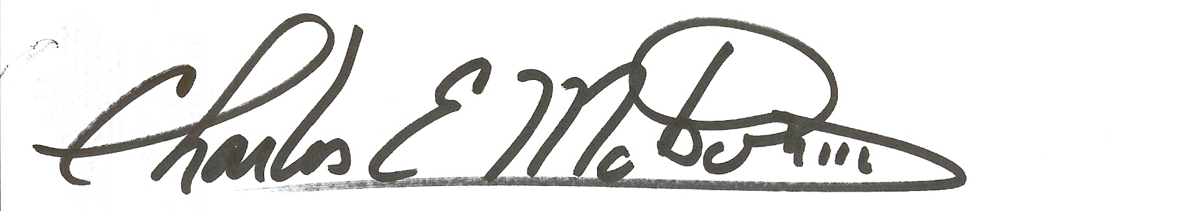

Charles E. Motson, III
Island Manager

Attached:
2010 financials
2011 year to date financials
Hat Island Tariff 4-11
Public Notice

¹ SECTION 1. Definition of Membership.…For purposes of these By-Laws, a husband and wife and any other persons or entities jointly owning a lot or lots shall be considered collectively as being one owner. Proof of ownership shall be as recorded in the office of the Auditor of Snohomish County, Washington.
SECTION 4. Membership Privileges. The privileges of membership, including the right of access to, and use of, the Association's property and facilities, shall be extended to the lot owner/owners and their legal dependents.

