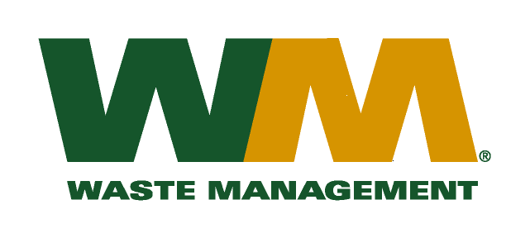
July 29, 2026
Washington Utilities and Transportation Commission
Chandler Plaza Building
1300 S. Evergreen Park Drive SW
P.O. Box 47250
Olympia, WA 98504-7250

Subject: Waste Management of Greater Wenatchee, a division of Waste Management of Washington, Inc. (G-237); Tariff # 12
Enclosed are revised tariff pages 2, 21, 22, 24 and 25 and new appendices D and E to the above-referenced tariff. The purpose of these tariff revisions is to establish a new rate for subscription based yard waste collection in the urban growth boundaries of Chelan and Douglas counties.
Enclosed for your review is our analysis to develop this new service rate. Customers will be notified of this new service option on their next regularly scheduled billing. If you have any questions or need additional information, please contact or me at (425) 814-7840.
Very truly yours,

Michael A. Weinstein
Senior Pricing Manager, Pacific Northwest Market Area

cc: Lewis Carver
Ken Gimpel

