March 5, 2010

Advice No. 3665T

David Danner
Executive Director and Secretary
1300 S. Evergreen Park Dr. S.W.
P.O. Box 47250
Olympia, Washington 98504-7250

Dear Mr. Danner:

Qwest Corporation is forwarding for filing the sheet listed on Attachment A.

This filing modifies Section 2.8.1 by adding a term and condition (Section 2.8.1.B.4.c.) for the single tenant/occupant building to be consistent with the same provision that is in the multi-tenant building section of the tariff (Section 2.8.1.B.5.c). This term provides more clarity regarding the property/building owner’s responsibilities in the termination of Qwest facilities at the building to be served.

Qwest is requesting an effective date of April 5, 2010.

If you have questions concerning this filing, please contact Marie Larchick on (402) 422-7482. Thank you.

Sincerely,

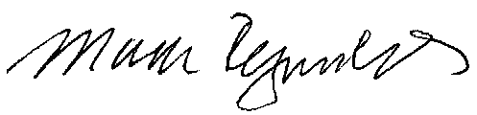

Mark Reynolds

Attachments

Attachment A

Advice No. 3665T
Page 1 of 1

EXCHANGE AND NETWORK SERVICES
WN U-40

SECTION | SHEET | REVISION

2 78 2

