WN U-74 |  |  | Second Revision of Sheet No. 37.1
 |  |  | Canceling First Revision of Sheet No. 37.1
PACIFIC POWER & LIGHT COMPANY
 |  |  |  |  |  |  |  |  |  |  | FOR COMMISSION’S RECEIPT STAMP
 | SCHEDULE 37  COGENERATION AND SMALL POWER PRODUCTION  AVAILABILITY:  This schedule applies to any person or entity, hereinafter referred to as the Seller, who owns Qualifying Facilities the output of which is offered to the Company pursuant to WAC 480-107-095(1)and WAC 480-107-095(2) and is 2 MW or less.  PAYMENTS MADE TO SELLER:  The Seller shall be paid by the Company a capacity and energy payment as provided under the terms of a Power Purchase Agreement.  DEFINITIONS:  Qualifying Facilities: as used in this schedule shall have the same meaning as in Chapter 480-107-007 of the Washington Administrative Code.  TERMS AND CONDITIONS:  - The Seller will be required to enter into a written Power Purchase Agreement and an Interconnection Agreement in a form satisfactory to the Company prior to interconnection of the Company and the Seller’s facilities and the selling power to the Company.  - All costs of interconnection of the Seller’s facilities with the Company's system will be borne by the Seller. Such costs will include the initial cost of interconnection, O&M cost, and any other costs incurred by the Company from time to time with respect to the Seller’s facilities and the interconnection with the Company's system.  - The Seller shall indemnify and hold harmless the Company from any and all liability arising from the operation and interconnection of the Seller’s facilities. The Company will require evidence of the insurance to this effect.  - The Seller shall provide a lockable disconnect switch to isolate the Seller’s generation from the Company's system. Such switch shall be accessible to the Company and the Company shall have the right to lock such disconnect switch open whenever necessary to maintain safe electrical operation conditions, or whenever the Seller’s facilities adversely affect the Company's system.  - Except for the metering, the Seller shall own and maintain all facilities on the Seller’s side of the singe point of delivery as specified in the Power Purchase Agreement. The Seller’s facility, including interconnecting equipment, shall be inspected and approved by the state electrical inspector and any other public authority having jurisdiction before any connection is made to the Company's system.  (Continued) |  |  |  |  |  |  |  |  |  |  |  | (C)
Issued |  |  |  |  | February 17, 2010 |  | Effective |  |  | March 19, 2010
Issued by |  |  |  | PACIFIC POWER & LIGHT COMPANY
By |  | 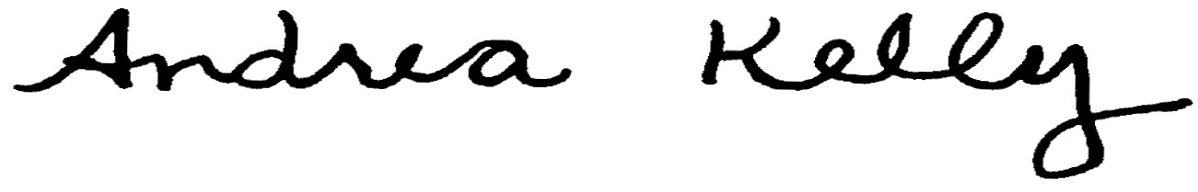  Andrea L. Kelly |  |  |  |  |  | Title | VP, Regulation
 |  | TF2 37-1.REV |  |  |  | Advice No. |  |  |  |  |  | 10-02
Form F

