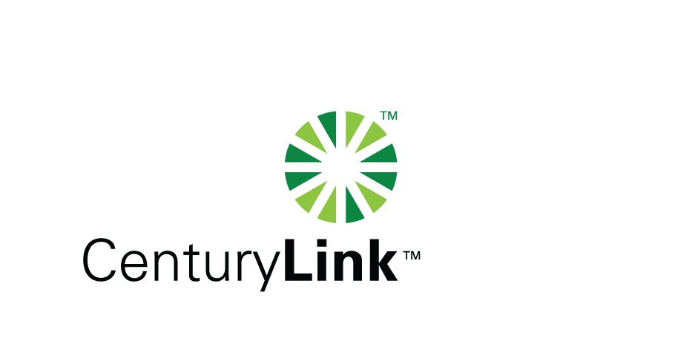

www.centurylink.com
5454 WEST 110TH STREET
OVERLAND PARK, KS 66211

November 30, 2009

Via Electronic Filing

Mr. David W. Danner, Executive Director and Secretary
Washington Utilities and Transportation Commission
P.O. Box 47250
1300 S. Evergreen Park Drive SW
Olympia, WA 98504-7250

RE: Advice No. WA 09-11 for United Telephone Company of the Northwest d/b/a CenturyLink

Dear Mr. Danner:

Enclosed for filing please find revisions to the United Telephone Company of the Northwest d/b/a CenturyLink WN U-3. This filing is submitted with a November 30, 2009 issue date and a proposed effective date of January 1, 2010.

The tariff page enclosed for review and approval is as follows:

WN U-3

Schedule AE-14 | 1st Revised Sheet 2

The purpose of this filing is to establish a franchise fee to be collected from all customers living within the Yakama Indian Nation boundaries. The Yakama Nation enacted Resolution T-177-02 which levies a 3% tax on gross revenues derived from utility operations on the Reservation.

I, Debra Levy, in compliance with WAC 480-80-103, certify that I have authority to issue tariff revisions on behalf of United Telephone Company of the Northwest d/b/a CenturyLink.

Commission consideration and timely approval of these pages are respectfully requested. Upon approval, please return one stamped approved copy of this filing for our records. Please feel free to contact me if you have any questions regarding this filing.

Sincerely,
Debra Levy

Enclosures

WA 09-11
Debra Levy
Tariff Analyst II
Voice: (913) 345-7571
Fax: (913) 345-6756

