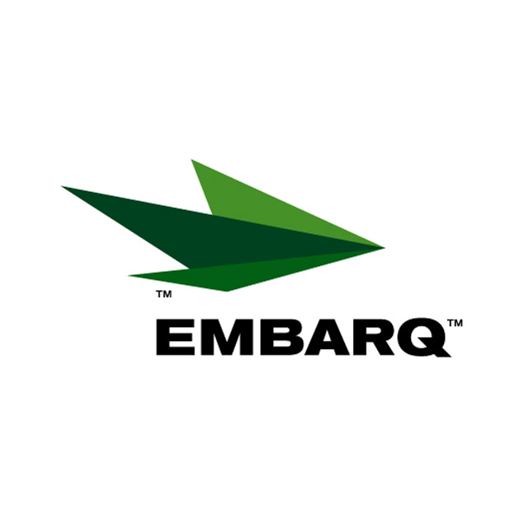

October 7, 2009

Mr. David W. Danner, Executive Director and Secretary
Washington Utilities and Transportation Commission
P.O. Box 47250
1300 S. Evergreen Park Drive SW
Olympia, WA 98504-7250

Re: Correct change in trade name for Embarq Communications, Inc.

Dear Mr. Danner:

Enclosed for electronic filing is a copy of Embarq Communications, Inc. master license application with the Department of Licensing registering the trade name CenturyLink Communications. The company intends to begin using the trade name beginning October 8, 2009.

Please feel free to contact me should you have any questions. I can be reached at 360-943-6996

Sincerely,

Mary M. Taylor
Regulatory Government Relations Manager

Attachments

