WASHINGTON UTILITIES AND TRANSPORTATION COMMISSION

STAFF INVESTIGATION REPORT
OF THE BUSINESS PRACTICES OF

Irvington Transfer and Storage d/b/a ITS Global Relocation Services
Docket TV-091445

Prepared by:
Carlene Hughes
Compliance Program Coordinator
Compliance Investigations Section
November 10, 2009

TABLE OF CONTENTS

Section Page

Purpose, Scope, and Authority 3

Investigation Summary 4

Background 5

Investigation 6

Summary of Violations 15

PURPOSE, SCOPE, AND AUTHORITY

Purpose
The purpose of this investigation is to review the company records, policies and processes of Irvington Transfer and Storage doing business as ITS Global Relocation Services (ITS), to ensure compliance with the household goods laws, rules and tariff.

In June 2008, Dave and Judy Crawley filed a consumer complaint with the commission against ITS. Upon investigation of the complaint and review of the records involved in the Crawley move, staff found numerous violations of commission rules and tariff.

In March 2009, the commission sent ITS a compliance letter informing the company that it was in violation of a number of commission rules and tariff requirements, including the company’s refusal to refund improper tariff charges to the customer who had filed a consumer complaint with the commission. The letter required ITS to respond to the commission with a compliance plan indicating how the company planned to change its practices to comply with the commission laws, rules and tariff requirements. The letter also instructed the company to have representatives attend commission-sponsored tariff and rule training.

As a follow up, to ensure compliance with the rules and tariff, the commission issued a data request for specific ITS business records issued after the implementation of the company’s new compliance plan. The purpose of this investigation is to review the requested 2009 records to determine if after training and implementing a compliance plan, the company is now in compliance with the commission rules.

Scope
The scope of the audit includes the documents from all residential moves performed by Irvington during May 2009, the company’s complaint and claim information from January 1, 2009, through May 31, 2009.

Authority

Staff undertakes this audit under the authority of the Revised Code of Washington (RCW) 80.01.040(3). In addition, RCW 80.04.070 makes it clear that the commission is authorized to conduct such an audit.

Appendix A includes the full text of RCW 80.01.040(3) and RCW 80.04.070.

INVESTIGATION SUMMARY

In 2009, Compliance Investigations staff began an investigation of ITS’s business practices based on the company’s prior non-compliance with commission rules and tariff. In 2008, staff recorded 69 violations against ITS during the investigation of a consumer complaint. The company was sent a compliance letter in March 2009, and in response filed a compliance plan with the commission outlining the action taken to comply with commission rules. Also in March 2009, employees of the company attended commission-sponsored rule and tariff training. In July 2009, staff sent the company a data request asking for company documents for the moves it conducted during May of 2009, to check the company’s compliance with state laws, commission rules, and tariff requirements.

Staff has determined that in spite of ongoing technical assistance, ITS still failed to substantially comply with the household goods rules and tariff. Staff recommends a one hundred dollar penalty for each of the violations shown below:

- Failure to include e-mail address of company on estimate form.
VIOLATION: Tariff 15-C, Item 85 (2)(a)
- Failure to include customer phone number on estimate form.
VIOLATION: Tariff 15-C, Item 85(2)(d)
- Failure to include origin of shipment or destination of shipment on estimate form.
VIOLATION: Tariff 15-C, Item 85(2)(f)
- Failure to properly calculate mileage for distance move between Battle Ground and Allyn on estimate.
VIOLATION: Tariff 15-C, Item 105(6)
- Failure to list proper tariff rate for long-carry charge on estimate.
VIOLATION: Tariff 15-C, Item 160
- Failure to issue a supplemental estimate when the circumstances surrounding the move changed to increase the cost of the move.
VIOLATION: WAC 480-15-630(3)
- Failure to include e-mail address of company on bill of lading.
VIOLATION: Tariff 15-C, Item 95(1)(a)
- Failure to include address of intermediate stop on bill of lading.
VIOLATION: Tariff 15-C, Item 95(1)(f)
- Failure to properly calculate mileage for distance move between Battle Ground and Allyn on bill of lading.
VIOLATION: Tariff 15-C, Item 95(1)(l)(i)

Total recommended penalty of $900.

BACKGROUND

Introduction
This investigation was conducted to ensure that ITS is in compliance with commission rules, tariff and state statutes regarding the transportation of household goods. ITS was provided rule and tariff technical assistance in a commission compliance letter, instructed to file a compliance plan with the commission and attend commission-sponsored rule and tariff training, all in an effort to ensure the company complies with the laws governing the transportation of household goods. In July 2009, the commission requested company records for moves it conducted during May 2009, upon which this investigation was based. The results of the review of those records are recorded in staff’s recommendations.

Company Information
Irvington Transfer and Storage Company d/b/a ITS Global Relocation Services and Pro Van Services, is located at 5515 NE 148th Avenue, Portland, Oregon. ITS received its household goods operating authority in September 2003 under permit number HG-19176.

Gene Doeneka is the president and general manager of the company.

On March 16, 2009, ITS filed its 2008 Annual Report showing a total revenue for its Washington intrastate operations as $18,814. The annual report stated the company provided a total of 13 moves in Washington in 2008. The bulk of this company’s operations are conducted in Oregon.

INVESTIGATION

Commission staff had numerous contacts with ITS during the processing of a consumer complaint filed in 2008. In June 2008, Dave and Judy Crawley filed a consumer complaint with the commission against ITS. Upon investigation of the complaint and review of the records involved in the Crawley move, staff recorded 69 violations of commission rules and tariff against the company.

Compliance Letter
In March of 2009, Commission staff sent ITS a compliance letter informing the company that it was in violation of a number of commission rules and tariff requirements, including its refusal to refund improper tariff charges to a customer who had filed a consumer complaint with the commission. Staff required ITS to respond to the commission with a compliance plan indicating how the company planned to change its practices to comply with the commission laws, rules and tariff requirements.

The commission’s compliance letter stated in part:

Mr. Doekeka,
The Washington Utilities and Transportation Commission (commission) recently reviewed a consumer complaint regarding ITS Global Relocation Service (Irvington or ITS).

As part of the complaint process, staff reviewed the documents submitted by you to determine your company’s compliance with Washington Administrative Code (WAC) rules governing the transportation of household goods, specifically, WAC 480-15.

Upon completion of this review, staff found Irvington’s business practices appear to violate a number of commission rules and tariff requirements, including refusal to refund improper charges, as outlined in the attached compliance summary.

According to state statute, the commission is authorized to assess penalties of up to $1,000 per day for each violation of commission rules. While staff could recommend the commission take action against ITS, including penalties for violation of commission rules or tariff, it does not intend to do so at this time.

Instead, you must attend commission-sponsored rule and tariff training and submit a compliance plan to commission staff indicating how the company plans to change its practices to comply with applicable laws, rules and tariff requirements. If, in the future, ITS’ efforts fail to show improved compliance, we will likely ask the commission to take enforcement action against your company.

You must respond to this letter by March 25, 2009, with a compliance plan addressing each of the items listed in the following pages. You must explain what actions the company intends to take, including an estimated completion date, to come into compliance with each issue identified.

Attached to the compliance letter was a Compliance Summary that detailed the violations staff found, provided references to rules or tariff items to educate the company on specific items, and listed the actions ITS must take to full the requirements of the compliance plan.

The Compliance Summary stated:

ESTIMATES and SUPPLEMENTAL ESTIMATES
RCW 81.80.132 requires that when a carrier gives an estimate of charges for services in transporting household goods, the carrier will endeavor to accurately reflect the actual charges. WAC 480-15-630 describes that a carrier must provide an estimate and describes specific information required on the estimate. WAC 480-15-660 describes supplemental estimates and when they are required. Item 85 in Tariff 15-C describes the specific information required in a written estimate.

Staff found that Irvington’s Estimated Cost of Services form does not comply with the commission rules and Tariff 15-B. The estimate form staff reviewed for the Crawley complaint is in violation of the following commission rules and tariff:
- The estimate does not indicate whether it is binding or non-binding;
- The estimate does not contain a space for the customer to sign and date the form;
- The estimate does not include the required language that the carrier must release the goods upon payment of 110 percent of the estimate;
- The estimate does not include the required language that the cost of the move may not exceed 125 percent of the estimate.
- The estimate does not include a signature line that the customer was provided a copy of the brochure “Your Guide to Moving in Washington State”;
- The estimate contains charges for “preliminary services” and “mothtreating and wrapping” that are not allowed for SIT services; and,
- The estimate does not include a section that describes the forms of payment the carrier will accept, including terms or conditions that apply to the payments.

Additionally, Irvington failed to provide a customer a supplemental estimate when the cost of the move increased in violation of WAC 480-15-660.

Compliance Plan - Estimates
Irvington Transfer must revise its estimate form to include all of the required items in WAC 480-15 and Tariff 15-C, Item 85. Irvington Transfer must submit to the commission a copy of the revised estimate form with its compliance plan.
Irvington Transfer must review Item 85 of Tariff 15-C and WAC 480-15-630 and WAC 480-15-660, Estimates, and provide a detailed explanation in its compliance plan the actions the company intends to take, including a completion date, to comply with each of the requirements listed in the rule and the tariff including the issuance of supplemental estimates.

BILL OF LADING – FORMAT
WAC 480-15-710 and Tariff 15-C, Item 95 state the requirements for the format and completion of the household goods bill of lading.

The bill of lading form staff reviewed for the Crawley complaint is in violation of the following commission rules and tariff:
- The bill does not include the correct valuation options that a customer must choose from prior to the movement of their household goods;
- The bill does not contain the proper options for the type of estimate provided (binding or non-binding), nor does it include the proper tariff language for estimates;
- The bill includes incorrect storage option language;
- The bill fails to require the customer’s signature for the storage-in-vehicle option;
- The bill fails to include the company’s permit number; and,
- The bill of lading contract terms and conditions are incorrect and do not comply with the current tariff contract requirements.

Compliance Plan – Bill of Lading
Irvington Transfer must revise its bill of lading form to include all of the required items in WAC 480-15-710 and Tariff 15-C, Item 95. Irvington Transfer must submit to the commission a copy of the revised bill of lading form with its compliance plan.
Irvington Transfer must review WAC’s 480-15-710 and Tariff Item 95 and provide a detailed explanation in its compliance plan and the actions the company intends to take, including a completion date, to comply with each of these bill of lading requirements listed in the rule and the tariff.

BILL OF LADING – COMPLETION
In addition to using an improper bill of lading format, Irvington Transfer failed to properly complete the bill of lading used in the Crawley consumer complaint.

The completion of the bill of lading form was in violation of the following commission rules and tariff:
- Irvington Transfer improperly billed for packing materials (queen mattress $32.10);
- Irvington Transfer improperly billed for credit card fees ($84.03);
- Irvington Transfer failed to have the customer initial a valuation option prior to commencing the move;
- Irvington Transfer failed to have a company representative sign for receipt of the customer’s goods at the origin of the shipment; and,
- Irvington Transfer failed to require the customer sign and date the bill acknowledging delivery of the goods.

RULE OR TARIFF NON-COMPLIANCE
Staff found the Irvington Transfer improperly stated rule or tariff requirements in other documents provided to its customer.

- Irvington Transfer’s “mandatory receipt” form is an Oregon form that states the customer received a copy of the Oregon “General Information for Shippers”. Irvington used this form to show it gave the customer the Washington UTC Rights and Responsibilities Brochure. This form provides improper move and estimate information and cannot be used for Washington customers. Washington customers should not be required to sign a form that states regulations apply to office furniture (not defined as household goods in Washington) or that the final charge for the move will be based on tariff rates regardless of any estimate for service (Order for Service also states this language). That is not true for Washington customers. Washington customers are not required to pay more than 25 percent above the estimate, unless a supplemental estimate is provided.

Compliance Plan – Rule and Tariff Compliance
Irvington Transfer must review Tariff 15-C and provide a detailed explanation in its compliance plan, and the actions the company intends to take, including a completion date, that it understands and will comply with each of the tariff item requirements.
Irvington Transfer must also contact commission staff and schedule attendance in a commission-sponsored tariff and rule training session to be completed by no later than June 1, 2009. You may contact Suzanne Stillwell, Deputy Assistant Director, at 360-664-1103 to sign up for a commission training class.

Staff also enclosed with the compliance letter copies of the commission’s Washington Administrative Code Rules 480-15, and the commission’s Household Goods Tariff 15-C.

A copy of the commission compliance letter and summary are included in Appendix B.

Irvington Response
On March 23, 2009, the commission received a response from Mr. Gene Doeneka, President and General Manager of ITS, in which he stated the company had taken the following compliance plan actions:

- Mr. Doeneka and Randy Woolcott, Sales Consultant and Manager, would attend a UTC sponsored rule and tariff training class in April.
- Estimate forms were corrected and all terms in Item 85 of Tariff 15-C would be complied with and included in the company’s training meeting in April 2009.
- Bill of Lading form was brought into compliance with the commission requirements and Item 90 and 95 of Tariff 15-C will also be covered in the intra-company training taking place in April 2009.

Mr. Doeneka also stated:

“We are very proud of our record in this endeavor and have had very few serious customer complaints, with merit, during my 10 years in control here. We will seriously endeavor to uphold the rules of the new Tariff 15-C and continue with good business practices and customer service policies that we have built our solid reputation upon for many, many years.”

A copy of Mr. Doeneka’s letter is included in Appendix C.

On March 27, 2009, Gene Doeneka attended commission-sponsored rule and tariff training at the commission. The class was given by Suzanne Stillwell, Deputy Assistant Director, and Carlene Hughes, Compliance Program Coordinator, Consumer Protection and Communications Section. The class covered all aspects of the commission’s household goods rules and Tariff 15-C.

Data Request
To ensure compliance after implementation of the company’s compliance plan and attending commission-sponsored rule and tariff training, the commission issued a data request to Irvington for business records utilized after the compliance plan went into effect.

The commission’s data request, dated July 1, 2009, stated in part:

As part of a follow-up investigation of your household goods moving company, the commission requires ITS Global Relocation Services (ITS) provide the following information and documents:

- For every residential move performed within the state of Washington from May 1, 2009 through May 31, 2009, please provide all supporting documents related to each customer’s move, including, but not limited to, the bill of lading, estimate, supplemental estimate, inventory records, weight slips, and all documents related to temporary storage of the goods.

- A copy of the company’s complaint and claims register, listing all complaints and claims received from January 1, 2009 through May 31, 2009, including all documents related to each complaint and claim.

The company was required to furnish the documents to staff by July 17, 2009.

A copy of the commission’s data request is included in Appendix D.

Response to Data Request
On July 17, 2009, ITS submitted documents for the one move the company states it conducted during May 2009, a long distance mileage-rated move from Battleground to Allyn, Washington.

The company also enclosed one claim record for the period of January 1, 2009 through May 31, 2009.

2009 Compliance with Commission Rules
As part of the investigation, commission staff reviewed the documents and policy descriptions received from ITS in response to the data request, and company documents on file with the commission.

The following investigation results indicate ITS’s compliance with commission statutes and rules.

Claim Files
Staff found the claim file and documents (one claim dated April 2009), in compliance with commission rules.

Estimate
As part of the initial compliance letter to ITS, staff listed the areas of non-compliance found during the review of the consumer’s complaint and the documents used for the consumer’s move. The compliance letter, in addition to specifically listing the elements in the company’s previous estimate form that were in violation, the compliance letter provided the following additional technical assistance:

RCW 81.80.132 requires that when a carrier gives an estimate of charges for services in transporting household goods, the carrier will endeavor to accurately reflect the actual charges. WAC 480-15-630 describes that a carrier must provide an estimate and describes specific information required on the estimate. WAC 480-15-660 describes supplemental estimates and when they are required. Item 85 in Tariff 15-C describes the specific information required in a written estimate.

When staff reviewed the estimate form submitted for the one ITS move conducted in May 2009, staff found the following areas of non-compliance on the form:

- Estimate format does not include the e-mail address of company.
Violation of Tariff 15-C, Item 85(2)(a), Estimates, which requires the carrier to include on all binding or non-binding estimates the carrier’s name, address, phone number, fax number (if any), and e-mail address, if any.

- No customer phone number is listed on the estimate form.
Violation of Tariff 15-C, Item 85(2)(d), which requires the carrier to include on all binding or non-binding estimates the customer’s name, phone number and address.

- No address of the origin of shipment or address of the destination of shipment.
Violation of Tariff 15-C, Item 85(2)(f), which requires the carrier to include on all binding or non-binding estimates the origin, destination and any intermediate stops for the shipment.

- Improper mileage calculation for distance move between Battle Ground, Washington, and Allyn, Washington. Estimate shows 158 miles. Correct household goods mileage guide calculation is 140 miles.
Violation of Tariff 15-C, Item 105(6), which required carriers to use a mileage guide that calculates mileage using the most current version of the Household Goods Carriers Bureau Mileage guide to determine mileage or other mileage calculation software, such as Rand McNally’s MileMaker, that results in the same mileage calculation as the Household Goods Carries Bureau Mileage guide.

- Improper long-carry charge. Estimate shows “long caring [sic]” charge at $2.00 CWT.
Violation of Tariff 15-C, Item 160, Long Carry Charges, which requires if goods must be carrier more than 75 feet between the carrier’s vehicle and the door of the individual living unit, the carrier may charged the customer in addition to all other applicable rates and charges between $0.69 and $1.46 per each 100 pounds carried for each 50 feet (of fraction of 50 feet) beyond the first 75 feet.

- Company instructed customer to add additional information to the estimate (“long-caring” charge), instead of issuing a supplemental estimate.
Violation of WAC 480-15-630(3), that states a supplemental estimate is required if the circumstances surrounding the move change in a way that causes rates or charges to increase. The customer must accept and sign the supplemental estimate prior to additional work being performed.

A copy of the Estimated Cost of Services form is included in Appendix E.

Findings
Irvington is not using the correct estimate format, did not complete the estimate form correctly as required by rule and tariff, and did not issue a supplemental estimate in accordance with WAC 480-15-630.

Bill of Lading
The commission compliance letter informed ITS of the following rules and tariff items that apply to bills of lading:

WAC 480-15-710 and Tariff 15-C, Item 95 state the requirements for the format and completion of the household goods bill of lading.

When staff reviewed the bill of lading for the Kaptur move conducted in May 2009, staff found the following areas of non-compliance on the bill of lading form:

- Bill of lading format does not include e-mail address of company.
Violation of Tariff 15-C, Item 95(1)(a), that requires the carrier to include on the bill of lading the name, permit number, address, telephone number of the carrier and the fax, Web site, and e-mail address, if any.

- Estimate indicated an intermediate stop in Port Orchard. The bill of lading did not include the address of the intermediate stop.
Violation of Tariff 15-C, Item 95(1)(f), which requires the bill of lading to include the exact address of any additional pickup points or stops to partially load or unload.

- Improper mileage distance shown for move from Battle Ground to Allyn, Washington.
Violation of Tariff 15-C, Item 95(1)(l)(i), which requires if the shipment will be calculated using mileage rates, the bill of lading must include the mileage of the move. The correct mileage for the move is 140 household goods miles, ITS completed the bill of lading showing the mileage as 158 miles.

A copy of the bill of lading is included in Appendix F.

Findings
Irvington is not using the correct bill of lading format and did not complete the bill of lading form correctly as required by rule and tariff.

SUMMARY OF VIOLATIONS

- Failure to include e-mail address of company on estimate form.
VIOLATION: Tariff 15-C, Item 85(2)(a)
- Failure to include customer phone number on estimate form.
VIOLATION: Tariff 15-C, Item 85(2)(d)
- Failure to include origin of shipment or destination of shipment on estimate form.
VIOLATION: Tariff 15-C, Item 85(2)(f)
- Failure to properly calculate mileage for distance move between Battle Ground and Allyn on estimate.
VIOLATION: Tariff 15-C, Item 105
- Failure to list proper tariff rate for long-carry charge on estimate.
VIOLATION: Tariff 15-C, Item 160
- Failure to issue a supplemental estimate when the circumstances surrounding the move changed to increase the cost of the move.
VIOLATION: WAC 480-15-630(3)
- Failure to include e-mail address of company on bill of lading.
VIOLATION: Tariff 15-C, Item 95(1)(a)
- Failure to include address of intermediate stop on bill of lading.
VIOLATION: Tariff 15-C, Item 95(1)(f)
- Failure to properly calculate mileage for distance move between Battle Ground and Allyn on bill of lading.
VIOLATION: Tariff 15-C, Item 95(1)(l)(i)

Appendix A

RCW 80.01.040

General powers and duties of commission.
The utilities and transportation commission shall:
(1) Exercise all the powers and perform all the duties prescribed by this title and by Title 81 RCW, or by any other law.
(2) Regulate in the public interest, as provided by the public service laws, all persons engaging in the transportation of persons or property within this state for compensation.
(3) Regulate in the public interest, as provided by the public service laws, the rates, services, facilities, and practices of all persons engaging within this state in the business of supplying any utility service or commodity to the public for compensation.
(4) Make rules and regulations necessary to carry out its other powers and duties.
[2007 c 234 § 1; 1985 c 450 § 10; 1961 c 14 § 80.01.040. Prior: (i) 1949 c 117 § 3; Rem. Supp. 1949 § 10964-115-3. (ii) 1945 c 267 § 5; Rem. Supp. 1945 § 10459-5. (iii) 1945 c 267 § 6; Rem. Supp. 1945 § 10459-6. Formerly RCW 43.53.050.]

RCW 80.04.070

Inspection of books, papers, and documents.
The commission and each commissioner, or any person employed by the commission, shall have the right, at any and all times, to inspect the accounts, books, papers and documents of any public service company, and the commission, or any commissioner, may examine under oath any officer, agent or employee of such public service company in relation thereto, and with reference to the affairs of such company: PROVIDED, That any person other than a commissioner who shall make any such demand shall produce his authority from the commission to make such inspection.
[1961 c 14 § 80.04.070. Prior: 1911 c 117 § 77; RRS § 10415.]

Appendix B

March 4, 2009

Gene Doeneka
ITS Global Relocation Services
PO Box 20367
Portland, OR 97294

RE: Violations of Household Goods Rules and Tariff 15-C

Mr. Doeneka:

The Washington Utilities and Transportation Commission (commission) recently reviewed a consumer complaint regarding ITS Global Relocation Service (Irvington or ITS).

As part of the complaint process, staff reviewed the documents submitted by you to determine your company’s compliance with Washington Administrative Code (WAC) rules governing the transportation of household goods, specifically, WAC 480-15.

Upon completion of this review, staff found Irvington’s business practices appear to violate a number of commission rules and tariff requirements, including refusal to refund improper charges, as outlined in the attached compliance summary.

According to state statute, the commission is authorized to assess penalties of up to $1,000 per day for each violation of commission rules. While staff could recommend the commission take action against ITS, including penalties for violation of commission rules or tariff, it does not intend to do so at this time.

Instead, you must attend commission-sponsored rule and tariff training and submit a compliance plan to commission staff indicating how the company plans to change its practices to comply with applicable laws, rules and tariff requirements. If, in the future, ITS’ efforts fail to show improved compliance, we will likely ask the commission to take enforcement action against your company.

You must respond to this letter by March 25, 2009, with a compliance plan addressing each of the items listed in the following pages. You must explain what actions the company intends to take, including an estimated completion date, to come into compliance with each issue identified.

The compliance plan may be directed to Carlene Hughes, Compliance Program Coordinator, Compliance Investigations Section. Ms. Hughes can be reached at 360-664-1224, by e-mail at chughes@utc.wa.gov, or by letter at the address listed above.

Sincerely,

David W. Danner
Executive Director and Secretary

ESTIMATES and SUPPLEMENTAL ESTIMATES

RCW 81.80.132 requires that when a carrier gives an estimate of charges for services in transporting household goods, the carrier will endeavor to accurately reflect the actual charges. WAC 480-15-630 describes that a carrier must provide an estimate and describes specific information required on a the estimate. WAC 480-15-660 describes supplemental estimates and when they are required. Item 85 in Tariff 15-C describes the specific information required in a written estimate.

As part of the investigation of the consumer complaint filed in June 2008 by customer Crawley, staff reviewed Irvington’s estimate and bill of lading forms.

Staff found that Irvington’s Estimated Cost of Services form does not comply with the commission rules and Tariff 15-B. The estimate form staff reviewed for the Crawley complaint is in violation of the following commission rules and tariff:
- The estimate does not indicate whether it is binding or non-binding;
- The estimate does not contain a space for the customer to sign and date the form;
- The estimate does not include the required language that the carrier must release the goods upon payment of 110 percent of the estimate;
- The estimate does not include the required language that the cost of the move may not exceed 125 percent of the estimate.
- The estimate does not include a signature line that the customer was provided a copy of the brochure “Your Guide to Moving in Washington State”;
- The estimate contains charges for “preliminary services” and “mothtreating and wrapping” that are not allowed for SIT services; and,
- The estimate does not include a section that describes the forms of payment the carrier will accept, including terms or conditions that apply to the payments.

Additionally, Irvington failed to provide a customer a supplemental estimate when the cost of the move increased in violation of WAC 480-15-660.

Compliance Plan - Estimates
Irvington Transfer must revise its estimate form to include all of the required items in WAC 480-15 and Tariff 15-C, Item 85. Irvington Transfer must submit to the commission a copy of the revised estimate form with its compliance plan.
Irvington Transfer must review Item 85 of Tariff 15-C and WAC 480-15-630 and WAC 480-15-660, Estimates, and provide a detailed explanation in its compliance plan the actions the company intends to take, including a completion date, to comply with each of the requirements listed in the rule and the tariff including the issuance of supplemental estimates.

BILL OF LADING – FORMAT

WAC 480-15-710 and Tariff 15-C, Item 95 state the requirements for the format and completion of the household goods bill of lading.

The bill of lading form staff reviewed for the Crawley complaint is in violation of the following commission rules and tariff:
- The bill does not include the correct valuation options that a customer must choose from prior to the movement of their household goods;
- The bill does not contain the proper options for the type of estimate provided (binding or non-binding), nor does it include the proper tariff language for estimates;
- The bill includes incorrect storage option language;
- The bill fails to require the customer’s signature for the storage-in-vehicle option;
- The bill fails to include the company’s permit number; and,
- The bill of lading contract terms and conditions are incorrect and do not comply with the current tariff contract requirements.

Compliance Plan – Bill of Lading
Irvington Transfer must revise its bill of lading form to include all of the required items in WAC 480-15-710 and Tariff 15-C, Item 95. Irvington Transfer must submit to the commission a copy of the revised bill of lading form with its compliance plan.
Irvington Transfer must review WAC’s 480-15-710 and Tariff Item 95 and provide a detailed explanation in its compliance plan and the actions the company intends to take, including a completion date, to comply with each of these bill of lading requirements listed in the rule and the tariff.

BILL OF LADING – COMPLETION
In addition to using an improper bill of lading format, Irvington Transfer failed to properly complete the bill of lading used in the Crawley consumer complaint.

The completion of the bill of lading form was in violation of the following commission rules and tariff:
- Irvington Transfer improperly billed for packing materials (queen mattress $32.10);
- Irvington Transfer improperly billed for credit card fees ($84.03);
- Irvington Transfer failed to have the customer initial a valuation option prior to commencing the move;
- Irvington Transfer failed to have a company representative sign for receipt of the customer’s goods at the origin of the shipment; and,
- Irvington Transfer failed to require the customer sign and date the bill acknowledging delivery of the goods.

RULE OR TARIFF NON-COMPLIANCE
Staff found the Irvington Transfer improperly stated rule or tariff requirements in other documents provided to its customer.

- Irvington Transfer’s “mandatory receipt” form is an Oregon form that states the customer received a copy of the Oregon “General Information for Shippers”. Irvington used this form to show it gave the customer the Washington UTC Rights and Responsibilities Brochure. This form provides improper move and estimate information and cannot be used for Washington customers. Washington customers should not be required to sign a form that states regulations apply to office furniture (not defined as household goods in Washington) or that the final charge for the move will be based on tariff rates regardless of any estimate for service (Order for Service also states this language). That is not true for Washington customers. Washington customers are not required to pay more than 25 percent above the estimate, unless a supplemental estimate is provided.

Compliance Plan – Rule and Tariff Compliance
Irvington Transfer must review Tariff 15-C and provide a detailed explanation in its compliance plan, and the actions the company intends to take, including a completion date, that it understands and will comply with each of the tariff item requirements.
Irvington Transfer must also contact commission staff and schedule attendance in a commission-sponsored tariff and rule training session to be completed by no later than June 1, 2009. You may contact Suzanne Stillwell, Deputy Assistant Director, at 360-664-1103 to sign up for a commission training class.

Please find enclosed with this document are copies of the commission’s Washington Administrative Code Rules 480-15, and the commission’s Household Goods Tariff 15-C.

Appendix C

Appendix D

July 1, 2009

Gene Doeneka
ITS Global Relocation Services
PO Box 20367
Portland, OR 97294

RE: Data Request

Dear Mr. Doeneka,

Under Washington State law (RCW 81.04.070), the Utilities and Transportation Commission (commission) has the authority to inspect the accounts, books, papers and documents of any household goods moving company doing business in this state.

As part of a follow-up investigation of your household goods moving company, the commission requires ITS Global Relocation Services (ITS) provide the following information and documents:

- For every residential move performed within the state of Washington from May 1, 2009 through May 31, 2009, please provide all supporting documents related to each customer’s move, including, but not limited to, the bill of lading, estimate, supplemental estimate, inventory records, weight slips, and all documents related to temporary storage of the goods.

- A copy of the company’s complaint and claims register, listing all complaints and claims received from January 1, 2009 through May 31, 2009, including all documents related to each complaint and claim.

You are required to furnish copies of these documents to commission staff by no later than 5:00 p.m. July 17, 2009. Please attach a copy of this letter to the documents for reference.

If you have any questions you may contact Carlene Hughes, Compliance Program Coordinator, Compliance Investigations Section. Carlene Hughes can be reached at (360) 664-1224, or by e-mail at chughes@utc.wa.gov.

Sincerely,

David W. Danner
Executive Director and Secretary

Appendix E
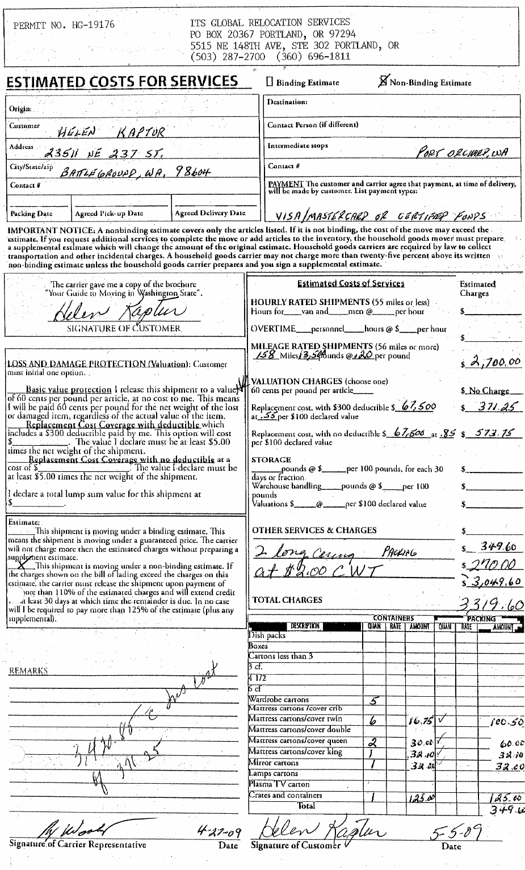

Appendix F

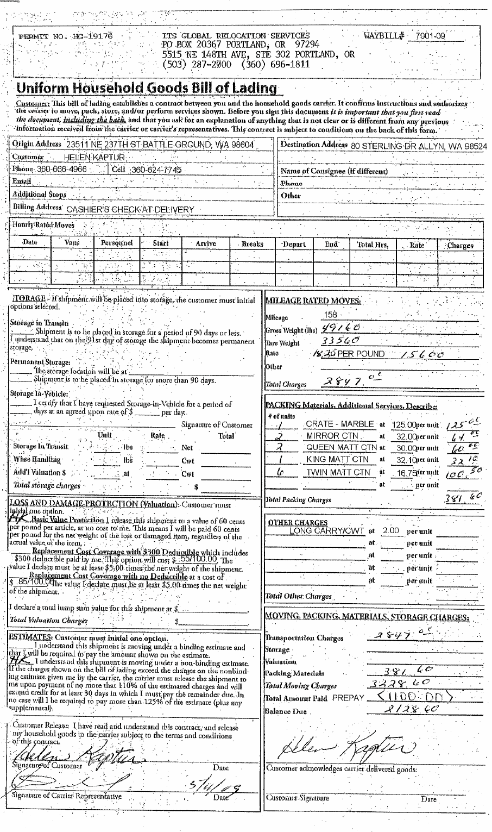

Upon instruction from commission staff to refund this improper charge back to the customer, Irvington Transfer refused.
The company’s letterhead shows an e-mail address of admin@itsglobalrelo.com.
Mr. Doeneka stated the move for Helen Kaptur was from Battleground to Allyn, Washington.
In response to staff’s request to explain why the company’s estimate had charges listed on it that were written by the customer, not the company’s estimator, Mr. Doeneka responded: “At estimate date, at Ms Kaptur's residence, it appeared to Randy [the estimator] that getting a semi close to the home may not be possible and that a shuttle may be necessary. He left the unsigned estimate with Ms. Kaptur and requested our operations manager to schedule a visit for his opinion regarding semi accessibility. Dan Smith went out to residence and advised that he felt our driver could get close enough to avoid a shuttle service, but that two long carries should be added to the cost estimate. Randy called the potential shipper and had her add the cost of two possible long carries to the estimate form.”
Upon instruction from commission staff to refund this improper charge back to the customer, Irvington Transfer refused.

