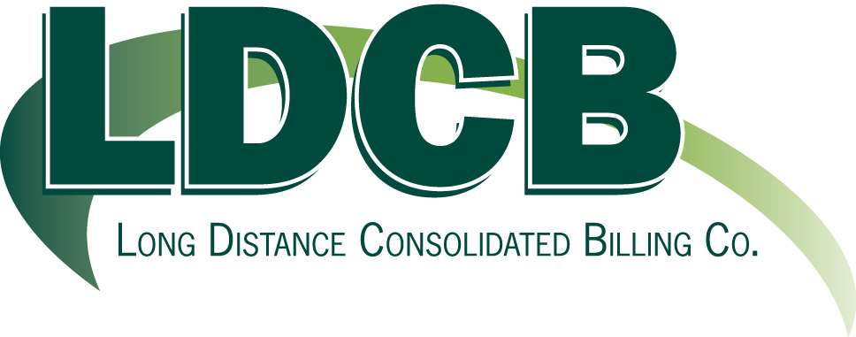

November 3, 2008

Mr. David Danner
Executive Secretary
Washington Utilities and Transportation Commission
1300 S. Evergreen Park Drive, S.W.
P.O. Box 47250
Olympia, WA 98504-7250

Re: Long Distance Consolidate Billing Co.; Petition for Exemption of WAC 480-120- 147(1)(c)

Dear Mr. Danner:

Long Distance Consolidated Billing Co. (“LDCB”) hereby petitions the Washington Utilities and Transportation Commission (“the Commission”) for an exemption from the “drop-off” requirement set forth in WAC 480-120-147(1)(c). Please find enclosed for filing the original and twelve copies of LDCB’s Petition for Exemption.

Please acknowledge receipt of this filing by file-stamping and returning the extra copy of the Petition in the self-addressed, stamped envelope provided for this purpose. Should you require additional information, please contact the undersigned.

Sincerely,

Jan Lowe,
President
Long Distance Consolidated Billing Co.

Enclosures

cc: Simon ffitch, Public Counsel Section, Washington State Office of the Attorney General

20 W. Washington St./Suite 6A/Clarkston, MI 48346/(248)625-3245/fax#(248)625-4337

