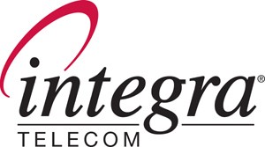

730 Second Avenue South - Suite 900 - Minneapolis – Minnesota 55402

May 14, 2008

Ms. Carole J. Washburn
Executive Secretary
WA Utilities & Transportation Commission
1400 S. Evergreen Park Drive S.W.
P.O. Box 40128 Via Email to: records@wutc.wa.gov and
Olympia, WA 98504-0128 FedEx Overnight Mail

Re: PETITION OF INTEGRA TELECOM OF WASHINGTON, INC. FOR APPROVAL OF AN ALTERNATIVE MEASUREMENT OF SERVICE QUALITY REPORTING PURSUANT TO WAC 480-120-439(12)

Dear Ms. Washburn:

Enclosed for filing is the original Petition for Alternative Measurement and Reporting under WAC 480-120-439(12) of Integra Telecom of Washington, Inc. This filing has also been made electronically via email to the Commission’s Records Center. Please contact the undersigned with any questions or concerns.

Sincerely,

Cathy Murray
Manager, Regulatory Affairs
Integra Telecom
730 2nd Avenue South, Suite 900
Minneapolis, MN 55402-2456
(612) 436-1632 (direct)
(612) 436-6816 (department fax)
camurray@integratelecom.com

Enclosures
Cc: Kristin Russell, WUTC

