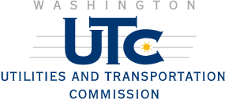
1300 S. Evergreen Park Drive SW
Post Office Box 47250
Olympia, Washington 98504-7250
360-664-1232 or 360-664-1222
Fax 360-586-1150
TTY 360-586-8203 or 1-877-210-5963
Web: www.wutc.wa.gov
E-Mail: records@wutc.wa.gov

Grade Crossing Protection Fund
APPLICATION FOR FUNDING

The commission’s objectives in distributing monies from its Grade Crossing Protective Fund (GCPF) are to reduce accident frequency and severity at both public and private railroad crossings and to reduce pedestrian trespassing and the frequency of trespass-related deaths and injuries along railroad rights-of-way. Any public, private, or nonprofit entity may submit an application to the commission for GCPF monies.

The focus of the GCPF program is to fund projects that demonstrate a need for improved public safety related to one of the following four categories:

- Grade crossing safety projects. Grants for improvements to warning devices at public grade crossings must be requested through the commission’s petition process pursuant to RCW 81.53.261. Contact Kathy Hunter at (360) 664-1257 for more information.
- Trespass prevention projects. Examples of projects in this category include fencing or other physical barriers that prevent trespassing on railroad rights-of-way, pedestrian warning devices, establishing new public grade crossings, installing channeling devices, media or public relations campaigns, and enforcement-related activities.
- Private crossing safety improvements. Examples of projects in this category include private crossing closures, installation of private crossing-specific warning devices, installation of nighttime or off-hours locked gates, and improvements to existing warning devices.
- Miscellaneous safety projects. Examples of projects in this category include improvements to motorists’ ability to see approaching trains, including the removal of physical obstructions, participation in roadway improvements at or approaching grade crossings, and mitigation of crossing closures.
All projects that fall within any of these four general categories are eligible for funding consideration.
Please complete and submit the following
information as part of the application process.

Applicant Name: Terri Heikkila
Organization: Washington State Parks and Recreation Commission

Address: 7150 Cleanwater Drive SW , P.O. Box 42650

Olympia, WA 98504-2650

Office Phone: (360) 902-8656

E-mail: terri.heikkila@Parks.wa.gov

Cell Phone:

Fax Number: 360-902-8840

Type of Application: Preliminary engineering work (topography & geotechnical) for pedestrian bridge design.

Private crossing safety improvement

Trespass prevention

Miscellaneous

Please list all of the other companies (e.g., railroad companies) organizations, or state or local agencies that may be involved in implementing this proposal and the name, address and phone number of each.

Note: Requests for public grade crossing safety projects will be continue to be processed through the Commission’s regular petition process.

Project Information – Please attach additional information if needed.

1) Provide a detailed summary of the hazard being addressed, including any accident/incident
information or other supporting data. If filing this application electronically, photographs, drawings, or other optional materials that are not in electronic format may be sent to the mailing address specified in the “instructions” section and should be clearly identified as an attachment to your application:

Larrabee State Park was the first state park in the agency. Currently, the park encompasses 2,684 acres with 8,100 feet of saltwater shoreline. The Project is to provide a new pedestrian bridge across the existing railroad mainline and construct a gravel pathway to access Clayton Beach at Larrabee State Park. The bridge will have to span an active BNSF Rail line between Mount Vernon, WA and Bellingham, WA. No bridge currently exists. The pedestrian bridge would maintain the railroad’s clearance requirements. This bridge will be designed to accommodate the standard pedestrian design load of 85 psf or a 10,000 lb. 2-axel maintenance vehicle.

2) Provide a detailed description of your proposed project and explain how its implementation will

eliminate or mitigate the hazard. If available, please attach any drawings or construction plans

for your proposed project (see section 1 if filing electronically):

It is assumed that the bridge will be pre-manufactured with the abutments constructed on-site. The pedestrian pathway will require minimal grading to meet Americans with Disabilities Act (ADA) requirements. The site will need to be cleared of trees and debris for access to the site.
All pedestrian traffic will be diverted to the overpass, thus eliminating the safety issues associated with the current illegal at-grade crossing. The current at-grade crossing has been used for a number of years and, as in most trespass situations, was established without the property owners’ permission. The current illegal crossing is the only way to access to the beach from park property, except for an underpass that is approximately 3000 feet away from the parking lot. Therefore, almost all park visitors wishing to access the beach use the illegal trespass route. State Parks’ on-site staff will work with safety specialists from BNSF and the staff at WUTC to incorporate any suggested access changes.

3) Provide cost estimates, including those related to long-term maintenance:

This phase of the project is seeking funds ($20,000.00) to develop a base map and conduct geotechnical analysis. Future funds would be sought to pay for construction (scoped out at approximately $137,000.00) and design (estimated at $68,000.00). The proposed single-span bridge would be approximately 75 feet long and at least 12 feet wide, providing a 10-foot wide walking surface. The foundations supporting the abutments will depend on local soil conditions and environmental permitting restrictions. Generally, one of three types of foundations are used to support bridge structures: spread footings, driven piles and drilled shafts.

4) Estimated timeline of project, if approved:

The first phase of the project is to collect site information on topography and soil conditions.
With that information we will be able to look at options and do preliminary engineering including permit submittal. Once a final design is agreed to, construction funding would be sought to implement.

5) If known, provide a description of how the project’s success would be measured:

The success of this project will be measured initially by completing the appropriate surveying and geotechnical inventory and analysis to move into the engineering phase of work. Ultimately, success will be measured upon the completion of the overall project by which all pedestrian traffic is diverted to the overpass, thus eliminating the safety issues associated with the current at-grade crossing.

6) Other comments:
The gravel pathway will lead from Chuckanut Drive to the pedestrian bridge and down to the beach. Total length of the pathway is approximately 1,500 feet and the path width will be ten feet. The path material will be 3-inch thick Crushed Surfacing Top Course (CSTC). The cost of the pathway will be approximately $15,000. The site will require clearing grubbing and minor grading for the pathway.

For questions or assistance, please contact Mark Halliday at 360-664-1232 (e-mail mhallida@wutc.wa.gov) or Kathy Hunter at 360-664-1257 (e-mail khunter@wutc.wa.gov)

Instructions

After completing the Grade Crossing Protective Fund application, please send the original and two copies to:
Washington Utilities and Transportation Commission
Attention: Grade Crossing Protective Fund
1300 S. Evergreen Park Drive SW
Olympia, WA 98504-7250

Applications are available at www.wutc.wa.gov/GCPFgrants. A signed application may be filed electronically at records@wutc.wa.gov. When filing electronically, please specify “Grade Crossing Protective Fund” in the subject line.

Please ensure that the names and addresses of representatives from the relevant railroad company and local jurisdiction are correct and listed in the application.

Funding

RCW 81.53.271 allows the commission to grant up to twenty thousand dollars for selected projects without requiring a monetary match. The commission, however, may limit the amount of funding per project to a lesser amount so that an optimal number of projects may be funded with regard to relative safety benefits and project costs. The commission may also consider funding for larger safety projects for which the GCPF grant would constitute some portion of the total cost.

Selection of Projects

The commission will initiate a “call for projects,” soliciting applications within a specific timeframe. After the specified submittal deadline, all applications will be reviewed simultaneously. Further information about the Grade Crossing Protective Fund may be obtained on the commission’s website at www.wutc.wa.gov/GCPFgrants, or by contacting Mark Halliday at (360) 664-1232 or Kathy Hunter at (360) 664-1257.
The commission will review and select projects for funding based on the relative severity of the hazard being addressed, the safety benefits resulting from a project, the costs of implementing a project, and geographic diversity. Final award of GCPF grants will be contingent upon the recipient signing an agreement specifying the terms of the grant.

Exhibit “A”

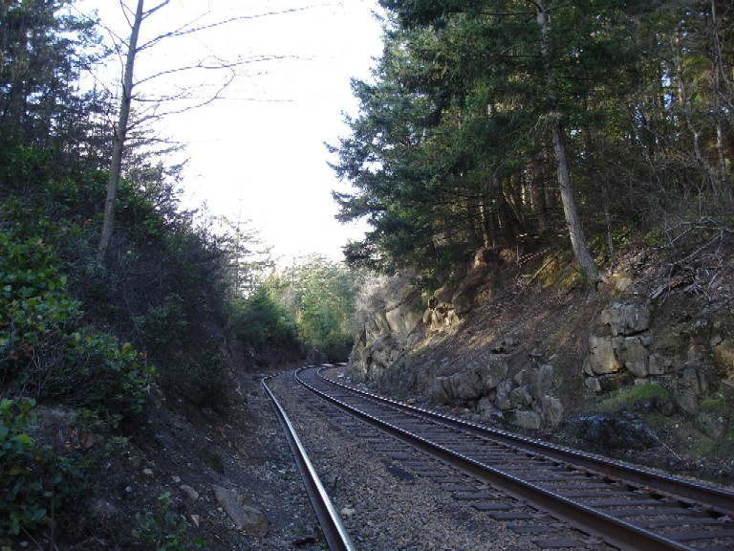
Approximate area for bridge placement. Please notice the curve in the tracks. This curve is approximately 1500 feet from the current at-grade crossing being used by park guests.

Exhibit “B”
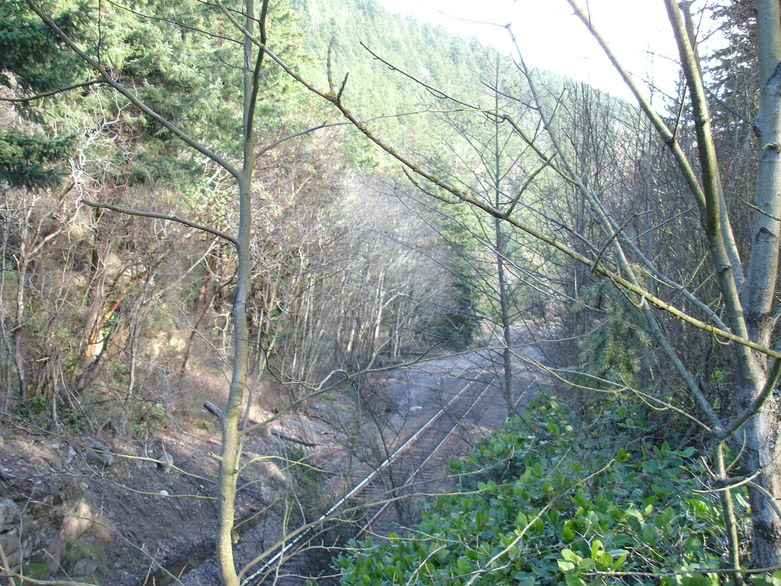
Approximate location where at grade trespass is occurring.
Currently park guests access the beach over the tracks via a path off Chuckanut Drive. This proposal would eliminate this hazard.

/tmp/in/input.doc

