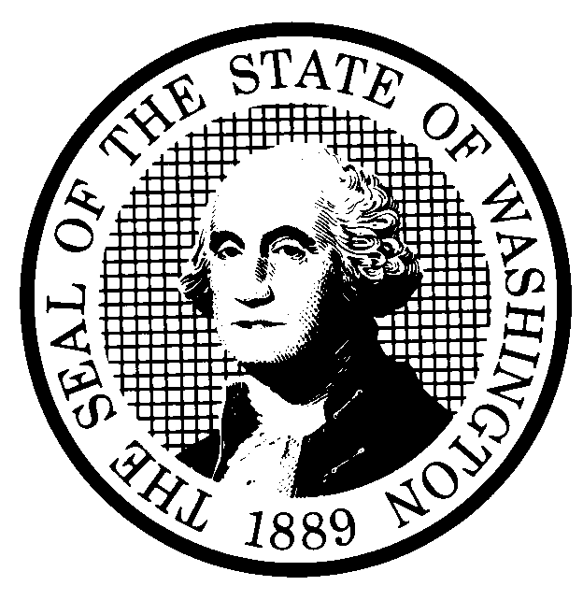 | PREPROPOSAL STATEMENT OF INQUIRY |  | CR-101 (June 2004)  (Implements RCW 34.05.310)  Do NOT use for expedited rule making
Agency: WASHINGTON UTILITIES & TRANSPORTATION COMMISSION (UTC)

Subject of possible rule making: Consider review of WAC 480-15 Household Goods Carriers.
Docket TV-070466
Statutes authorizing the agency to adopt rules on this subject: RCW 80.01.040, RCW 81.04.160, RCW 81.04.250, RCW 81.28.040, RCW 81.80.120, RCW 81.80.130, and RCW 81.80.290.
Reasons why rules on this subject may be needed and what they might accomplish: The current rules in WAC 480-15 went into effect in July 2000, after the federal government made extensive changes to the trucking industry. Given changes in the industry over the past seven years, as well as our experience with the current rules, we are now in a position to streamline the rules, provide greater flexibility for companies and less regulatory oversight by the UTC while still maintaining important consumer protections. We propose to streamline and clarify WAC 480-15. We propose simplifying some rules, aligning our rules more closely with the federal interstate household goods carrier rules where reasonable, and streamlining other rules to increase flexibility, decrease regulation and maintain consumer protection.

Identify other federal and state agencies that regulate this subject and the process coordinating the rule with these agencies: None
Process for developing new rule (check all that apply):
Negotiated rule making
Pilot rule making
Agency study
Other (describe)
The Commission will ask for initial written comments and will conduct a workshop on May 24, 2007.
How interested parties can participate in the decision to adopt the new rule and formulation of the proposed rule before publication:
(List names, addresses, telephone, fax numbers, and e-mail of persons to contact; describe meetings, other exchanges of information, etc.)
Interested persons may contact the Executive Secretary, Washington Utilities and Transportation Commission, P.O. Box 47250, 1300 S. Evergreen Park Drive, S.W., Olympia, Washington, 98504-7250; Telephone (360) 664-1174; Facsimile (360) 586-1150.

Interested persons may file written comments on the CR-101 by May 18, 2007.

For specific information regarding opportunities for written comment and to ensure receipt of further information concerning this rulemaking, please see the attachment to this form.

DATE  April 18, 2007 |  | CODE REVISER USE ONLY
NAME (TYPE OR PRINT)
Carole J. Washburn

SIGNATURE |  | Filed with the Code Reviser’s Office  April 18, 2007, 11:38 a.m.  WSR 07-09-104
TITLE
Executive Secretary

WASHINGTON UTILITIES AND TRANSPORTATION COMMISSION
CR-101 - ATTACHMENT
DOCKET NO. TV-070466

In addition to revising the rules, the Commission will also revise the household goods tariff (Tariff 15-B). The Commission can not change rules unless it also changes the associated tariff; the tariff puts many of the rules into effect.

To identify the rule changes envisioned in this rulemaking, the Commission has prepared a set of draft rules, as well as revisions to the tariff and consumer information guide, which are available for your review and comment on the Commission’s web site at www.wutc.wa.gov/070466. If you are unable to access the Commission’s web page and would like a copy of the draft rules mailed to you, please contact the Commission’s Records Center at (360) 664-1234. All of these documents include Commission Staff’s recommendations for revising the rules, tariff and consumer information.

Parties have the opportunity to file written comments and attend a workshop to discuss the recommended revisions, as discussed below.

Interested persons may contact the Executive Secretary, Washington Utilities and Transportation Commission, P.O. Box 47250, Olympia, Washington, 98504-7250, 360-664-1174 (Fax: 360-586-1150).

WRITTEN COMMENTS AND STAKEHOLDER WORKSHOP
Written comments may be submitted to the Commission at the address given above and should be filed with the Commission no later than May 18, 2007, for consideration at the May 24, 2007, stakeholder workshop.
Electronic copies. The Commission requests that comments be provided in electronic format to enhance public access, for ease of providing comments, to reduce the need for paper copies, and to facilitate quotations from the comments. Comments may be submitted by electronic mail to the Commission’s Records Center at records@wutc.wa.gov. Please include:

- The docket number of this proceeding (TV-070466)
- The commenting party’s name
- The title and date of the comment or comments

An alternative method for submitting comments may be by mailing/delivering an electronic copy on a 3 ½ inch, IBM-formatted, high-density disk, in .pdf Adobe Acrobat format or in Word 97 or later. Include all of the information requested above. The Commission will post on the Commission’s web site all comments that are provided in electronic format. The web site is located at http://www.wutc.wa.gov/070466.

If you are unable to file your comments electronically or to submit them on a disk, the Commission will always accept a paper document.

Opportunity for further comment is anticipated. Information about the schedule and other aspects of the rulemaking, including comments, will be posted on the Commission’s web site as it becomes available. If you wish to receive further information on this rulemaking you may (1) call the Commission’s Records Center at 360-664-1234, (2) e-mail the Commission at <records@wutc.wa.gov>, or (3) mail written comments to the address above to the attention of Carole J. Washburn, Secretary. When contacting the Commission, please refer to Docket TV-070466 to ensure that you are placed on the appropriate service list. Questions may be addressed to Vicki Elliott (360) 664-1100 or e-mail at velliott@wutc.wa.gov.

TO CONTINUE RECEIVING NOTICES AND INFORMATION ABOUT THIS RULEMAKING -- The Commission wants to ensure its mailings are sent to persons who are interested in the topic and want to receive that information. ANY PERSON WHO COMMENTS will continue to receive notices and information. If you do not submit comments but wish to remain on the mailing list for this rulemaking, please advise the Records Center by any one of the following methods: (1) send a note with your name, address (or a copy of your mailing label), and telephone and fax numbers referencing Docket TV-070466, and the words "Please keep me on the mailing list"; or (2) E-mail your name, address, telephone and fax numbers, referencing Docket TV-070466, and the words "Please keep me on the mailing list" to <records@wutc.wa.gov>. Please note that all information in the mailings will be accessible through the Commission's Internet web site at <http://www.wutc.wa.gov/070466>. THOSE PARTIES WHO DO NOT RESPOND MAY NOT RECEIVE FURTHER MAILINGS OR INFORMATION ON THE RULEMAKING.
NOTICE

