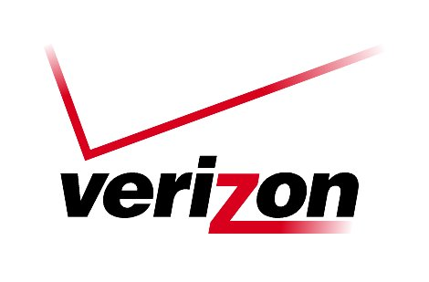 Verizon Northwest Inc.

1800 – 41st Street, WA0105RA
P. O. Box 1003
Everett, WA 98206-1003
Fax: 425-261-5262

March 2, 2007

Advice No. 3229

Ms. Carole J. Washburn, Executive Secretary
Washington Utilities and Transportation Commission
1300 S. Evergreen Park Drive, S. W.
Olympia, Washington 98504-7250

Dear Ms. Washburn:

Verizon Northwest Inc. submits for filing Advice No. 3229 a filing in the Local Network Access Services, Collocation Service Tariff, WN U-20 to delete a Note that appears on the tariff sheets listed on Attachment A to this filing that states: “Changes to terms and conditions approved in Docket No. UT-031731 remain in effect until March 1, 2007.” On February 5, 2007 Verizon Northwest Inc. filed with the Commission a petition for a permanent waiver of WAC 480-120-560(2) and (3) regarding implementation intervals for requests for collocation. The Commission approved Verizon’s waiver in Docket No. UT-070268 effective February 28, 2007. The waiver exemption is effective after February 28, 2007.

No cost documentation is submitted with this filing. This filing does not impact rates. The stated effective date is April 1, 2007, however, the company requests approval of this tariff filing on less than statutory notice (LSN) with an effective date of March 15, 2007. The LSN form is attached to this filing.

Please contact Lin Fogg at (425) 261-6380 with questions.

Very truly yours,
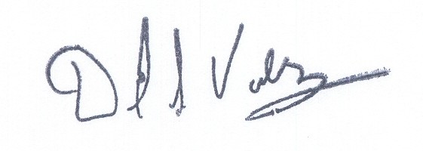

David S. Valdez
Senior Vice President - West
Public Affairs, Policy and Communications

DSV:LF:lf
Attachments
(WAIGOU-20-0153)

Ms. Carole J. Washburn
March 2, 2007
Advice No. 3229

Attachment A

Local Network Access Services – Collocation Service, WN U-20

Table of Contents 5th Revised Sheet 1

4th Revised Sheet 8

4th Revised Sheet 11

4th Revised Sheet 14

4th Revised Sheet 15

4th Revised Sheet 15.1

3rd Revised Sheet 15.1.1

3rd Revised Sheet 15.2

3rd Revised Sheet 72

3rd Revised Sheet 73

VERIZON NORTHWEST INC.
EVERETT, WASHINGTON

N O T I C E

Verizon Northwest Inc. submits for filing Advice No. 3229, a filing in the Local Network Access Services, Collocation Service Tariff, WN U-20.

The purpose of this filing is to delete a Note that appears on the tariff sheets listed on Attachment A to this filing that states: “Changes to terms and conditions approved in Docket No. UT-031731 remain in effect until March 1, 2007.” On February 5, 2007 Verizon Northwest Inc. filed with the Commission a petition for a permanent waiver of WAC 480-120-560(2) and (3) regarding implementation intervals for requests for collocation. The Commission approved Verizon’s waiver in Docket No. UT-070268 effective February 28, 2007. The waiver exemption is effective after February 28, 2007.

No cost documentation is submitted with this filing. This filing does not impact rates. The stated effective date is April 1, 2007, however, the company requests approval of this tariff filing on less than statutory notice (LSN) with an effective date of March 15, 2007. The LSN form is attached to this filing.

A copy of this tariff is available for public inspection at the following Verizon Plus store locations:

189 Cascade Mall Drive 1402 SE Everett Mall Way
Burlington Everett
Burlington Verizon Plus Everett Verizon Plus

511 Valley Mall Parkway 18700 33rd Ave. West, Suite D
East Wenatchee Lynnwood
East Wenatchee Verizon Plus Alderwood Verizon Plus

Posted at __________________________
__________________________
by __________________________

Post in above store location.

