 | 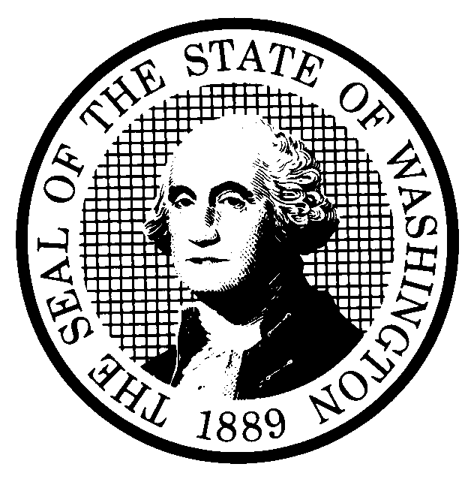 | EXPEDITED RULE MAKING |  |  |  |  | CR-105 (June 2004)  (Implements RCW 34.05.353)  EXPEDITED RULE MAKING ONLY
 | Agency: Washington Utilities and Transportation Commission
Title of rule and other identifying information: (Describe Subject)

Repeal WAC 480-62-155 – Train Speeds.

Docket TR-070198
NOTICE
THIS RULE IS BEING PROPOSED UNDER AN EXPEDITED RULE-MAKING PROCESS THAT WILL ELIMINATE THE NEED FOR THE AGENCY TO HOLD PUBLIC HEARINGS, PREPARE A SMALL BUSINESS ECONOMIC IMPACT STATEMENT, OR PROVIDE RESPONSES TO THE CRITERIA FOR A SIGNIFICANT LEGISLATIVE RULE. IF YOU OBJECT TO THIS USE OF THE EXPEDITED RULE-MAKING PROCESS, YOU MUST EXPRESS YOUR OBJECTIONS IN WRITING AND THEY MUST BE SENT TO
Name: Executive Secretary, Docket No. TR-070198
Agency: Washington Utilities and Transportation Commission
Address: P.O. Box 47250, Olympia, WA 98504-7250

AND RECEIVED BY April 9, 2007

Purpose of the proposal and its anticipated effects, including any changes in existing rules:

RCW 81.48.030 and RCW 81.48.040 direct the commission to set train speed limits in cities and towns and at grade crossings consistent with the hazards presented and the practical operation of trains. However, the Federal Railroad Safety Act prohibits states from issuing more stringent requirements on any subject already addressed by Federal Railroad Administration (FRA) rules. Because FRA rules already establish train speed limits, the commission may only take action to reduce train speeds when “necessary to reduce or eliminate an essentially local safety hazard,” as defined by P.L. 91-458, Sec 205 (49 USC Sec. 20106).

In June 2006, the Legislature adopted revisions to RCW 81.48.040, including a clear process for railroads to follow to increase train speeds. WAC 480-62-155 (Train Speeds), outlined the previous procedure used when the commission considered whether to alter train speed limits, either upon petition or upon its own motion. Because the revisions to RCW 81.48.040 established a new train speed increase process, this rule is no longer necessary.

Reasons supporting proposal:

The rule is no longer necessary due to changed circumstances surrounding train speed regulation in Washington.

 | Statutory authority for adoption: RCW 81.48.030, RCW 81.48.040, RCW 34.05.353 |  |  |  |  | Statute being implemented: N/A
Is rule necessary because of a:  Federal Law?  Federal Court Decision?  State Court Decision?  If yes, CITATION: |  |  | Yes  Yes  Yes | No  No  No | CODE REVISER USE ONLY  Filed with the Office of the Code Reviser  February 7, 2007, 10:05 a.m.  WSR 07-04-110
DATE
February 7, 2007
NAME (TYPE OR PRINT)
Carole J. Washburn
SIGNATURE

TITLE
Executive Secretary

(COMPLETE REVERSE SIDE)
Name of proponent: (person or organization)  Washington Utilities and Transportation Commission |  |  |  | Private  Public  Governmental
Name of agency personnel responsible for:
 | Name | Office Location | Phone
Drafting............... Betty Young,  Compliance Specialist |  | 1300 S. Evergreen Park Drive SW, Olympia, WA  98504-7250 | (360) 664-1202
Implementation.... Carole J. Washburn,  Executive Secretary |  | 1300 S. Evergreen Park Drive SW, Olympia, WA  98504-7250 | (360) 664-1174
Enforcement........ Carole J. Washburn,  Executive Secretary |  | 1300 S. Evergreen Park Drive SW, Olympia, WA  98504-7250 | (360) 664-1174
Agency comments or recommendations, if any, as to statutory language, implementation, enforcement, and fiscal matters:

None.

