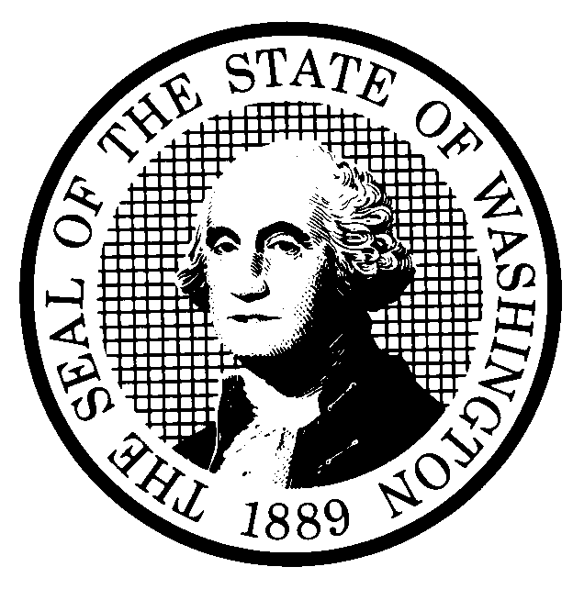 | PREPROPOSAL STATEMENT OF INQUIRY |  | CR-101 (June 2004)  (Implements RCW 34.05.310)  Do NOT use for expedited rule making
Agency: Washington Utilities and Transportation Commission

Subject of possible rule making: Develop rules to implement provisions of SHB 2426, passed by the legislature on March 3, 2006. Consider a rule to state ministerial delegation now effected by order.

Docket No. A-060357
Statutes authorizing the agency to adopt rules on this subject: RCW 80.01.040(4), RCW 80.04.160, and SHB 2426, 2006 session, Sec. 2.
Reasons why rules on this subject may be needed and what they might accomplish: The legislature in SHB 2426 of the 2006 legislative session authorized the Commission to delegate certain functions by rule or order, and directed the Commission to promulgate rules to identify a notice process to enable persons affected by a proposal to ensure that commissioners personally considered the matter. Rules may also be appropriate to specify the details of the process by which initial orders become final under Section 5(3) of the law.
Identify other federal and state agencies that regulate this subject and the process coordinating the rule with these agencies:

N/A
Process for developing new rule (check all that apply):
Negotiated rule making
Pilot rule making
Agency study
Other (describe) The Commission will schedule a workshop on May 11, 2006, and may schedule an additional workshop with representatives of affected constituencies in a manner designed to develop consensus among affected interests regarding any rule proposal. The Commission will ask for initial written comments by April 24, 2006, and may provide the opportunity for additional comments, if needed.
How interested parties can participate in the decision to adopt the new rule and formulation of the proposed rule before publication:
(List names, addresses, telephone, fax numbers, and e-mail of persons to contact; describe meetings, other exchanges of information, etc.)
Interested persons may contact the Secretary, Washington Utilities and Transportation Commission, P.O. Box 47250,
1300 S. Evergreen Park Drive, S.W., Olympia, Washington, 98504-7250; Telephone (360) 664-1174;
Facsimile (360) 586-1150

For specific information regarding opportunities for written comment, opportunities for participation in workshops, and to ensure receipt of further information concerning this rulemaking, please see the attachment to this form.

DATE  March 15, 2006 |  | CODE REVISER USE ONLY
NAME (TYPE OR PRINT)  Carole J. Washburn |  | Filed with the Code Reviser’s Office  March 15, 2006, 3:32 p.m.  WSR 06-07-099
SIGNATURE
TITLE
Executive Secretary

WASHINGTON UTILITIES AND TRANSPORTATION COMMISSION
CR-101 - ATTACHMENT
DOCKET NO. A-060357

You may contact the Secretary, Washington Utilities and Transportation Commission,
P.O. Box 47250, Olympia, Washington, 98504-7250, 360-664-1174 (Fax: 360-586-1150),
with questions or comments about this docket.

WRITTEN COMMENTS AND STAKEHOLDER WORKSHOP

Please file written comments with the Commission no later than April 24, 2006, for consideration at a May 11, 2006, stakeholder workshop.

Electronic filing. Please send us your comments electronically. You do not need to send paper copies.

- If possible, please send comments via the Commission’s web portal (www.wutc.wa.gov/e-filing).
- If you aren’t able to use the web portal, you may send comments by electronic mail to the Commission’s Records Center at records@wutc.wa.gov.
- You may mail or deliver an electronic copy to the address above, on a 3 ½ inch, IBM-formatted, high-density disk. Please use Word 97 or later and, if convenient, .pdf (Adobe Acrobat) format.
- The Commission will always accept a paper document. Send or deliver it to the address above.

Please include this information with your comments:

- The docket number of this proceeding (A-060357)
- Your name and contact information, so we can respond to you and attribute your comments
- The name of the person or entity who sponsors the comments, if you are sending them for another person or organization
- The title and date of the comment or comments

We will post comments on the Commission’s web site along with other information about the rulemaking, including schedule information and discussion drafts. The web site is located at http://www.wutc.wa.gov/060357.

We also expect to invite additional comments later in the rulemaking. We will use the contact information you provide with your comments to send you a notice of the opportunity to comment. If you don’t submit comments, you may watch the web site for schedule information, and if you ask, we will put you on a list to receive docket information. Please look to the notice box below to see how to get further notices and information.

You may also ask questions about this docket by contacting Bob Wallis at (360) 664-1142 or <bwallis@wutc.wa.gov>.

TO CONTINUE RECEIVING
NOTICES AND INFORMATION
ABOUT THIS RULEMAKING:

The Commission wants to ensure its mailings are sent to persons who are interested in the topic and want to receive that information.

IF YOU COMMENT, you will continue to receive notices and information.

IF YOU DON’T COMMENT, but want to remain on the mailing list for this rulemaking, please ask the Records Center by any of the following methods:

(1) E-mail your name and e-mail address to records@wutc.wa.gov. Simply say, "Please keep me on the mailing list for Docket No. A-060357"

(2) Send a note to the Commission offices with your name and e-mail address (or a copy of your mailing label), asking "Please keep me on the mailing list for Docket No. A-060357."

Please note that all information in the mailings will be available through the Commission's Internet web site at <http://www.wutc.wa.gov/060357>.

IF YOU DO NOT RESPOND,
YOU MAY NOT RECEIVE FURTHER
MAILINGS OR INFORMATION
ABOUT THE RULEMAKING.

----------NOTICE----------

