Grade Crossing Protective Fund:

Grant Application for Home Valley Park Fence Project

Section 1: Project Contacts

Skamania County Public Works:

Name: Arnold Bell
Title: Engineering Technician II
Address: PO Box 790 Stevenson WA. 98648
Phone Number: 509-427-3917
E-mail: abell@co.skamania.wa.us

Section 2: Hazard Summary

Home Valley Park is located south of SR-14 and BNSF rail line at milepost 57, in Home Valley WA. Within Skamania County we have had several incidents of people vs. train; at this particular site there has never been an incident. In the past there has been a brush barrier between the park and the railroad tracks, last year due to increase in accidents at the crossing we removed a large portion of that barrier. Now that the brush is gone there is a direct path to the tracks from the park. In the park there are three baseball fields with one being only 150’ away from the tracks, during the spring and summer months the park has a lot of activity, little league baseball, picnics, swimming, and sail boarding. Our highest concentration of children closest to the tracks is during the baseball season, field #1 is located closest to the tracks and is the main field for little league games. During the games the spectators sit with there backs to the tracks and watch the games, most of these families have other small children that play of to the side of the field, and tend to migrate towards the tracks. On at least one occasion a little league game was stopped by the field umpire when he notice a group of small children had made their way to within about thirty-five feet of the tracks.

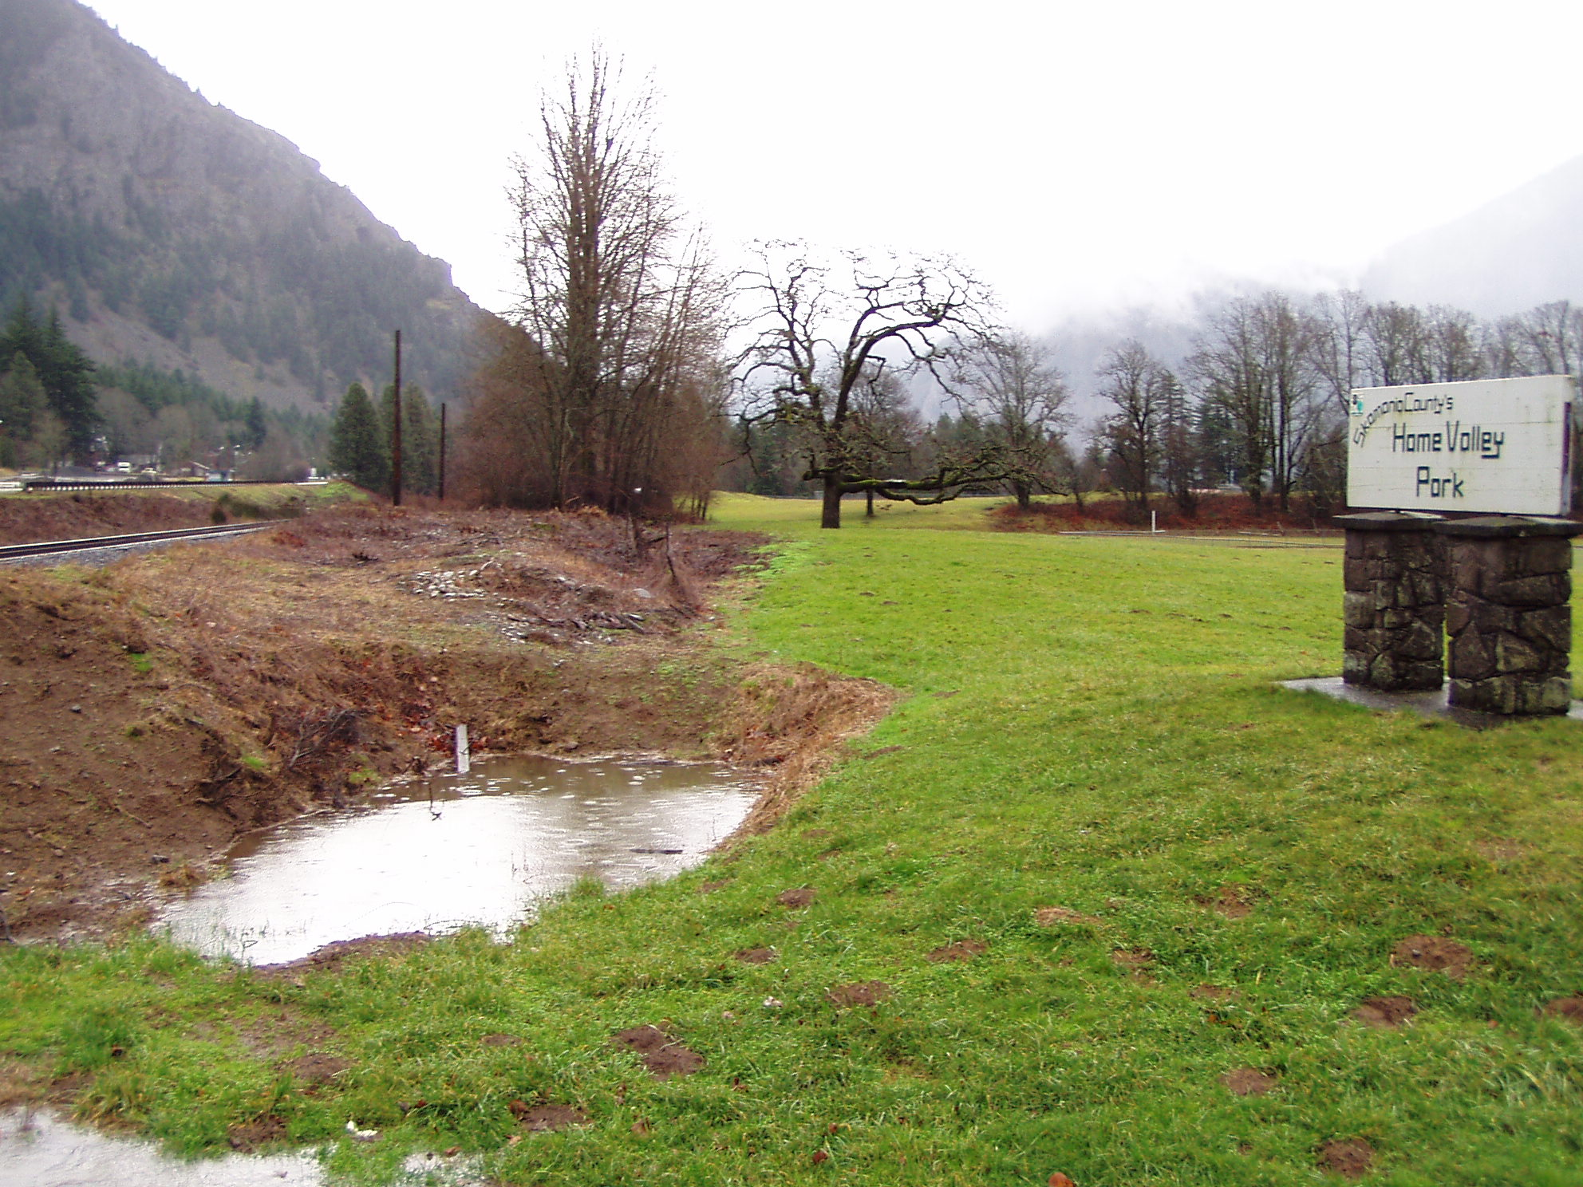

Standing at the entrance to the park looking east.

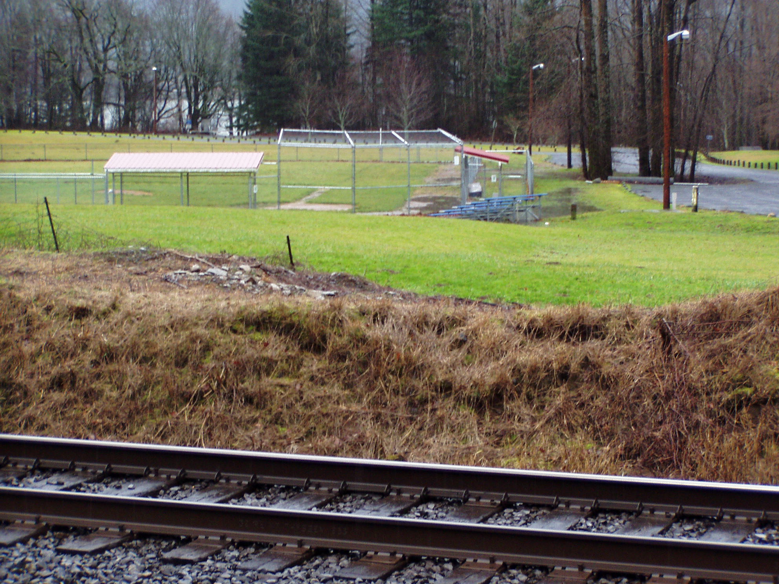

Standing in between SR-14 and railroad tracks looking south into park at field #1.

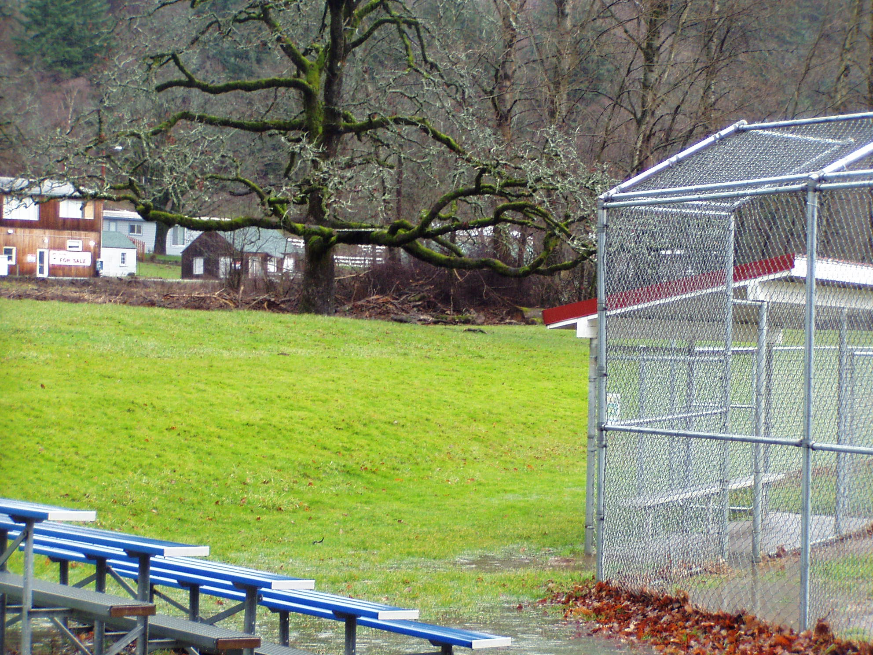

Standing in field #1 parking lot looking northeast at backstop and dugout area. The bleachers and grassy area behind dugout is where spectators sit and children play while watching the games. The large tree in the background is only 60 feet from the tracks.

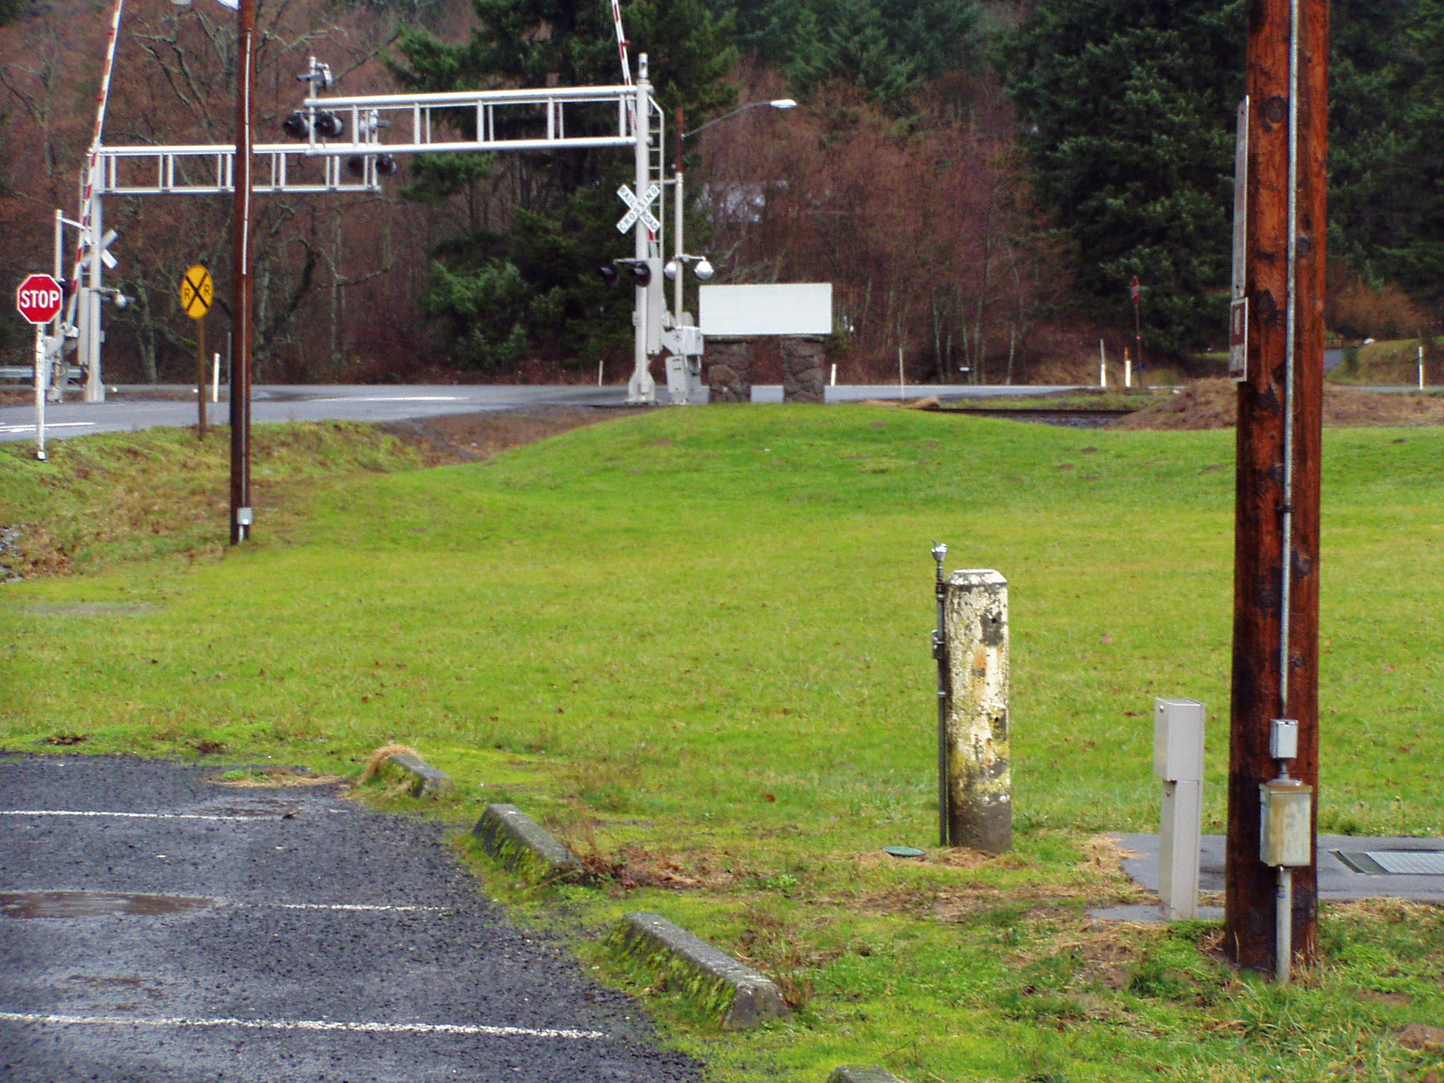

Standing in field #1 parking lot looking north at park entrance and railroad tracks, this is 185’ from tracks.

Section 3: Proposed Project

Our proposal is a simple one, we would like to put up a six-foot fence just inside county property that would serve as a barrier between the park and the tracks. The fence would consist of six foot chain link fencing that would run from the entrance of the park, thence east along the edge of the park a distance of 426’, we would also run a 100’ section south toward field#1. This we feel would be a sufficient barrier and deterrent to keep children from trespassing on to the railroad tracks.

Section 4: Cost Estimate and Project Timeline

These figures from like projects from the WSDOT Unit Bid Analysis Table.

ITEM | DESCRIPTION | UNIT | $/UNIT | TOTAL
1 | 6’ Chain Link Fence 526’ long | LF | 12.50 | 6575.00

We would anticipate starting the project mid June and finishing in the same month weather permitting. The weather in our area is quite wet and the ground would need sufficient time to dry so we could set the fence posts with the assurance that they would remain solid.

Section 5: Project Success

There is only one way to measure the success of this project and that is by seeing that a child or any other patron of the park does not get on to the railroad tracks or hit by a train while visiting our park.

