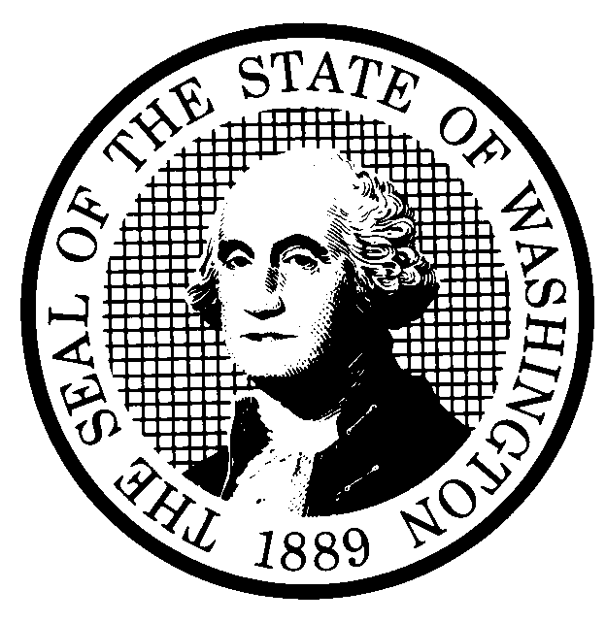 | PREPROPOSAL STATEMENT OF INQUIRY |  | CR-101 (June 2004)  (Implements RCW 34.05.310)  Do NOT use for expedited rule making
Agency: WASHINGTON UTILITIES AND TRANSPORTATION COMMISSION

Subject of possible rule making: Consider establishing regulations to govern the interconnection of consumer-owned power generation facilities to utility delivery facilities. Such regulations may include standards for applications for interconnection, processing of such applications, technical and engineering standards for interconnections, safety standards, insurance and liability provisions, and other provisions. DOCKET NO. UE-051106
Statutes authorizing the agency to adopt rules on this subject: RCW 80.01.040 and RCW 80.04.160
Reasons why rules on this subject may be needed and what they might accomplish: RCW 80.28.025 establishes a state policy to encourage electric power resources from renewable sources through use of incentives.

Substitute Senate Bill (SSB) 5101, Chapter 300, Laws of 2005, states that “the legislature intends to provide incentives for the greater use of locally created renewable energy technologies.” SSB 5101 also provides that utilities, in return for a credit against the public utility excise tax, may supply an incentive payment to consumers for consumer-generated electricity from renewable energy systems. However, the incentive payments created by SSB 5101 are only available to customers connected to the distribution system of a light and power business if “uniform standards for interconnection to the electric distribution system” are in effect for light and power businesses serving eighty percent of total customer load in the state.

Establishing standards for interconnection of customer-owned power generation facilities to the delivery systems of the investor-owned utilities would constitute substantial progress toward meeting the threshold condition established by SSB 5101 for customer incentive payments. In addition, a rule would establish uniformity among the investor-owned utilities regarding technical and process standards as well as safety and liability standards for such interconnections.

In addition, recently enacted amendments to Section 111(d) of the Public Utility Regulatory Policies Act of 1978 (16 U.S.C. 2621(d)) require the Commission to consider and determine whether to establish standards for interconnection.
Identify other federal and state agencies that regulate this subject and the process coordinating the rule with these agencies: The Federal Energy Regulatory Commission (FERC) regulates interconnection of generation facilities to transmission facilities used to transmit power in interstate commerce. FERC is finalizing regulations governing interconnection to FERC-jurisdictional facilities. These regulations may provide a model for regulations in Washington State.
Process for developing new rule (check all that apply):
Negotiated rule making
Pilot rule making
Agency study
Other (describe)
The Commission will ask for initial written comments, and may provide the opportunity for participation in workshop-style sessions as well as opportunities for additional comments.
How interested parties can participate in the decision to adopt the new rule and formulation of the proposed rule before publication:
(List names, addresses, telephone, fax numbers, and e-mail of persons to contact; describe meetings, other exchanges of information, etc.)
Interested persons may contact the Secretary, Washington Utilities and Transportation Commission, P.O. Box 47250, 1300 S. Evergreen Park Drive, S.W., Olympia, Washington, 98504-7250; Telephone (360) 664-1174; Facsimile (360) 586-1150.

Interested persons may file initial written comments on the CR-101 by October 14, 2005. For specific information regarding opportunities for written comment and to ensure receipt of further information concerning this rulemaking, please see the attachment to this form.

DATE  August 12, 2005 |  | CODE REVISER USE ONLY
NAME (TYPE OR PRINT)  Carole J. Washburn |  | Filed with the Code Reviser’s Office  August 12, 2005, 1:50 p.m.  WSR 05-17-083
SIGNATURE
TITLE
Executive Secretary

WASHINGTON UTILITIES AND TRANSPORTATION COMMISSION
CR-101 - ATTACHMENT
DOCKET NO. UE-051106

Interested persons may contact the Secretary, Washington Utilities and Transportation Commission, P. O. Box 47250, Olympia, Washington, 98504-7250, 360-664-1174 (Fax: 360-586-1150).

WRITTEN COMMENTS
Written comments may be submitted to the Commission at the address given above and should be filed with the Commission no later than October 14, 2005.
Electronic copies. The Commission requests that comments be provided in electronic format to enhance public access, for ease of providing comments, to reduce the need for paper copies, and to facilitate quotations from the comments. Comments may be submitted by electronic mail to the Commission’s Records Center at records@wutc.wa.gov. Please include:

- The docket number of this proceeding (UE-051106)
- The commenting party’s name
- The title and date of the comment or comments

An alternative method for submitting comments may be by mailing/delivering an electronic copy on a 3 ½ inch, IBM-formatted, high-density disk, in .pdf Adobe Acrobat format or in Word 97 or later. Include all of the information requested above. The Commission will post on the Commission’s web site all comments that are provided in electronic format. The web site is located at http://www.wutc.wa.gov/051106. If you are unable to file your comments electronically or to submit them on a disk, the Commission will always accept a paper document.

Opportunity for further comment is anticipated. Information about the schedule and other aspects of the rulemaking, including comments, will be posted on the Commission’s web site as it becomes available. If you wish to receive further information on this rulemaking you may (1) call the Commission’s Records Center at 360-664-1234, (2) e-mail the Commission at <records@wutc.wa.gov>, or (3) mail written comments to the address above to the attention of Carole J. Washburn, Secretary. When contacting the Commission, please refer to Docket No. UE-051106 to ensure that you are placed on the appropriate service list. Questions may be addressed to Dick Byers 360-664-1209 or e-mail at dbyers@wutc.wa.gov.

NOTICE

TO CONTINUE RECEIVING NOTICES AND INFORMATION ABOUT THIS RULEMAKING -- The Commission wants to ensure its mailings are sent to persons who are interested in the topic and want to receive that information. ANY PERSON WHO COMMENTS will continue to receive notices and information. If you do not submit comments but wish to remain on the mailing list for this rulemaking, please advise the Records Center by any one of the following methods: (1) send a note with your name, address (or a copy of your mailing label), and telephone and fax numbers referencing Docket No. UE-051106, and the words "Please keep me on the mailing list"; or (2) E-mail your name, address, telephone and fax numbers, referencing Docket No. UE-051106, and the words "Please keep me on the mailing list" to <records@wutc.wa.gov>. Please note that all information in the mailings will be accessible through the Commission's Internet web site at <http://www.wutc.wa.gov/051106>. THOSE PARTIES WHO DO NOT RESPOND MAY NOT RECEIVE FURTHER MAILINGS OR INFORMATION ON THE RULEMAKING.

