Cypress Communications Operating Company, Inc. – UT-031839
Staff Investigation - Annual Report/Regulatory Fees
November 21, 2003

Purpose
The purpose of this investigation is to determine if Cypress Communications Operating Company, Inc. (Cypress) is in violation of WAC 480-120-303 which requires public service companies to furnish annual reports to the Commission no later than May 1 each year.

Background
This investigation was prompted by Staff’s yearly review of annual reports and regulatory fees for telecommunications companies registered in the state of Washington.

On March 6, 2003, the Commission mailed 2002 Annual Report forms and 2003 Regulatory Fee packets to local and competitive telecommunications companies registered in Washington State. A letter signed by Carole Washburn instructed companies to file annual reports and pay regulatory fees by May 1, 2003. Companies requesting an extension were asked to do so prior to May 1, providing a reason for the requested extension (Appendix A).

On June 5, 2003, a letter signed by Carole Washburn was sent to each telecommunications company that had not filed an annual report by May 1, 2003. The letter stated that Staff intended to recommend enforcement action, including possible penalties and/or suspension or revocation of authority, for any company that failed to file a completed annual report (Appendix B).

Investigation
As of May 1, 2003, Cypress had not filed its 2002 annual report. Cypress filed its annual report on June 16, 2003.

Recommendation:
Penalize Cypress $100.00 for a violation of WAC 480-120-303.
Appendix A

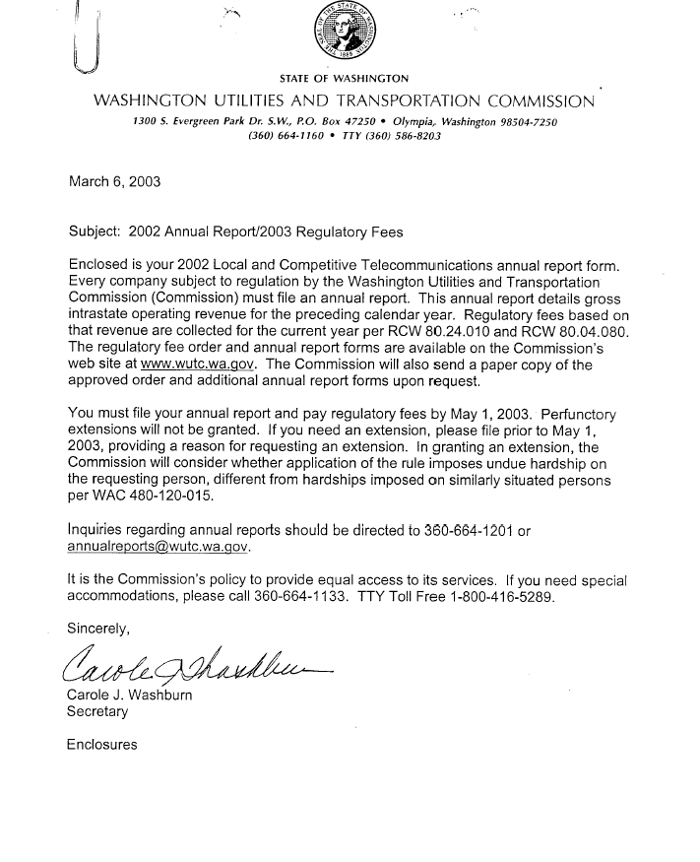
Appendix B

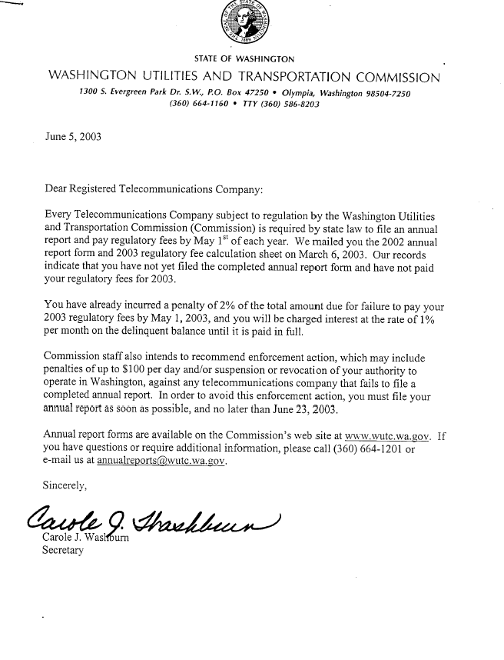
Appendix C

[Service Date September 30, 2003]

September 30, 2003

NOTICE OF IMPENDING REVOCATION OF REGISTRATION
AS A TELECOMMUNICATIONS COMPANY
AND OPPORTUNITY TO REQUEST A HEARING

Re: Revocation of Telecommunications Registrations for Failure to File Annual
Reports and Pay Regulatory Fees; Docket No. UT-031194

TO ALL TELECOMMUNICATIONS COMPANIES LISTED IN ATTACHMENT A:

Staff of the Washington Utilities and Transportation Commission (Commission Staff) recently conducted its yearly review of annual reports and regulatory fees for telecommunications companies registered in the state of Washington. As a result, Commission Staff identified the telecommunications companies listed in Attachment A as not complying with regulatory requirements for 2002, and in one case with the requirements for 2001. This notice is being served to all companies listed in Attachment A and their registered agents, if named, at their last known addresses on file with the Commission.

WAC 480-121-060 provides that the Commission may revoke a company’s registration for good cause after notice and opportunity for a hearing. Good cause includes failure to file an annual report or pay regulatory fees. In addition, the Commission may impose a penalty not to exceed $100 for each violation of statute, rule, or order under RCW 80.04.405. Each violation is a separate and distinct offense, and each day of a continuing violation will be deemed a separate and distinct violation. The Commission does not waive its authority to impose a penalty consistent with RCW 80.04.405 upon the companies listed in Attachment A.

If companies listed in Attachment A want to avoid revocation of its registration, the companies must, within 30 days of service of this notice, take one of two actions. First, companies may obtain regulatory compliance by submitting annual reports and paying regulatory fees that are delinquent. Second, companies may request a hearing to demonstrate why the company’s registration should not be revoked. Failure to respond within 30 days of this notice will result in the Commission entering an order revoking the company’s registration without further notice. Unregistered companies are prohibited from providing telecommunications services in the state of Washington.

Annual report forms are available on the Commission’s Internet web site – http://www.wutc.wa.gov -- or by contacting the Commission by email at annualreports@wutc.wa.gov or telephone at (360) 664-1201. Requests for hearings must comply with the Commission’s procedural rules, chapter 480-09 WAC, which are also available at the Commission’s Internet web site.

Sincerely,

CAROLE J. WASHBURN
Secretary

2001/2002 Delinquent Annual Report and 2002/2003 Regulatory Fee Payment -- A check mark means
that the Commission's records indicate that the company is delinquent in filing the designated material.
 | 2001 |  | 2002
Company Name | Annual Report | 2002 Regulatory Fees | Annual Report | 2003 Regulatory Fees
Access Communications, Inc. d/b/a Access Long Distance | ▪ | ▪ | ✓ | ✓
Accessline Communications, Corporation | ▪ | ▪ | ✓ | ✓
ACSI Local Swithced Services, Inc. | ▪ | ▪ | ✓ | ✓
Advantage Telecommunications, Corporation | ▪ | ▪ | ▪ | ✓
Allied Riser of Washington, Inc. | ▪ | ▪ | ✓ | ✓
Arizona Telephony Brokers, L.L.C. | ▪ | ▪ | ✓ | ✓
Backbone Communications, Inc. | ▪ | ▪ | ✓ | ✓
BullsEye Telecom, Inc. | ▪ | ▪ | ✓ | ✓
Choctaw Communications, Inc., d/b/a Smoke Signal Communications | ▪ | ▪ | ✓ | ✓
Communications Billing, Inc. | ▪ | ▪ | ✓ | ✓
Compass Telecommunications, Inc. | ▪ | ▪ | ✓ | ✓
Comtel Network, LLC | ▪ | ▪ | ✓ | ✓
Consolidated Billing Provider, LLC | ▪ | ▪ | ✓ | ✓
Convergence Technologies, Inc. | ▪ | ▪ | ✓ | ✓
Corporate Services Telcom, Inc. | ▪ | ▪ | ✓ | ✓
Eastern Telecommunications Incorporated | ▪ | ▪ | ✓ | ✓
ePhone Telecom, Inc. | ▪ | ▪ | ✓ | ✓
Equal Access Communications, LLC, d/b/a Equal Access | ▪ | ▪ | ✓ | ✓
Eztel Network Services, LLC. | ▪ | ▪ | ✓ | ▪
Gateway Networks Incorporated | ▪ | ▪ | ✓ | ✓
GFI Inc d/b/a GFI Communications | ▪ | ▪ | ✓ | ✓
Global Access & VOIP Corporation | ▪ | ▪ | ✓ | ✓
Global Crest Communications Inc. d/b/a Dimensions | ▪ | ▪ | ✓ | ✓
Intelecall Communications, Inc. | ▪ | ▪ | ✓ | ✓
Interwest Telecom Services | ▪ | ▪ | ✓ | ✓
LCI International Telecom Corp., d/b/a Qwest Communications Services | ▪ | ▪ | ✓ | ✓
Long Distance Billing Services, Inc. | ▪ | ▪ | ✓ | ✓
Maxcess, Inc. | ▪ | ▪ | ✓ | ▪
Maxxis Communications, Inc. | ▪ | ▪ | ✓ | ✓
Metromedia Communications Corporation | ▪ | ▪ | ✓ | ✓
Natel, LLC | ▪ | ▪ | ✓ | ✓
Network Access Solutions Corporation | ▪ | ▪ | ✓ | ✓
North County Communications Corporation | ▪ | ▪ | ✓ | ✓
Oregon Telecom, Inc., d/b/a Washington Telecom | ▪ | ▪ | ✓ | ✓
Phoenix Network, Inc. | ▪ | ▪ | ✓ | ✓
Pipeline Technologies, Inc | ▪ | ▪ | ✓ | ✓
Pro Plus Communications Corporation | ▪ | ▪ | ✓ | ✓
Public Communications Services, Inc. | ▪ | ▪ | ✓ | ✓
Radiant Telecom, Inc. | ▪ | ▪ | ✓ | ✓
rileydog, LLC d/b/a BIWireless | ▪ | ▪ | ✓ | ✓
ServiSense.com, Inc. | ▪ | ▪ | ✓ | ✓
Single Billing Services, Inc., d/b/a Asian American Association d/b/a Fiesta Tel | ▪ | ▪ | ✓ | ✓
Special Accounts Billing Group, Inc. | ▪ | ▪ | ✓ | ✓
St. Andrews Telecommunications, Inc. | ▪ | ▪ | ✓ | ✓
Telecommunications Consultants International, Inc., d/b/a Telecom International | ✓ | ✓ | ✓ | ✓
The Phone Company Management Group LLC d/b/a The Washington Phone Company | ▪ | ▪ | ✓ | ✓
TON Services, Inc. | ▪ | ▪ | ✓ | ✓
TransNet Connect, Inc. | ▪ | ▪ | ✓ | ✓
TSS Digital Services, LLC | ▪ | ▪ | ✓ | ✓
UKI Communications, Inc. | ▪ | ▪ | ✓ | ✓
United States Telecommunications, Inc. d/b/a Tel Com Plus | ▪ | ▪ | ✓ | ✓
Vanilla, Inc. | ▪ | ▪ | ✓ | ✓
Voice Connections, Inc. | ▪ | ▪ | ✓ | ✓
Who's Calling, Inc. | ▪ | ▪ | ✓ | ✓
World Communications, Inc. | ▪ | ▪ | ✓ | ✓
WorldTeq Corporation | ▪ | ▪ | ✓ | ✓
ZENEX Long Distance, Inc. | ▪ | ▪ | ✓ | ✓

