
9260 E. Stockton Blvd
Elk Grove, CA 95624

May 14, 2015

Mr. Steven V. King
Executive Director and Secretary
Washington Utilities and Transportation Commission
1300 S. Evergreen Park Drive SW
P.O. Box 47250
Olympia, WA 98504-7250

RE: Docket UT 090842, Order 06 - Quarterly Intercompany Receivables, Payables and Dividends Report

Dear Mr. King:

Pursuant to Condition 1 in Appendix A, Attachment 1 of Order 06 in Docket UT-090842, enclosed for filing is an original and seven copies of Frontier Communications Northwest Inc’s quarterly intercompany receivables, payables and dividends report for the first quarter 2015.

The report is marked “Highly Confidential per Protective Order in Docket UT-090842”. Therefore, a highly confidential and a redacted version of the report are included in this filing.

If you have any questions, please contact me at (916) 686-3588 or by email at joe.chicoine@ftr.com.

Sincerely,
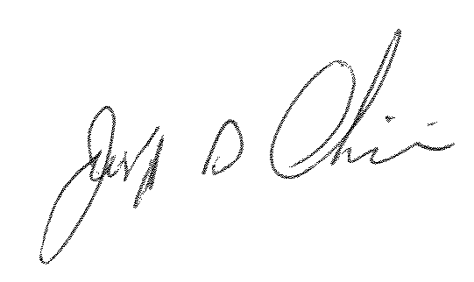
Joseph D. Chicoine
Manager, Compliance and Reporting

cc: Cathy Dahlquist, Frontier

