Interconnect Mediated Access (IMA)

GUI Screen Print Analysis

Screen Field Population

Overview

IMA GUI screen data fields can be populated via three methods:

- Auto-population – IMA application automatically populates the respective field(s) with the appropriate data independent of any end user action.

- Pre-population – an end user selects an option from a drop down list and the respective field(s) are populated with the appropriate data.

- Manually population – an end user manually enters the data into the respective field(s).

Document layout

This document was designed to (1) present the flow of Pre-Order transactions that provide auto-populated and/or pre-populated data to other Pre-Order and/or Order transactions and then (2) present the flow of Order transactions that provide auto-populated and/or pre-populated data to Order transactions.

Legend

- Screen names are in Bold.
- Field names are underlined.
- Links , Buttons and Tabs are in “quotes”
- Field values are in ‘quotes’
- Changes are noted in Yellow highlight (for IMA Release 9.0)

Note: The account name, address and telephone number used in this document is from a Qwest internal test account.
Interconnect Mediated Access (IMA)
Log In Screen
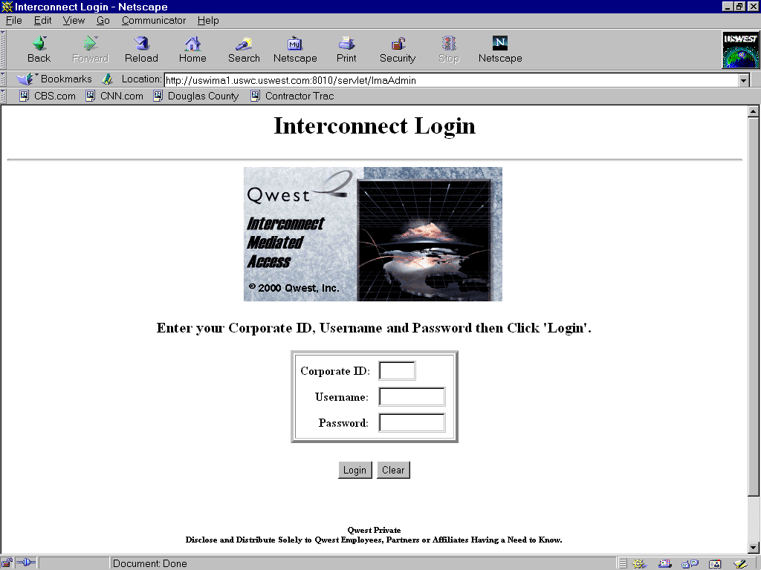

Manually populated fields:
- Corporate Id
- Username
- Password

Action:
- Click “Login” button
Interconnect Functions Screen
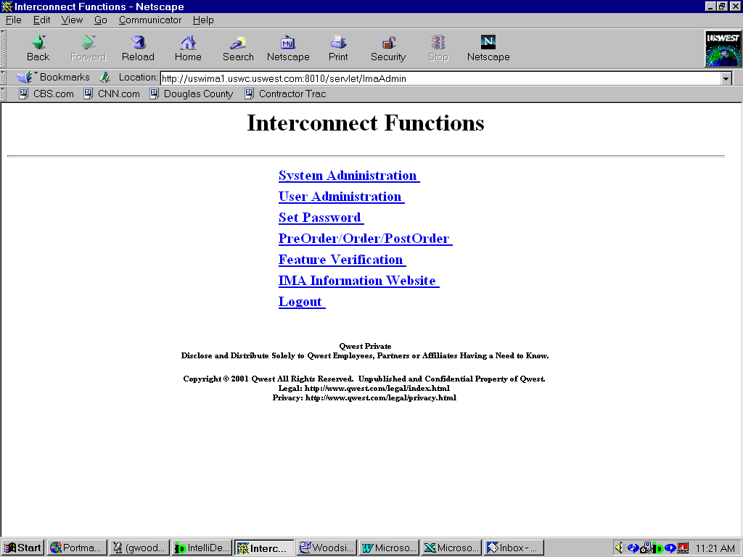

Action:
- Click “PreOrder/Order/PostOrder” link

IMA Pre-Order, Order, Post-Order Access Screen
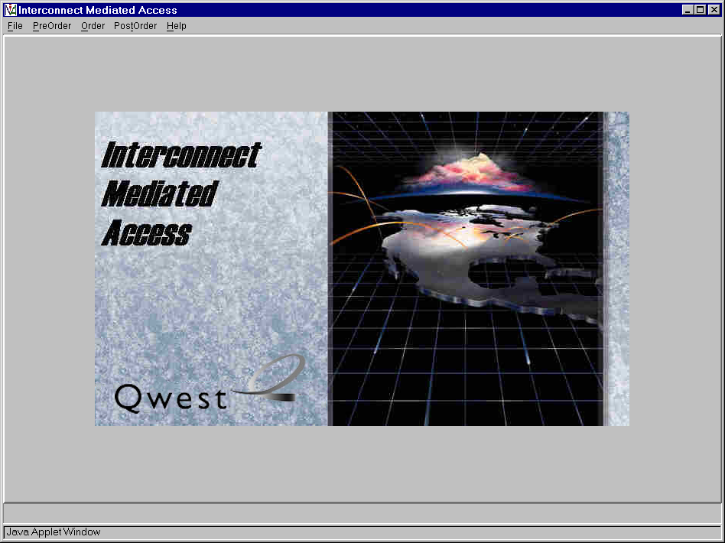

Action:
- Click “PreOrder” link

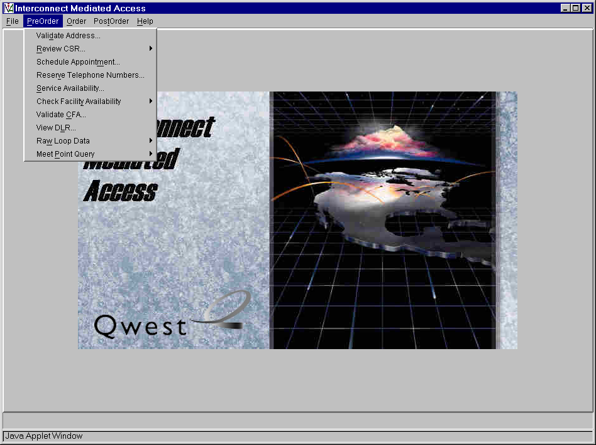

Action:
Click “Address Validation” link

Pre-Order Select Address Validation Type Screen
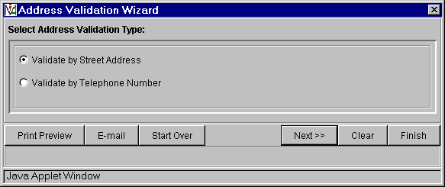

Action:
- Select “Validate by Street Address” or “Validate by Telephone Number”
- Click “Next>>” button

Note: Validation by Street Address will be used for this example.

Pre-Order Address Validation Input Screen
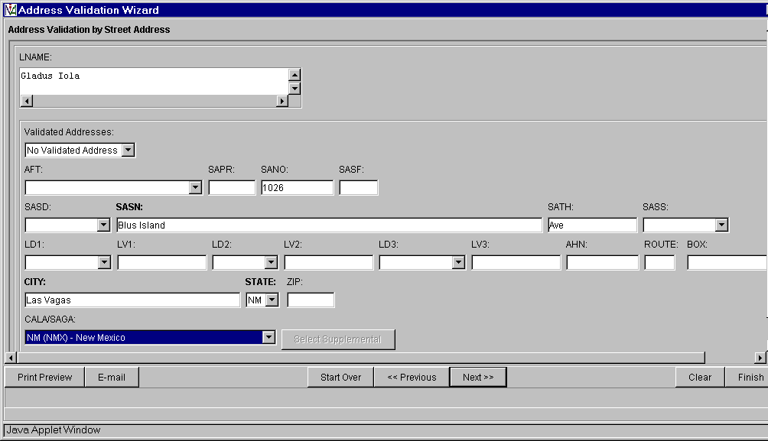

Pre-populated fields:
- Select AFT (Address Format Type) from drop down list if required
- Select SASD (Street Direction) from drop down list.
- Select LD1(Unit), LD2 (floor), LD3 (building) from drop down list (LD = Location Designator) if required

Manually populated fields:
- Customer Name in LNAME Field
- Appropriate Customer street address in SAPR, SANO, SASF, SASN, SATH, SASS, LV1, LV2, LV3 AHN, ROUTE, BOX, CITY, STATE, ZIP (LV is the Living Value associated with LD1, LD2, LD3)

Action:
- Click “Next>>” button.

Pre-Order Address Validation Response Screen
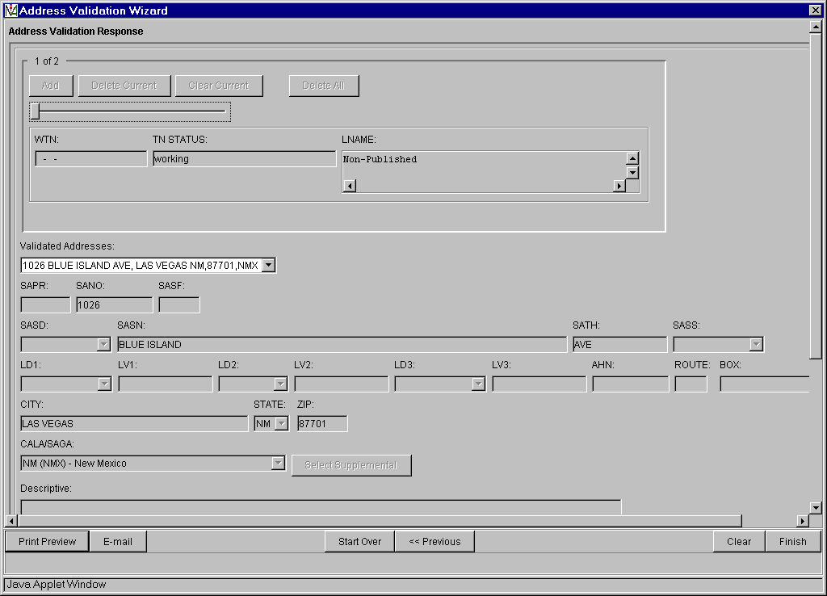

Action:
- For addresses with multiple TNs – view each TN status through the slide bar above the WTN field
- Click “Finish” button and return to IMA Pre-Order, Order, Post-Order Access Screen

The Pre-Order Address Validation query provides address field data for the following screens:

- Pre-Order Review Customer Service Record (CSR)

- Pre-Order TN Availability

- Pre-Order Check Facility Availability
- Design Services Facility Request
- High Capacity Facilities Request
- Convert POTS to Unbundled loop Request
- POTS Facility Request
- ISDN Facilities Request
- Unbundled ADSL Loop Qualification
- Qwest DSL Facilities Request

- Order - End User Form

- Order – Resale Private Line Form

- Order – Resale Form Form

IMA Pre-Order, Order, Post-Order Access Screen
Action:
- Click “PreOrder” link

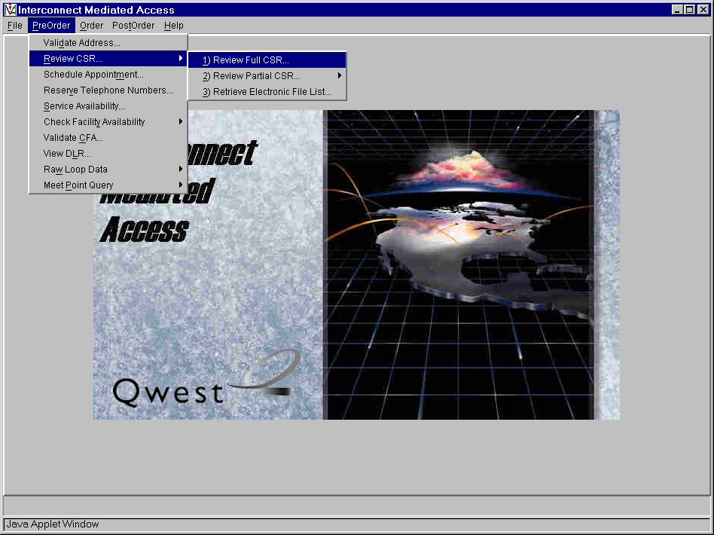
Action:
- Click “Review CSR” link
- Click “Review Full CSR” link
Pre-Order Review CSR Input Screen
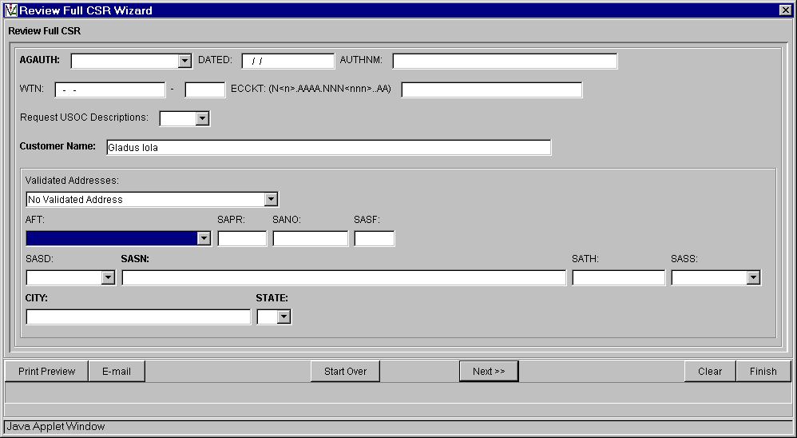

Auto-populated fields:
- Select AFT (Address Format Type) from drop down list if required
- Customer Name (from Pre-Order Address Validation Input Screen)

Pre-populated fields:
- Appropriate address fields are validated from the Pre-Order Address Validation Input Screen (SAPR, SANO, SASF, SASD, SASN, SATH, SASS, CITY, STATE)

Manually populated fields:
- AGAUTH, DATED, AUTHNM, WTN (OR ECCKT)

Action:
- Click “Next>>” button

Pre-Order Review CSR Response Screen
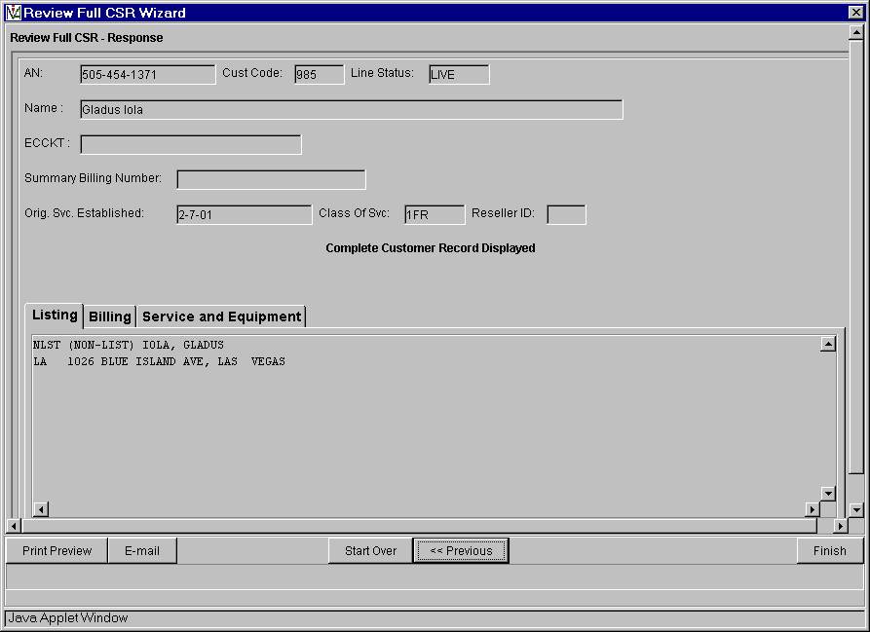

Action:
- Click “Finish” button and return to IMA Pre-Order, Order, Post-Order Access Screen

The Pre-Order Review CSR query provides the following field data to the Order - End User Form:
- Authorization data
- WTN or ECCKT data

IMA Pre-Order, Order, Post-Order Access Screen

Action:
- Click “PreOrder” link

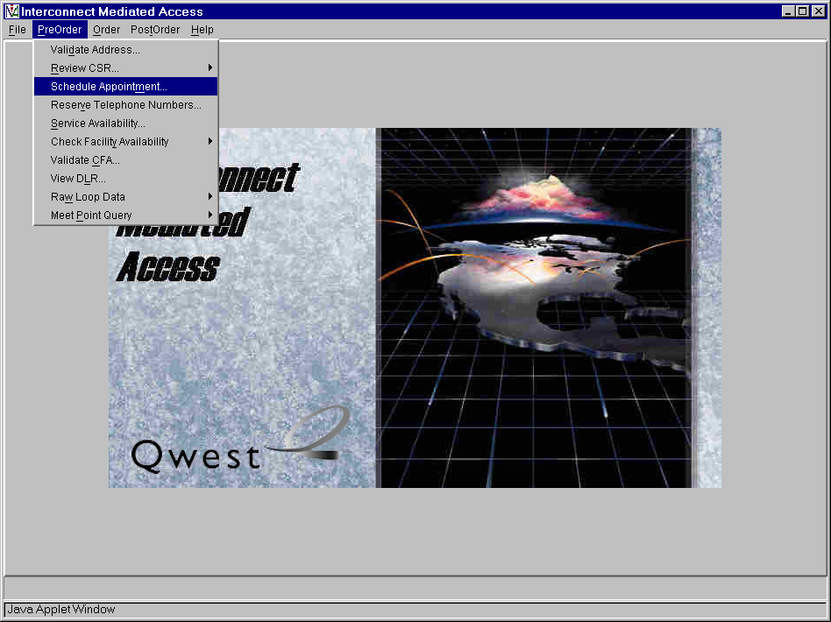
Action:
- Click “Schedule Appointment..” link

Pre-Order Appointment Scheduling Screen
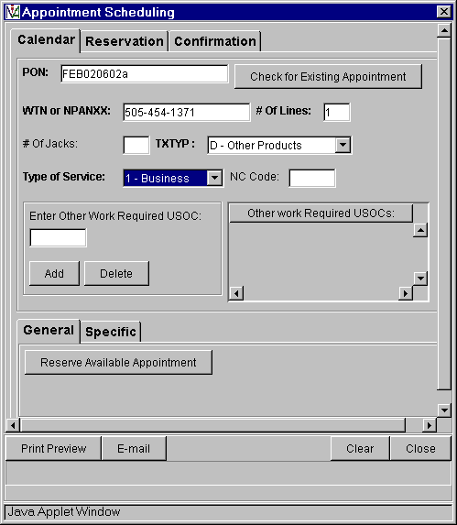

Pre-populated fields:
- Select Type of Service from drop down list.

Manually fields:
- PON
- WTN or NPANXX
- # OF LINES

Action:
- Click “Reserve Available Appointment” button
Pre-Order Appointment Scheduling Response Screen
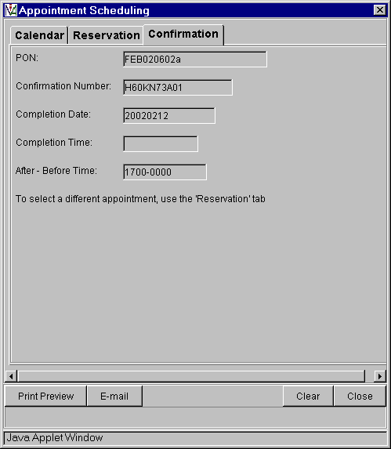

Action:
- Click “Close” button and return to IMA Pre-Order, Order, Post-Order Access Screen

The Pre-Order Appointment Scheduling query provides:
- PON data to the Pre-Order Reserve Telephone Number and Order Information screen
- DDD, APPTIME, and APTCON data to the Order - Local Service Request (LSR) Form.

IMA Pre-Order, Order, Post-Order Access Screen

Action:
- Click “PreOrder” link

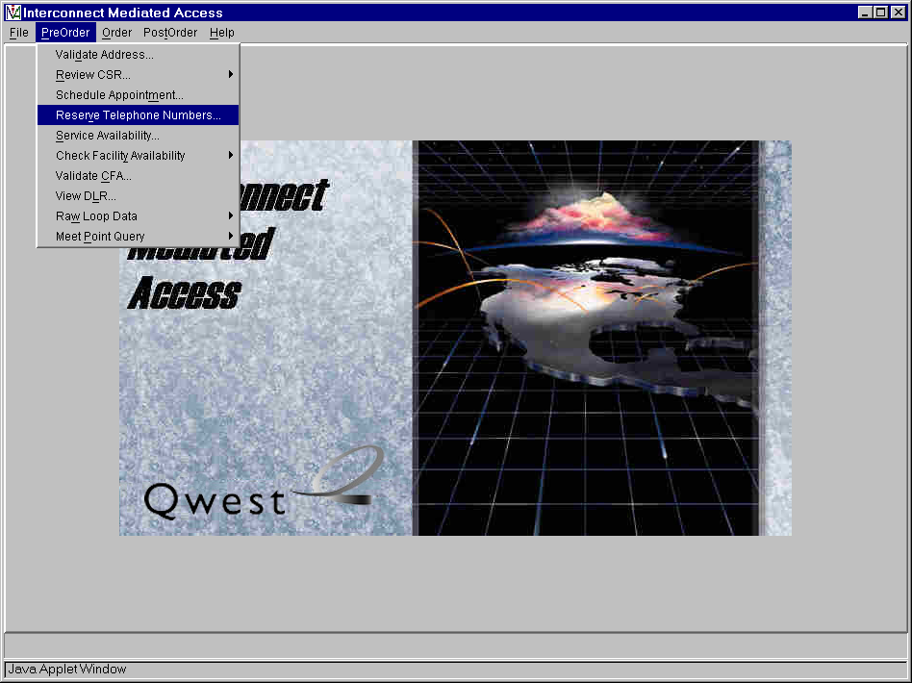

Action:
- Click “Reserve Telephone Numbers..” link

Pre-Order TN Availability Input Screen
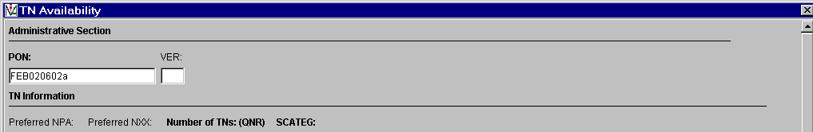
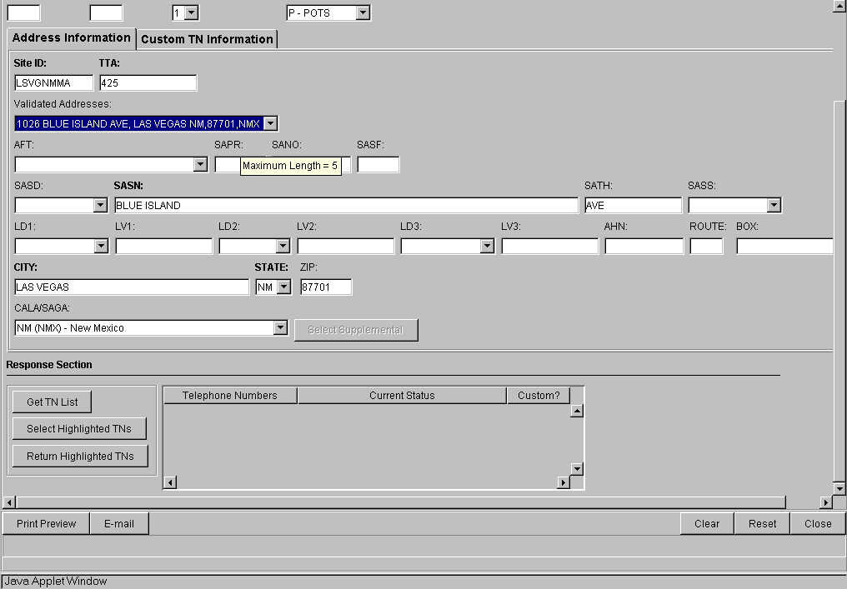

Auto-Populated fields:
- PON (from Pre-Order Schedule Appointment Scheduling Screen)
- NUMBER OF LINES set to 1 (change quantity from drop down list)

Pre-populated fields: (from Pre-Order Address Validation Input Screen, if address is validated)
- Select AFT (Address Format Type) from drop down list if required
- Appropriate address fields from Validated Address drop down list (Note new LD & LV fields)
- SITE ID when address is selected from Validated Address drop down list
- TTA when address is selected from Validated Address drop down list
- SCATEG from drop down list

Manual populated fields:
- Preferred NPA -optional
- Preferred NXX - optional

Action:
- Click “Get TN List” button

Pre-Order TN Availability Selection Screen
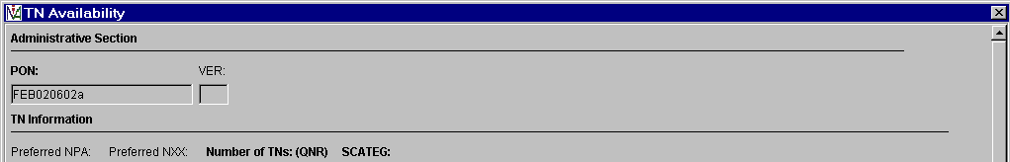
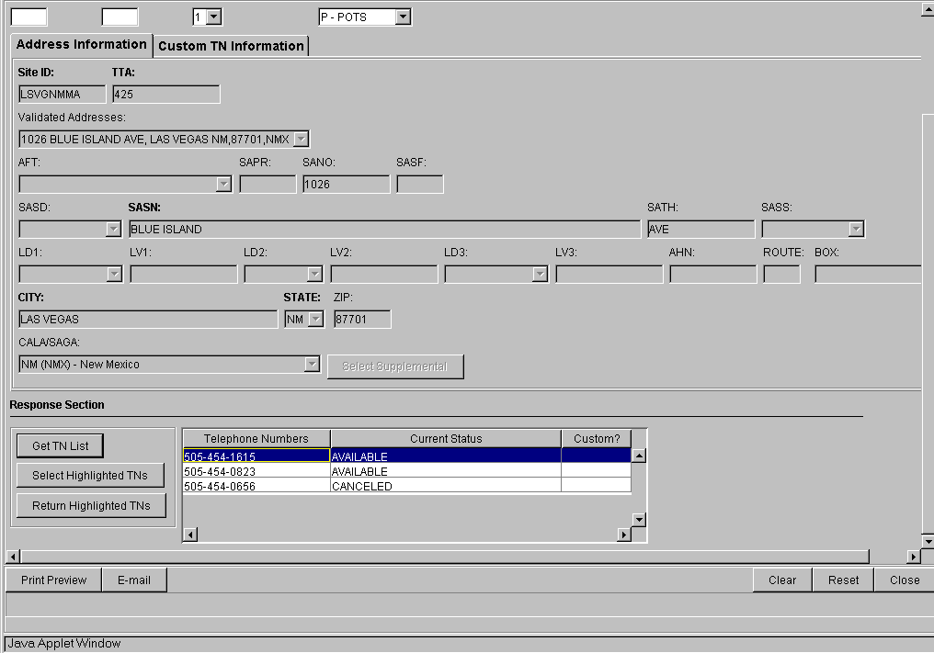

Action:
- Highlight Telephone number available
- Click “Select Highlighted TNs” button
TN Availability Selection screen
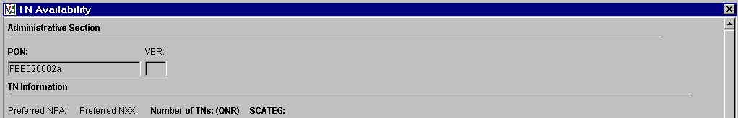
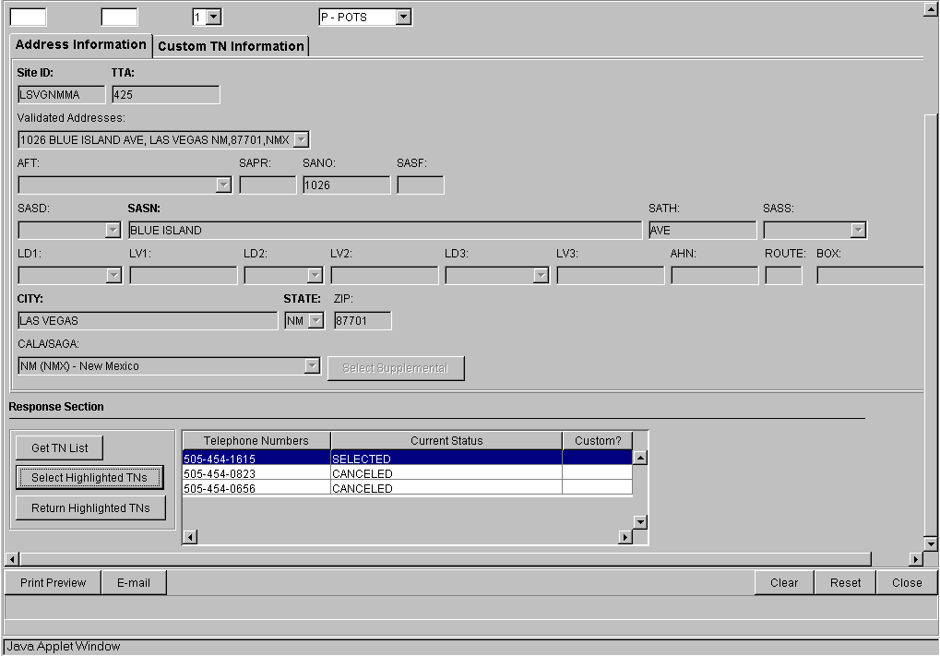

Action:
- Click “Close” button and return to IMA Pre-Order, Order, Post-Order Access Screen

The Pre-Order TN Availability provides TNList for the :
- Order – Resale Form (POTS)
- Order – Port Service Form

IMA Pre-Order, Order, Post-Order Access Screen

Action:
- Click “PreOrder” link

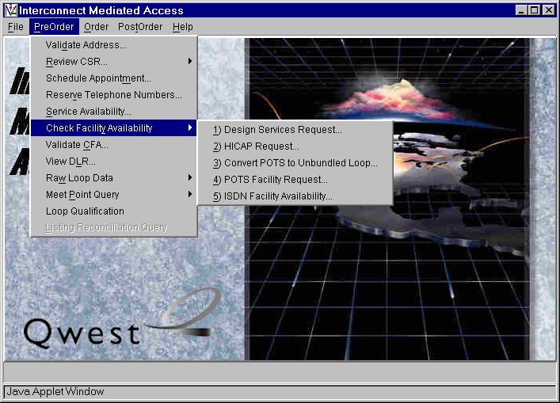

Action:
- Click “Check Facility Availability” link
- Click “Design Services Facility Request..” link

Note: Unbundled ADSL Loop Qualification and Qwest DSL Loop Qualification have been removed from the “Check Facility Availability” link and are now executed through the “Loop Qualification” link.
Pre-Order Design Services Facility Request Input Screen:
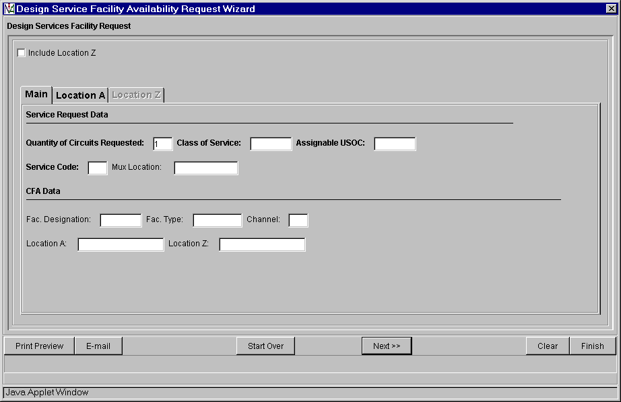

Pre-populated fields:
- Quantity of Circuits Requested defaults to a value of ‘1’ but can be manually changed.

Action:
- Click “Location A” Tab

Location A Tab
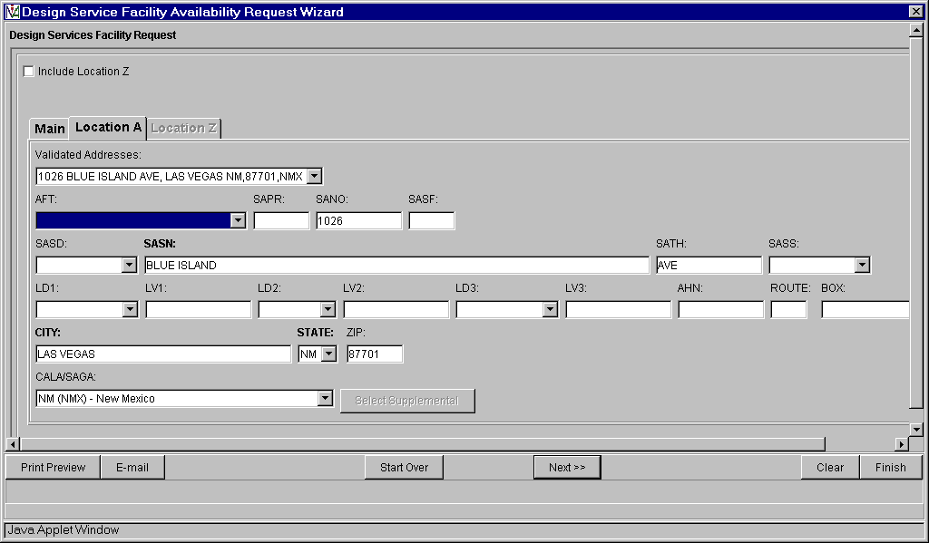

Pre-populated fields:
- Appropriate address fields from Pre-Order Address Validation Input Screen, if address is validated (Note new LD & LV fields)

Action:
- Select “Next>>” button, proceed with Facility Available Query and return to IMA Pre-Order, Order, Post-Order Access Screen

IMA Pre-Order, Order, Post-Order Access Screen

Action:
- Click “PreOrder” link

Action:
- Click “Check Facility Availability” link
- Click “HICAP Request..” link
Pre-Order High Capacity Facility Availability Request Wizard Request Screen
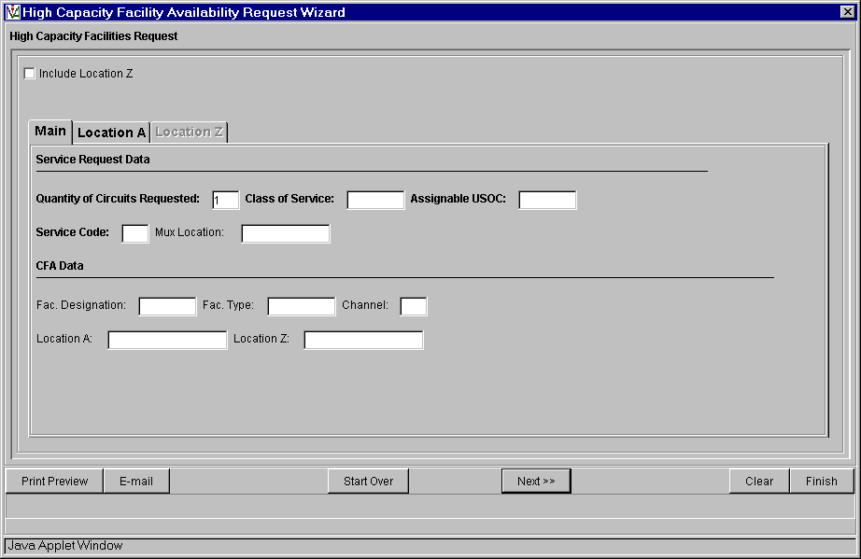

Pre-populated fields:
- Quantity of Circuits Requested defaults to a value of ‘1’ but can be manually changed
Action:
- Select “Location A” tab

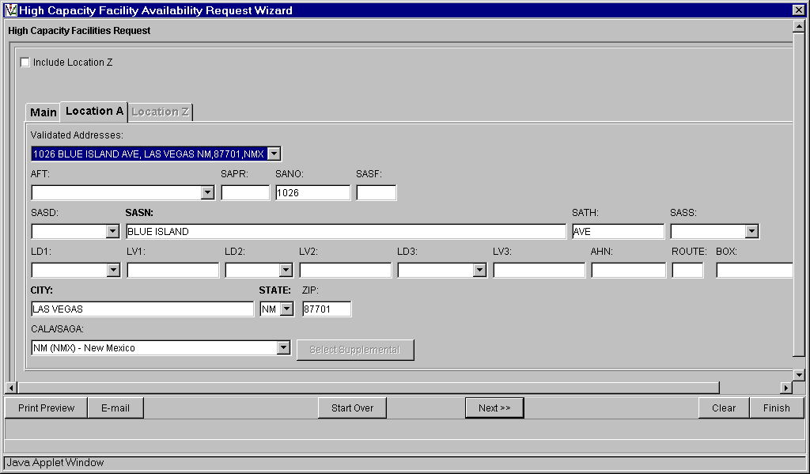

Pre-populated fields:
- Appropriate address fields from Pre-Order Address Validation Input Screen, if address is validated (Note new LD & LV fields)

Action:
- Select “Next>>” button, proceed with Facility Available Query and return to IMA Pre-Order, Order, Post-Order Access Screen
IMA Pre-Order, Order, Post-Order Access Screen

Action:
Click “PreOrder” link

Action:
- Click “Check Facility Availability” link
- Click “Convert POTS to Unbundled Loop Request..” link

Pre-order Unbundled loop Qualification Facility Availability Request Screen
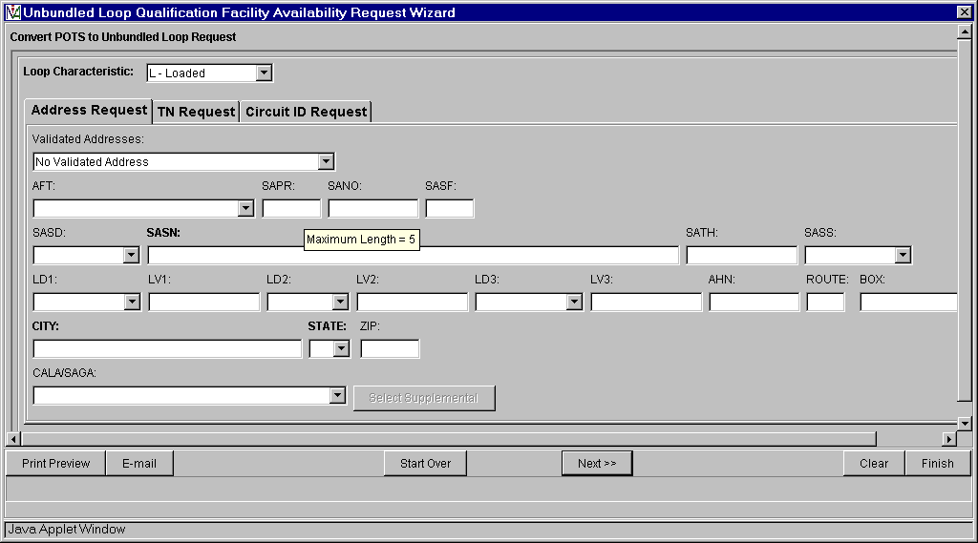

Pre-populated fields:
- Loop Characteristic field defaults to ‘L-Loaded’ but can access drop down list and change to ‘N-Non-Loaded’ or ‘D-Does Not Matter’
- Appropriate address fields from Pre-Order Address Validation Input Screen, if address is validated (Note new LD & LV fields)

Action:
- Select “Next>>” button, proceed with Facility Available Query and return to IMA Pre-Order, Order, Post-Order Access Screen.

IMA Pre-Order, Order, Post-Order Access Screen

Action:
- Click “PreOrder” link

Action:
- Click “Check Facility Availability” link
- Click “POTS Facility Request..” link
Pre-Order POTS Facility Availability Request Screen
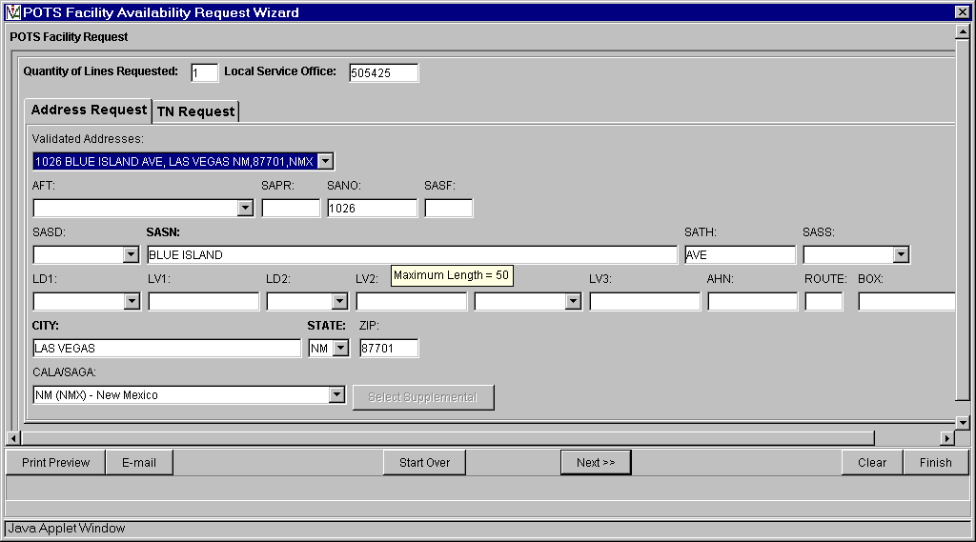

Pre-populated fields:
- Quantity of Lines Requested defaults to a value of ‘1’ but can be manually change
- Local Service Office from Pre-Order Address Validation Input Screen, if address is validated
- Appropriate address fields from Pre-Order Address Validation Input Screen, if address is validated (Note new LD & LV fields)

Action:
- Select “Next>>” key, proceed with Facility Available Query and return to IMA Pre-Order, Order, Post-Order Access Screen.

IMA Pre-Order, Order, Post-Order Access Screen

Action:
- Click “PreOrder” link

Action:
- Click “Check Facility Availability” link
- Click “ISDN Loop Qualification..” link
Pre-Order ISDN Loop Qualification Facility Availability Request Screen
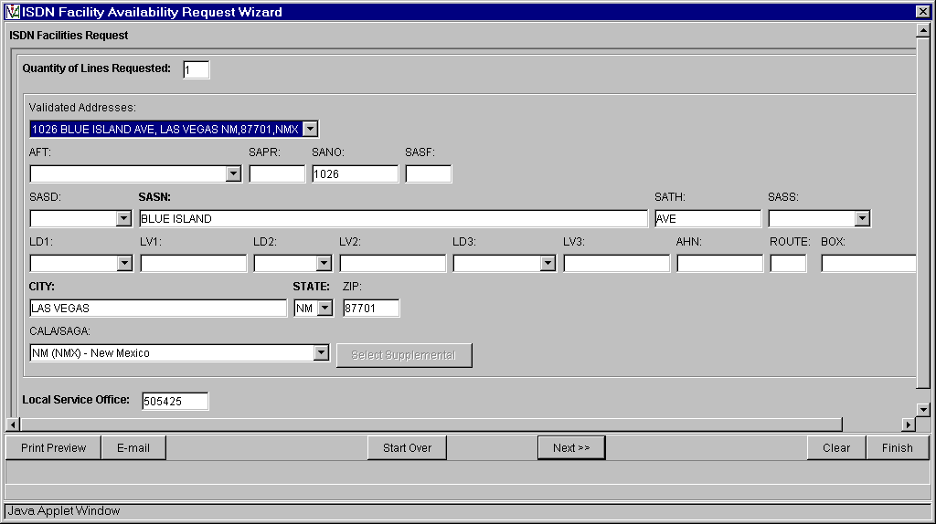

Pre-populated fields:
- Quantity of Lines Requested defaults to a value of ‘1’ but can be manually change
- Appropriate address fields from Pre-Order Address Validation Input Screen, if address is validated (Note new LD & LV fields)

Action:
- Select “Next>>” button, proceed with Facility Available Query and return to IMA Pre-Order, Order, Post-Order Access Screen.

IMA Pre-Order, Order, Post-Order Access Screen

Action:
- Click “PreOrder” link

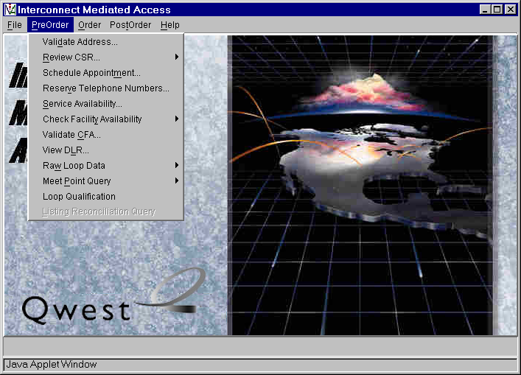

Action:
- Click “Loop Qualification” link

Loop Qualification Request Screen
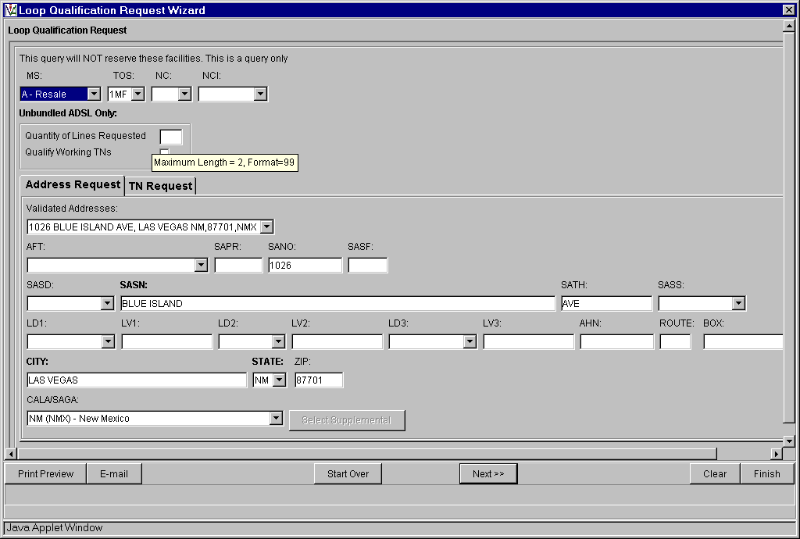

Note this is for all Loop Qualifications – Unbundled ADSL Loop Qualification and Qwest DSL Loop Qualification used to be executed through “Check Facility Availability’ link.

Auto-populated fields:
- MS (Market Segment) field defaults to ‘A-Resale’ but can change to ‘B-Unbundled’ from the drop down list

Pre-populated fields:
- Appropriate address fields from Pre-Order Address Validation Input Screen, if address is validated (Note new LD & LV fields)

Manual populated fields (if applicable):
- NC (Network Channel)
- NCI (Network Channel Interface)
- For ADSL only – Quantity of Lines
- For ADSL only – Qualify Working TNs
- Select AFT (Address Format Type) from drop down list if required

Action:
Select “Next>>” button
Loop Qualification Response Screen
(With Default Loop Qualification TAB)

Response will vary based upon parameters imputed in the request screen.
This is a response for a Resale Loop Qualification.
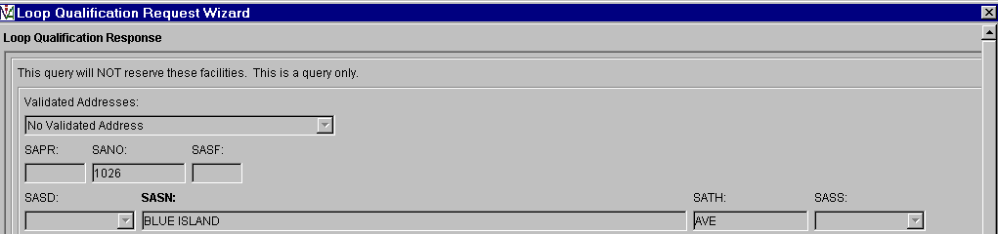
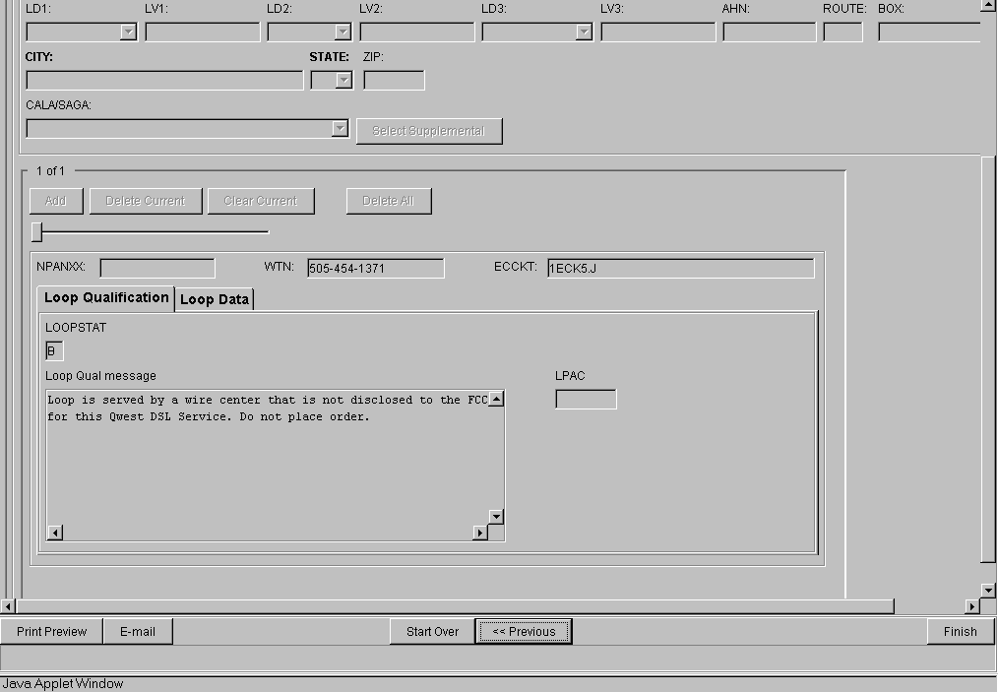

Action:
- Click “Loop Data” button to return loop related data
- Click “Finish” button and return to IMA Pre-Order, Order, Post-Order Access Screen

Loop Qualification Response Screen
(With Loop Data TAB)
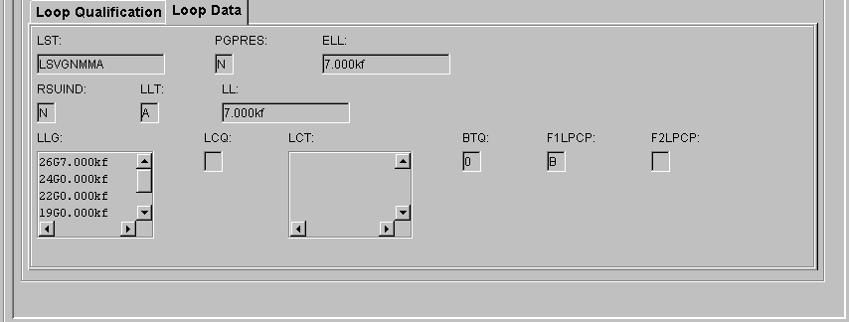

Note: This is the last of the Pre-Order screens.

IMA Pre-Order, Order, Post-Order Access Screen

Action:
Click “Order” link

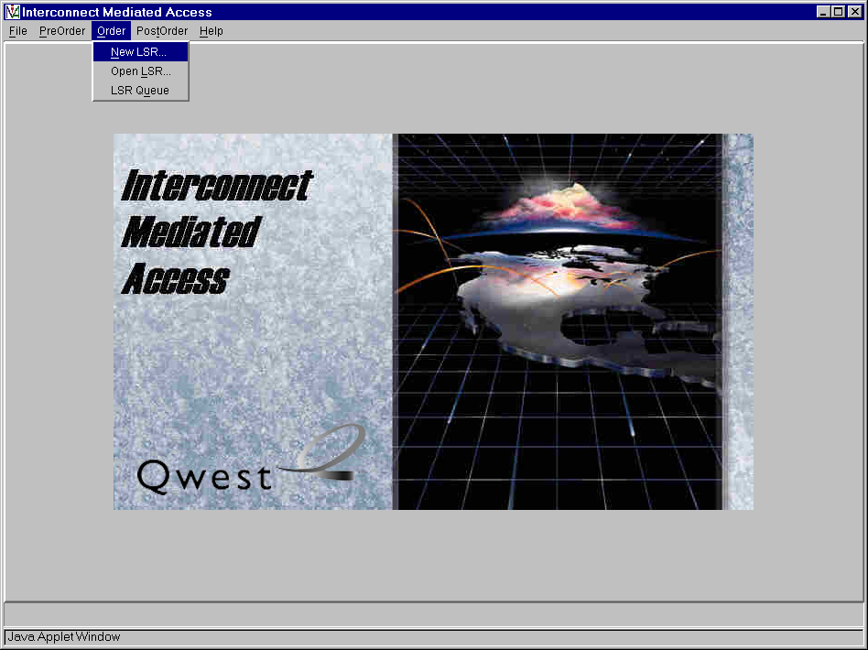

Action:
- Click “New Order” link
Order Information for New LSR Option
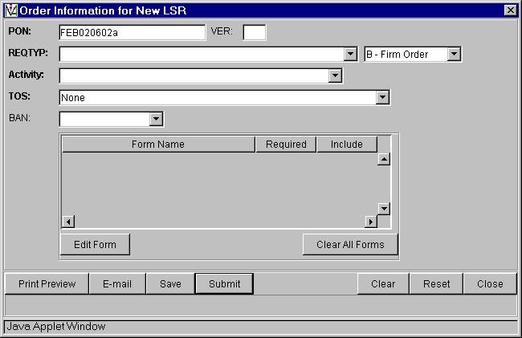

Auto-populated fields:
- PON ( from Pre-Order Schedule Appointment Scheduling Scren or Pre-Order TN Availability Selection Screen)

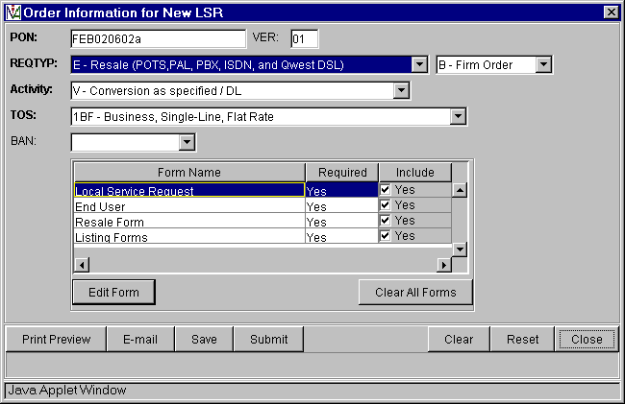
Local Service Request & End User Forms are not product specific and are not repeated in this document for each product presented.

Pre-populated fields:
- Select REQTYP from drop down list
- Select Activity from drop down list
- Select TOS from drop down list

Manually populated fields:
- Enter VER if appropriate

Action:
- From the “Form Name” list highlight Form to edit and press “Edit Form” button
Local Service Request Form - Admin
(Generic Copy)
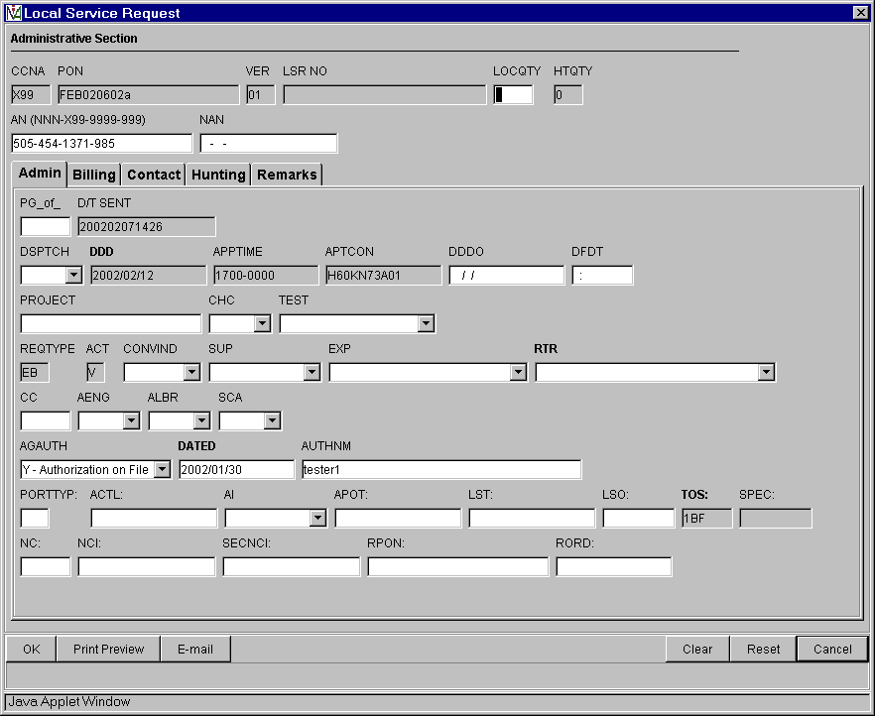

Auto-populated fields:
- CCNA
- PON
- VER
- AN
- DDD
- APPTIME
- APTCON
- AGAUTH
- DATED
- AUTHEM

Note:
- PON / VER – auto-populated from Order Information for New LSR Option Screen
- AN / AGAUTH / DATED / AUTHNM - auto-populated from Pre-order Review CSR Input Screen
- DDD / APPTIME / APTCON - auto-populated from Pre-order Schedule Appointment Scheduling Response Screen

Local Service Request Form - Billing
(Generic Copy)
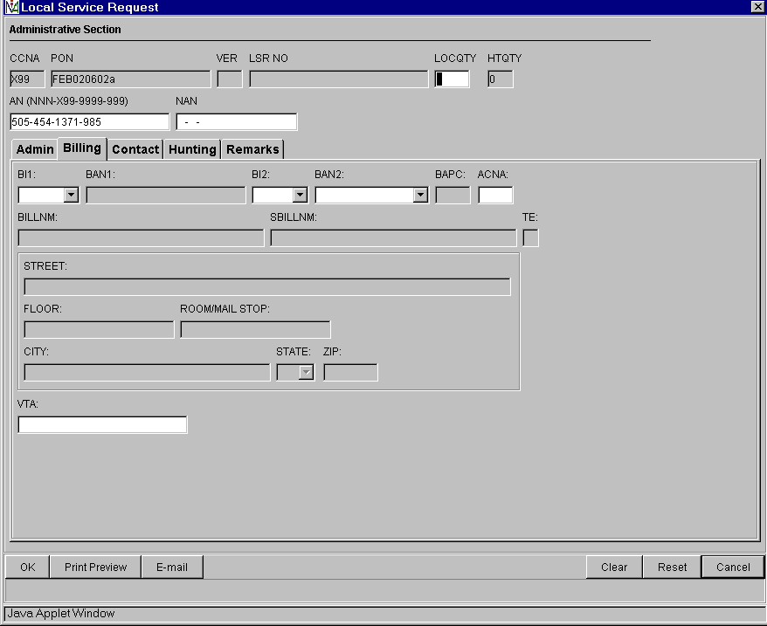
Local Service Request Form - Contact
(Generic Copy)
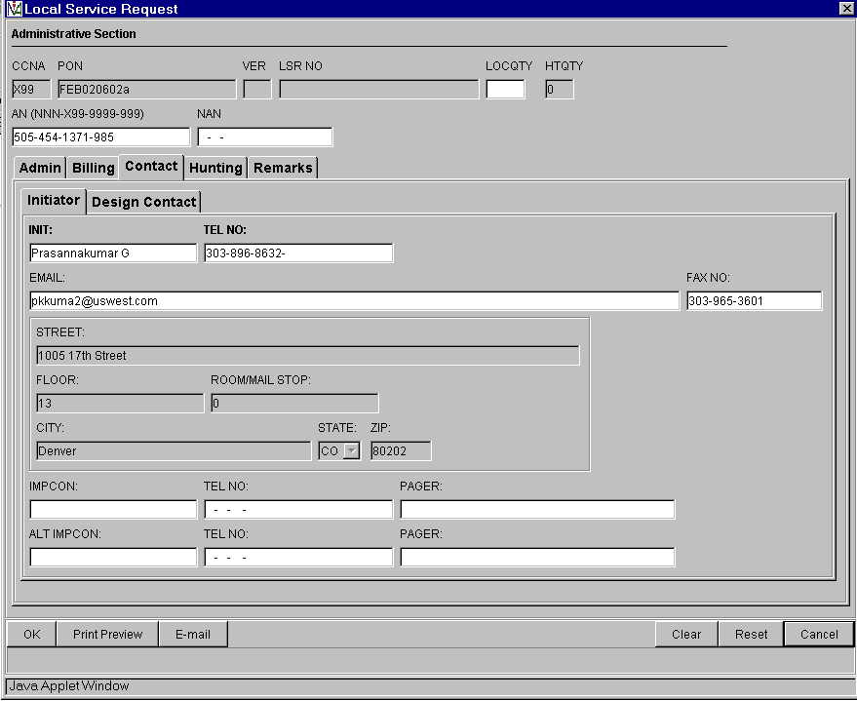
Local Service Request Form - Hunting
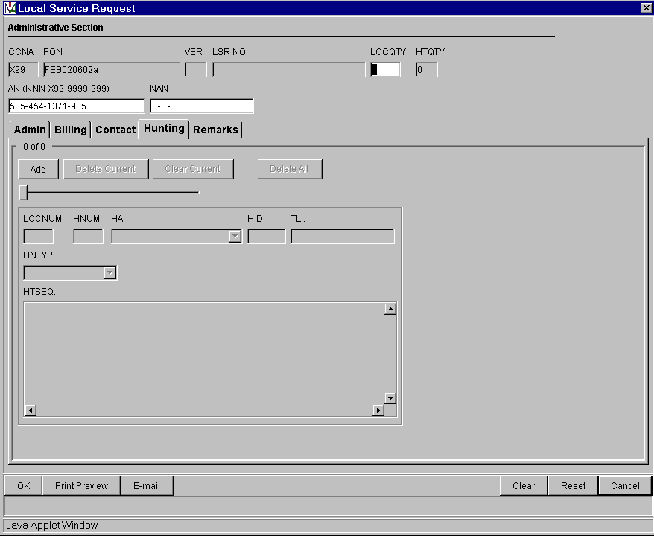
Local Service Request Form - Remarks
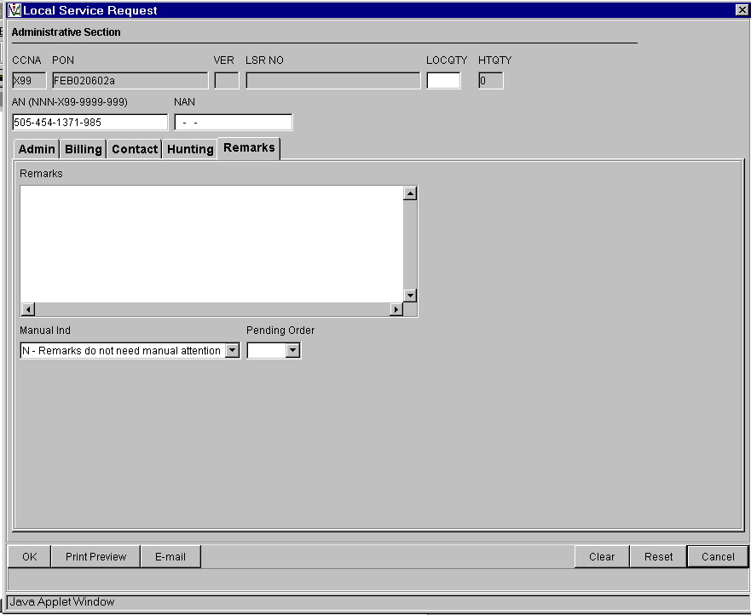
End User Form – Loc Access/Inside Wire
(Generic Copy)
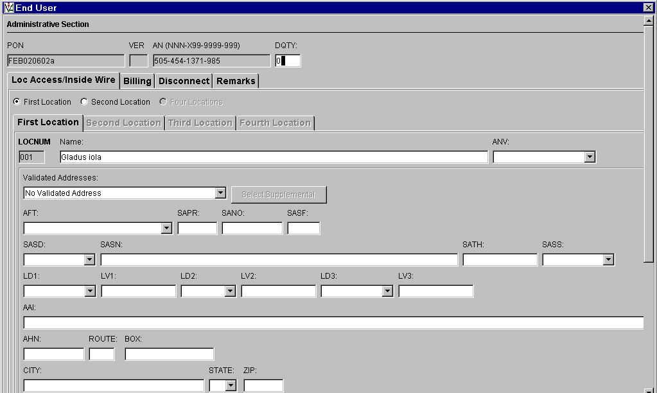
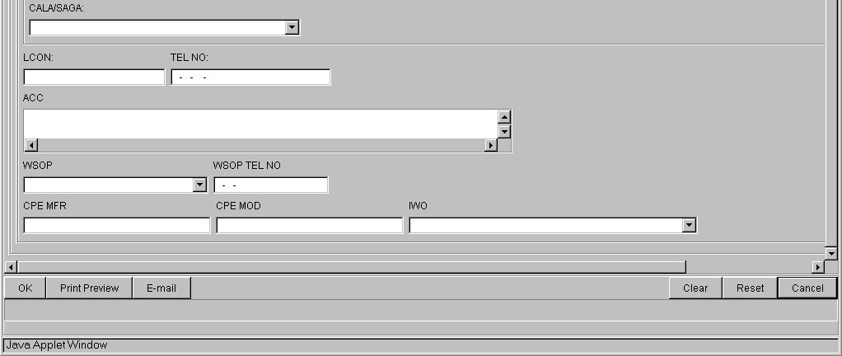
Auto-populated fields:
- PON
- VER
- AN
- Name
Pre-populated fields:
- Appropriate address fields from Pre-Order Address Validation Input Screen, if address is validated
Note:
- PON / VER – auto-populated from Order Information for New LSR Option Screen
- AN / Name - auto-populated from Pre-order Review CSR Input Screen

End User Form – Billing
(Generic Copy)
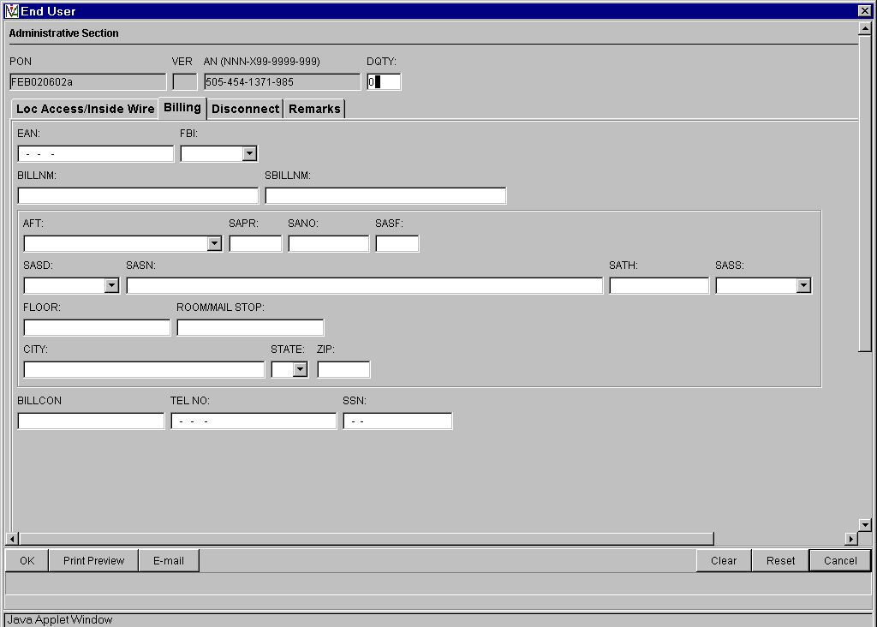
No additional data on this screen
End User Form – Disconnect
(Generic Copy)
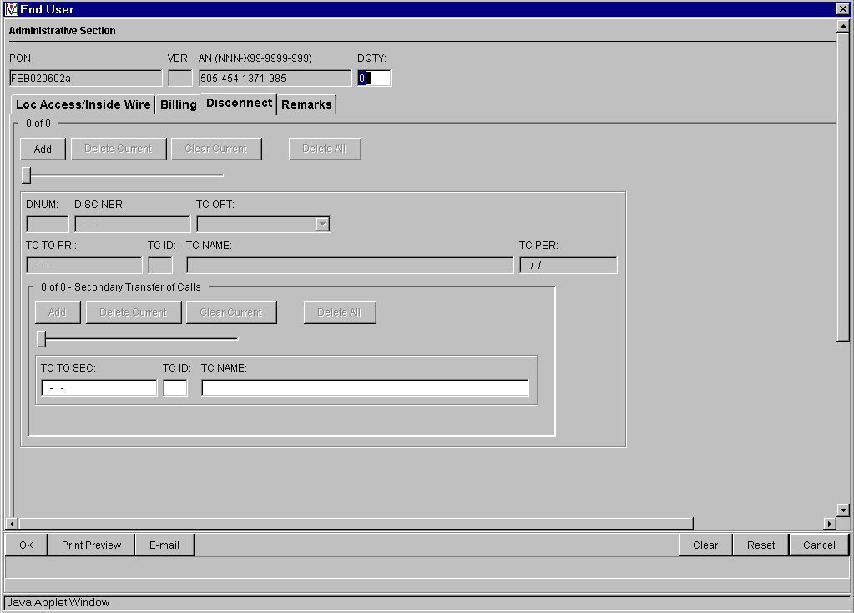
No additional data on this screen
End User Form – Remarks
(Generic Copy)
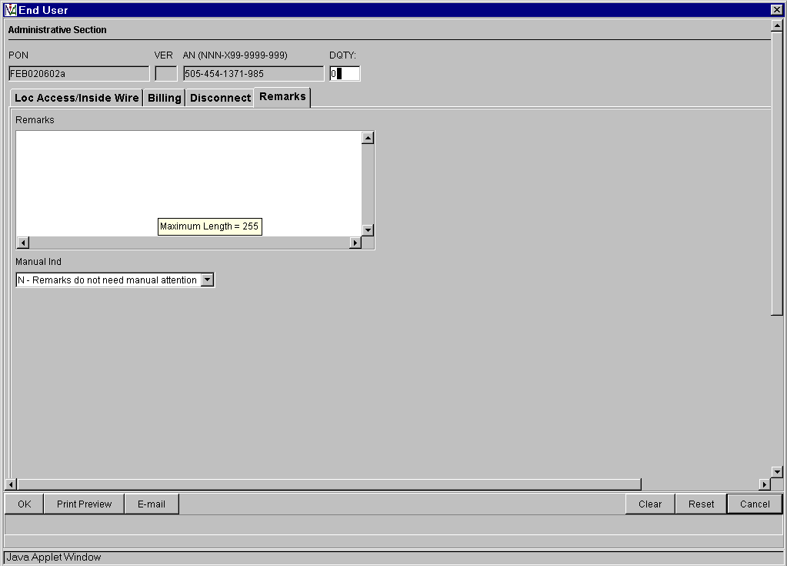
No additional data on this screen

POTS Resale Form – Service
(Product Specific)
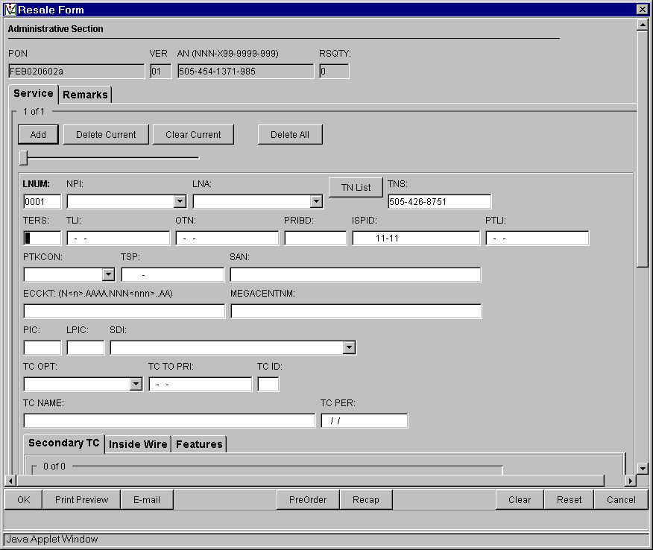

Auto-populated fields:
- PON
- VER
- AN

Pre-populated fields:
- Click “TN List” and select telephone number to populate in TNS field from Pre-Order TN Availability Selection Screen

Action:
- Click “Add” button
- Click TAB buttons to go to appropriate sections (i.e. “Secondary TC” TAB)

Note:
- PON / VER – auto-populated from Order Information for New LSR Option Screen
- AN - auto-populated from Pre-order Review CSR Input Screen
- TNS – pre-populated from Pre-Order Reserve Telephone Number Screen
POTS Resale Form - Service: Three Additional TABS:
Secondary TC
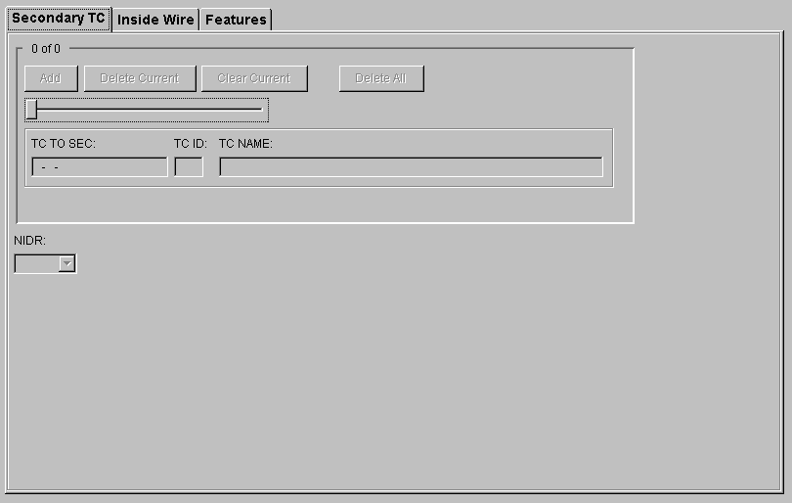
Inside Wire
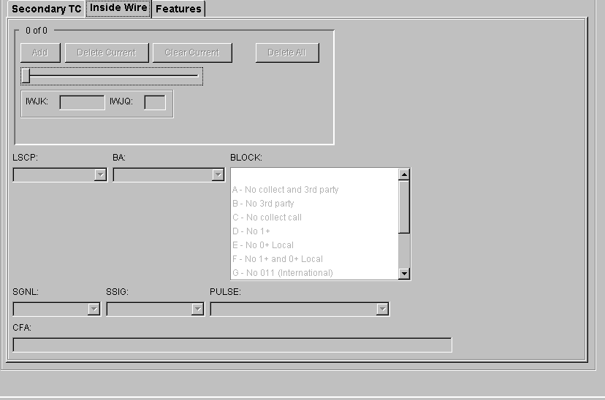
Features

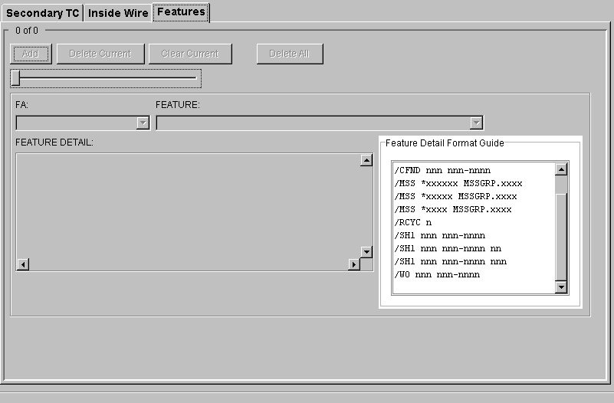

POTS Resale Form – Remarks
(Product Specific)
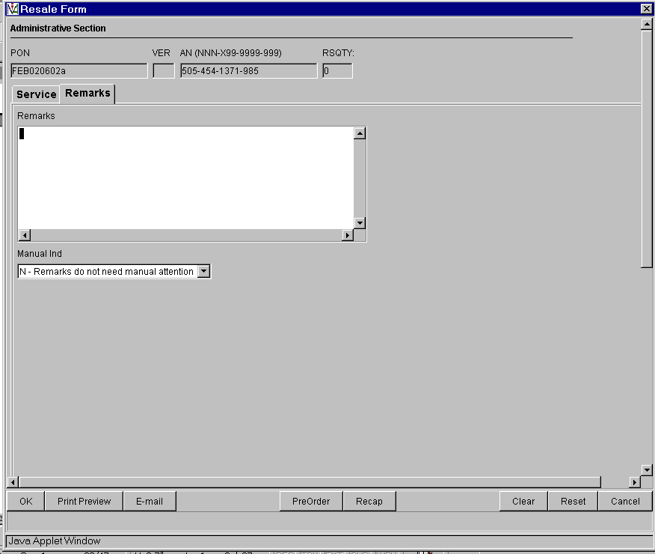

No additional data on this screen

Resale Private Line Form – Primary Loc
(Product Specific)
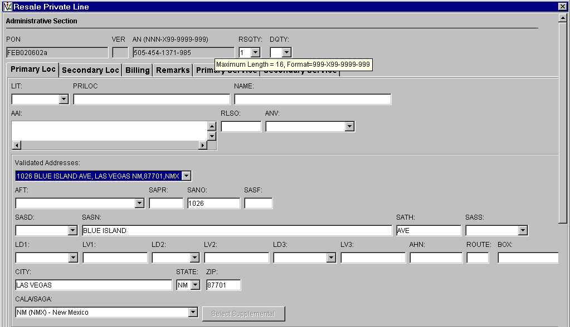
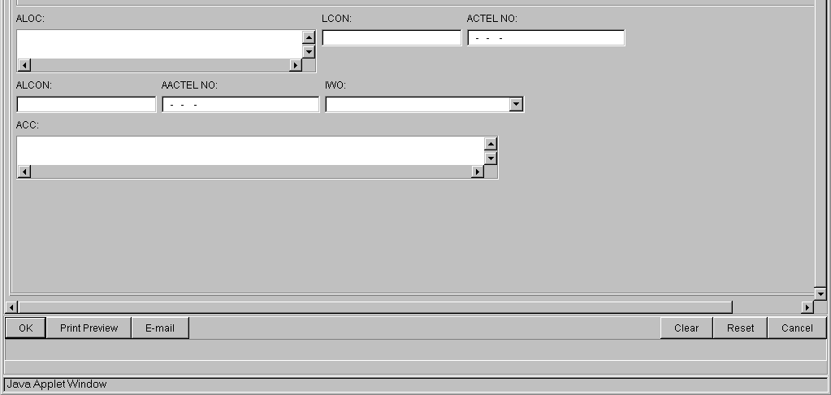
Auto-populated fields;
- PON
- VER
- AN
Pre-populated fields:
- Appropriate address fields
- For Primary Loc and Secondary Loc
Note:
- PON / VER – auto-populated from Order Information for New LSR Option Screen
- AN - auto-populated from Pre-Order Review CSR Input Screen
- Address related fields – Pre-Order Address Validation Input Screen, if address is validated

Resale Private Line Form – Secondary Loc
(Product Specific)

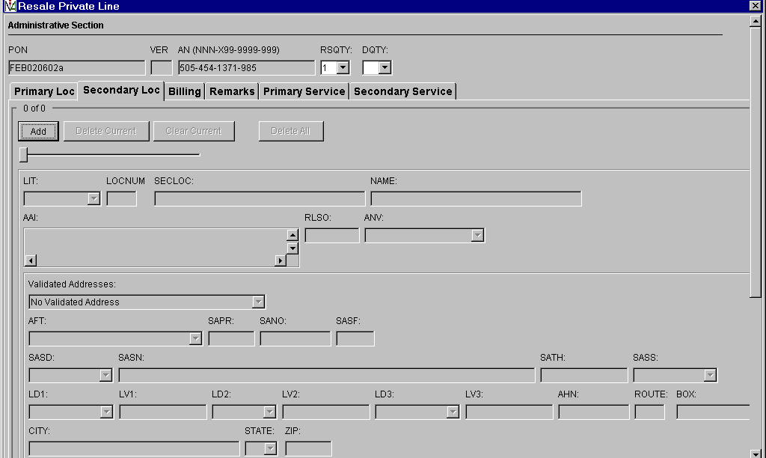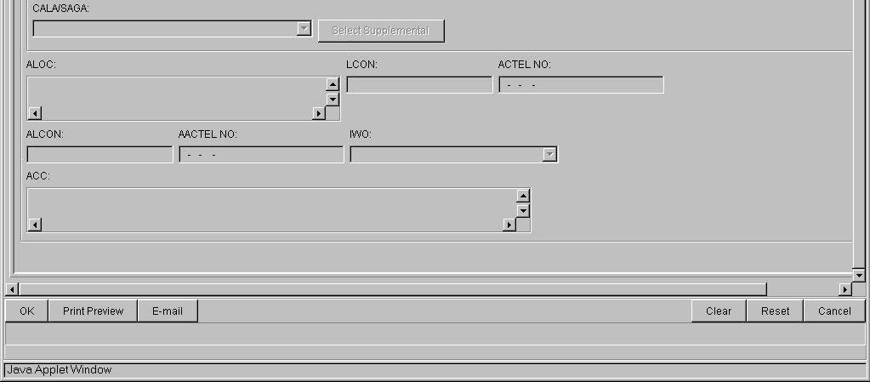

Resale Private Line Form – Billing
(Product Specific)
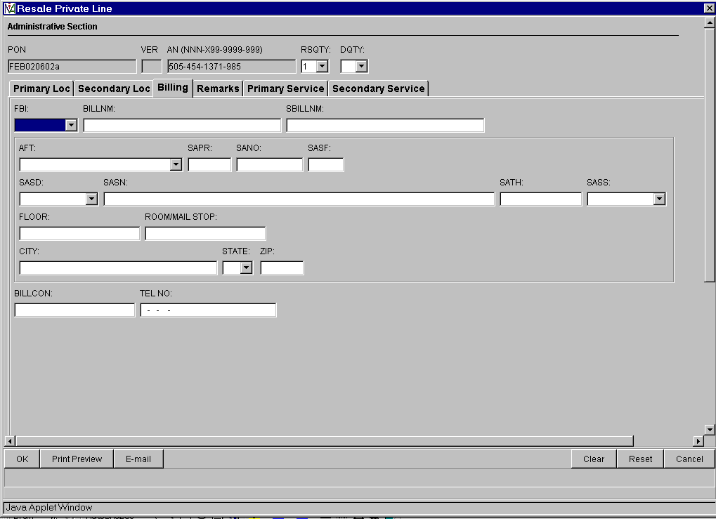
No additional data on this screen
Resale Private Line Form – Remarks
(Product Specific)
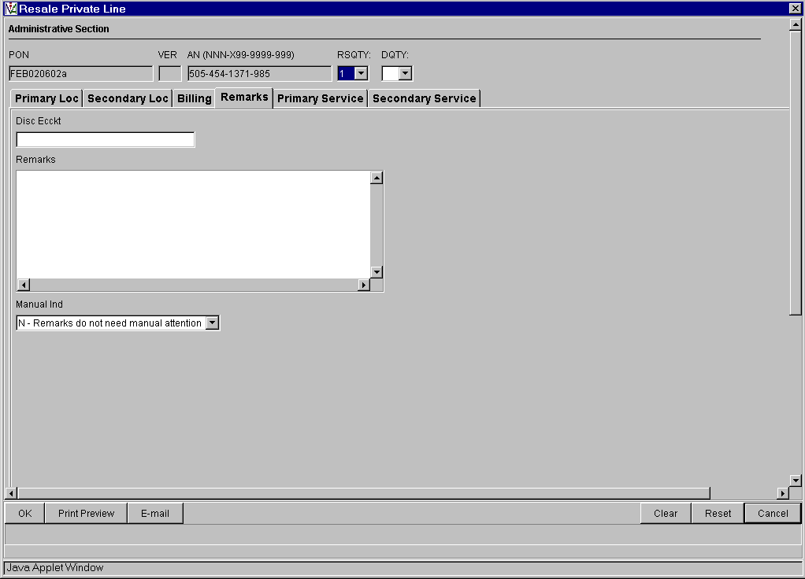

No additional data on this screen

Resale Private Line Form – Primary Service
(Product Specific)
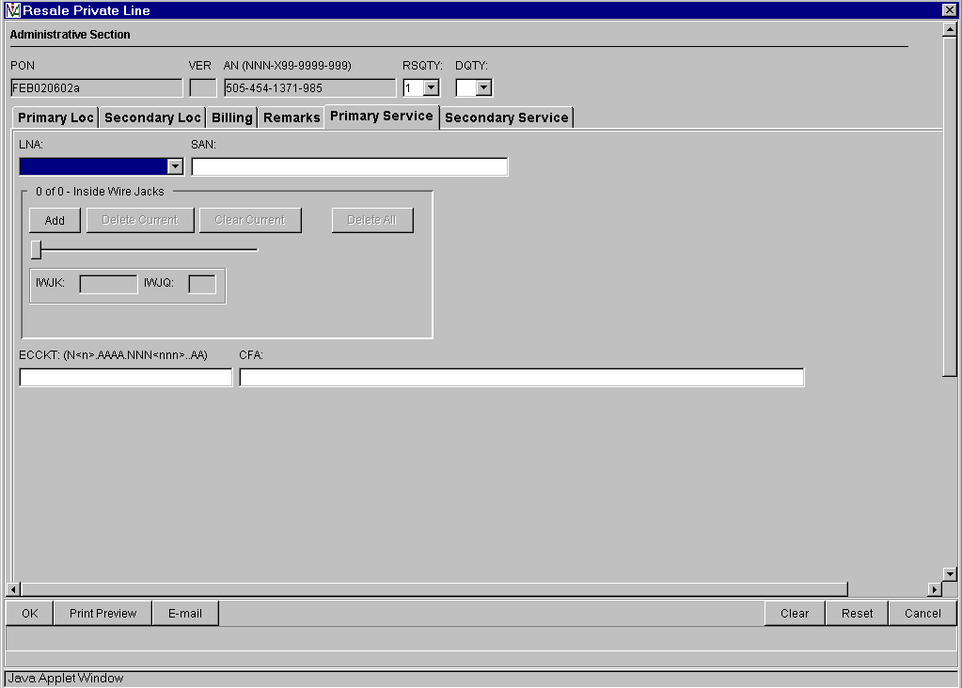
No additional data on this screen

Resale Private Line Form – Secondary Service
(Product Specific)
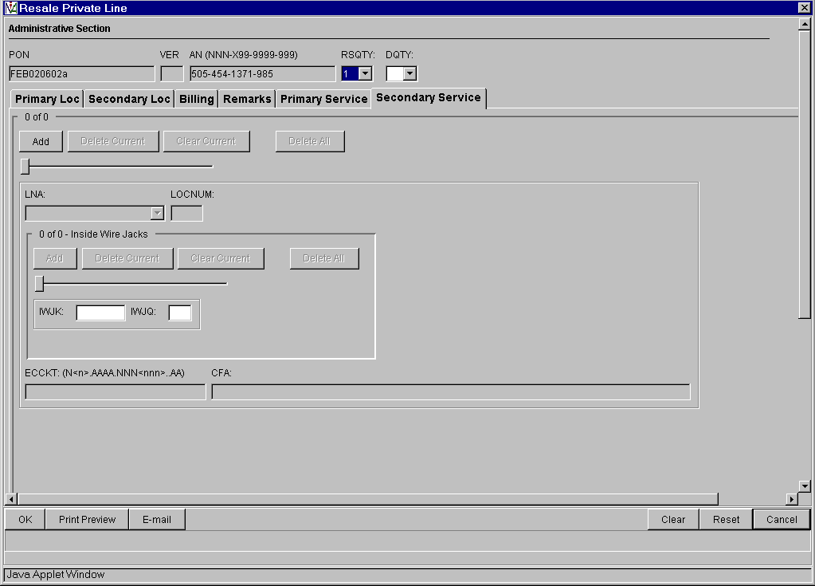
No additional data on this screen
Loop Service Form – Service
(Product Specific)
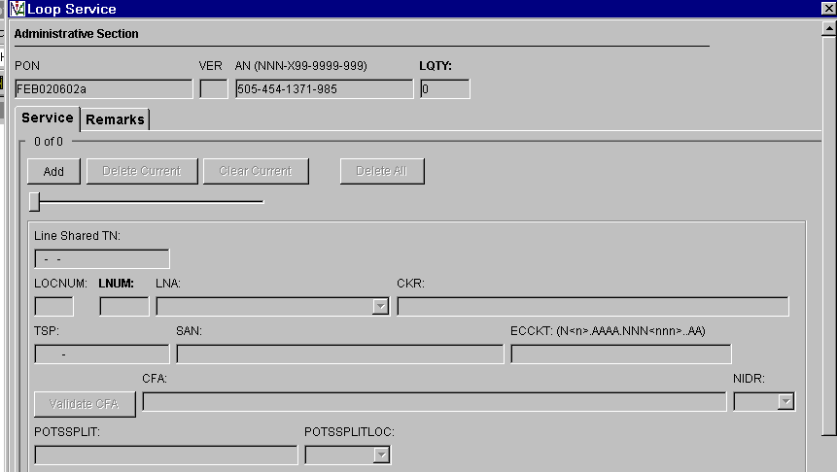
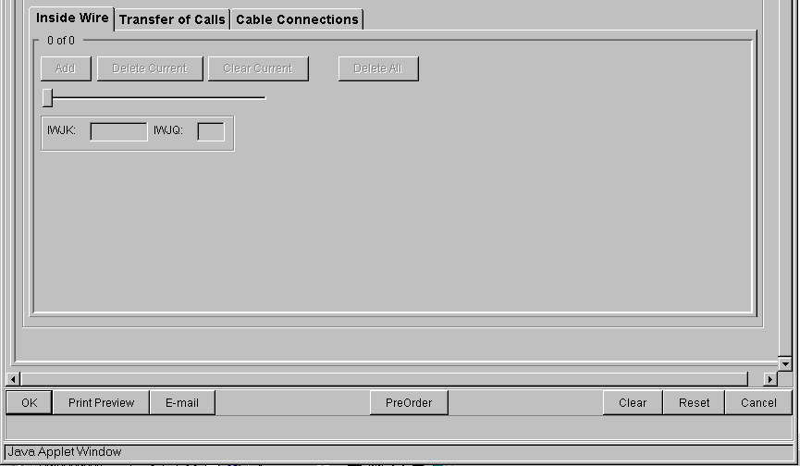

Auto-populated fields:
Inside Wire TAB
- PON
- VER
- AN

Action:
Click “Add’ button

Pre-populated fields:
- Click “Validate CFA” button or “PreOrder” button and execute Pre-Order CF Validation to pre-populate CFA field
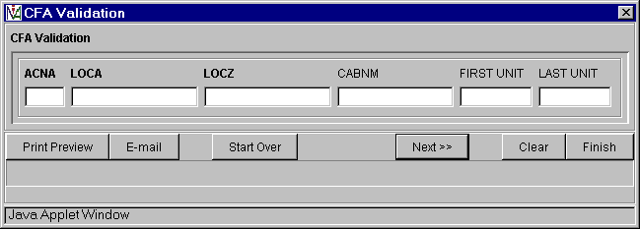

Note:
- PON / VER – auto-populated from Order Information for New LSR Option Screen
- AN - auto-populated from Pre-Order Review CSR Input Screen

Loop Service Form – Service: Two Additional TABS:
Transfer of Calls

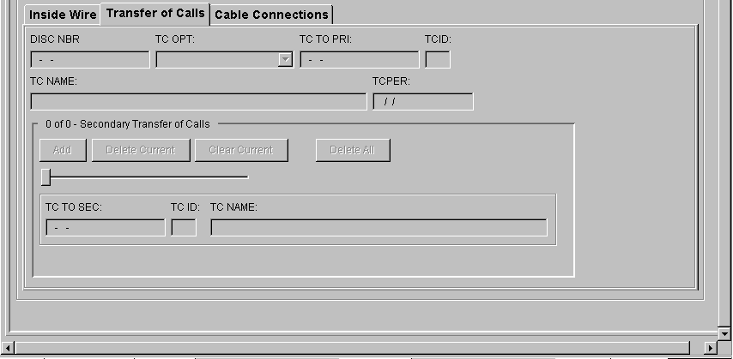

Cable Connection

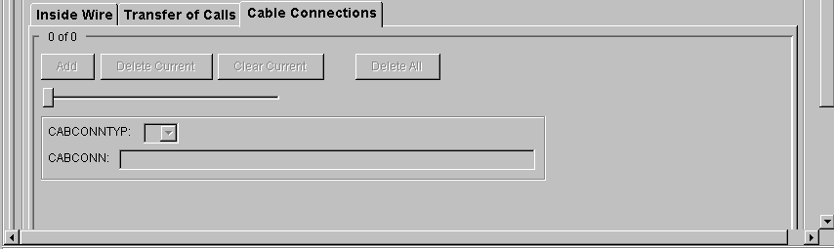

Loop Service Form – Remarks
(Product Specific)
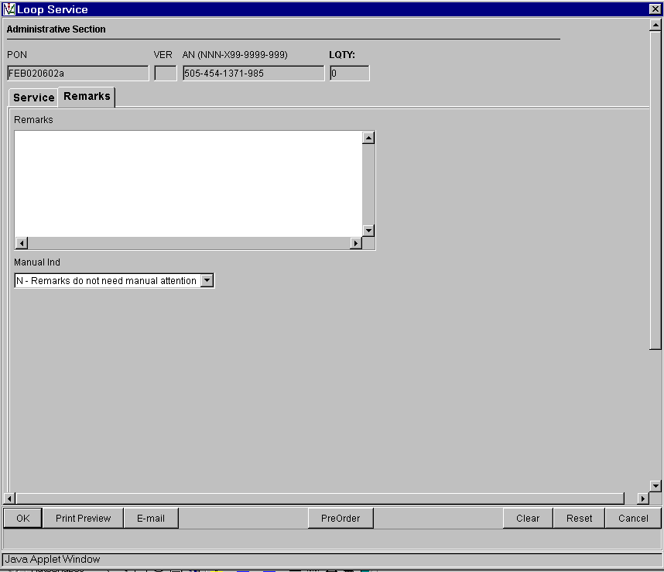
No additional data on this screen
Centrex Resale Form – Station Details
(Product Specific)
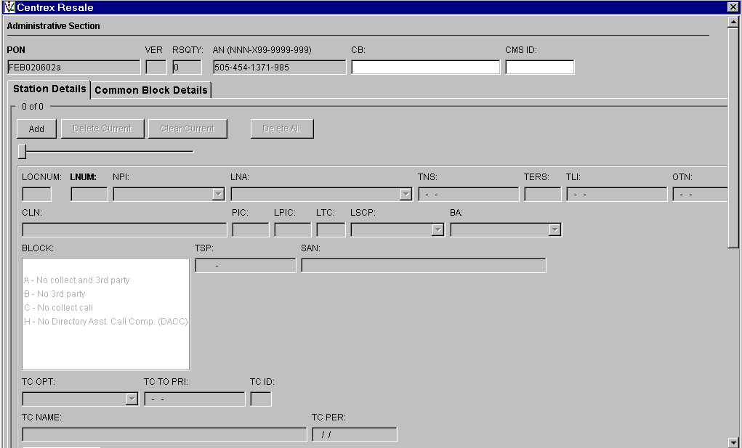
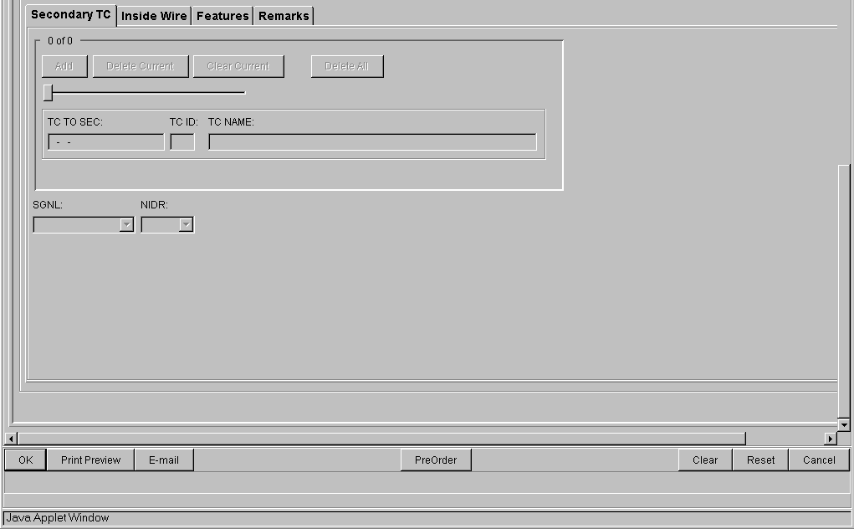
Secondary TC TAB

Auto-populated fields:
- PON
- VER
- AN

Note:
- PON / VER – auto-populated from Order Information
- AN - auto-populated from Pre-order Review CSR

Centrex Resale Form – Station Details: Three Additional TABS
Inside Wire
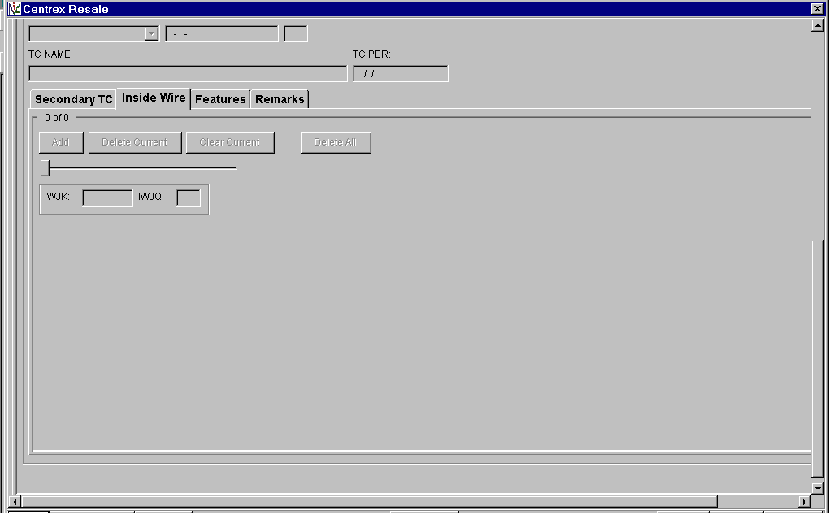

Features
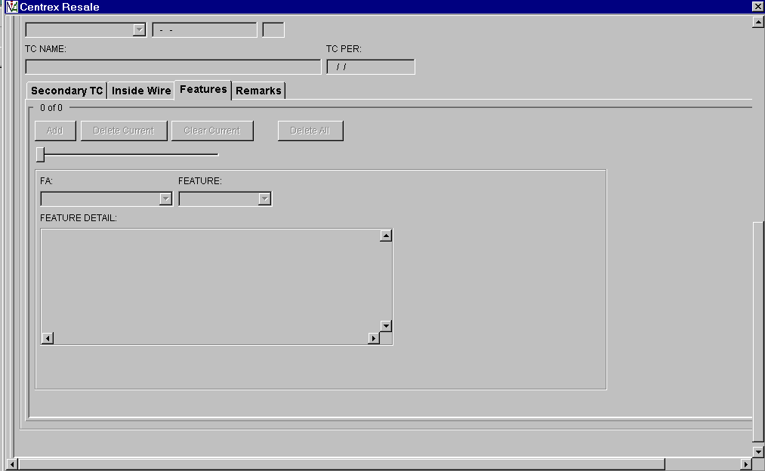

Remarks
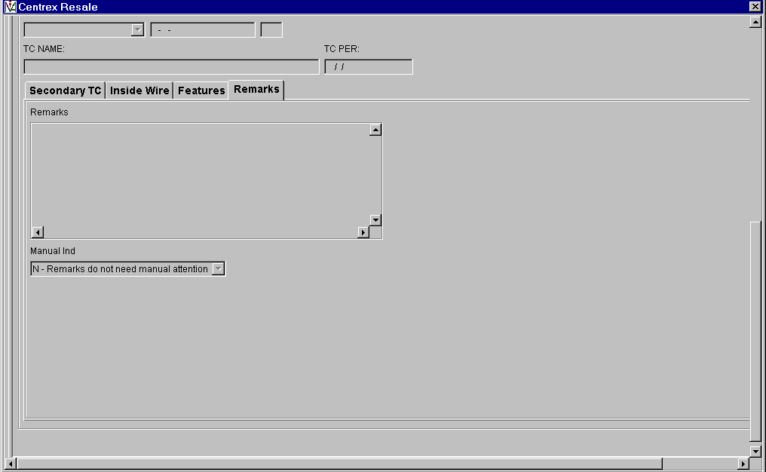

Centrex Resale Form – Common Block Details
(Product Specific)
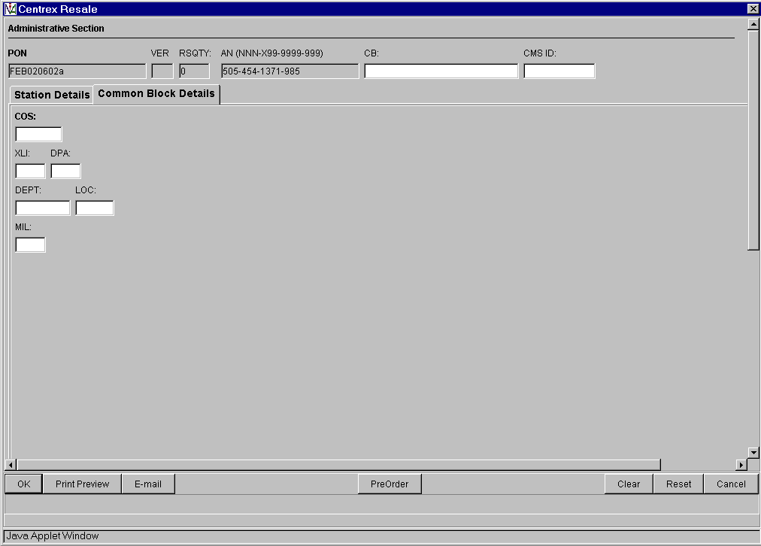
No additional data on this screen
Number Port Form - Service
(Product Specific)
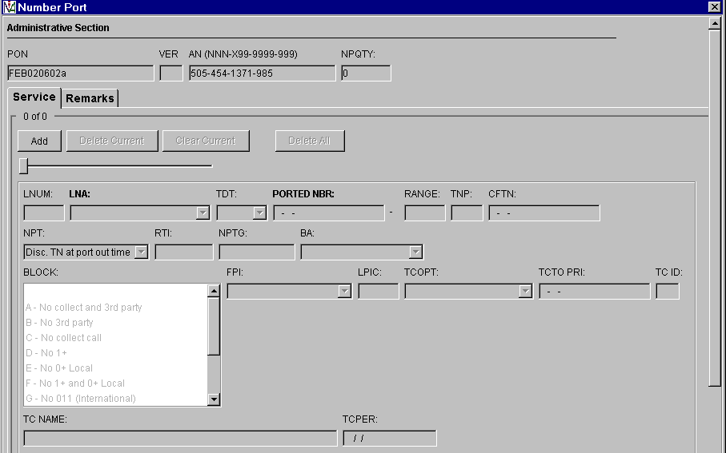
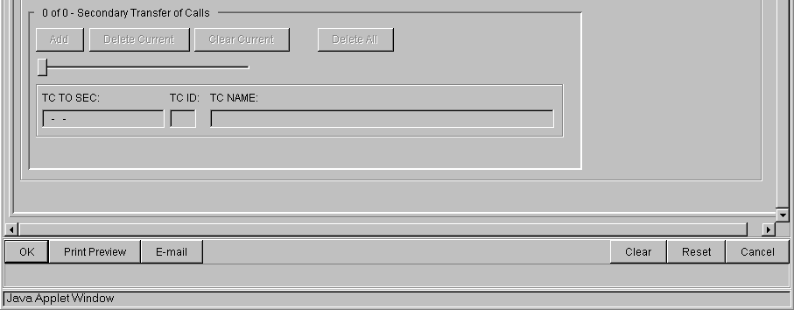

Auto-populated fields:
- PON
- VER
- AN

Note:
- PON / VER – auto-populated from Order Information for New LSR Option Screen
- AN - auto-populated from Pre-order Review CSR Input Screen

Number Port Form - Remarks
(Product Specific)
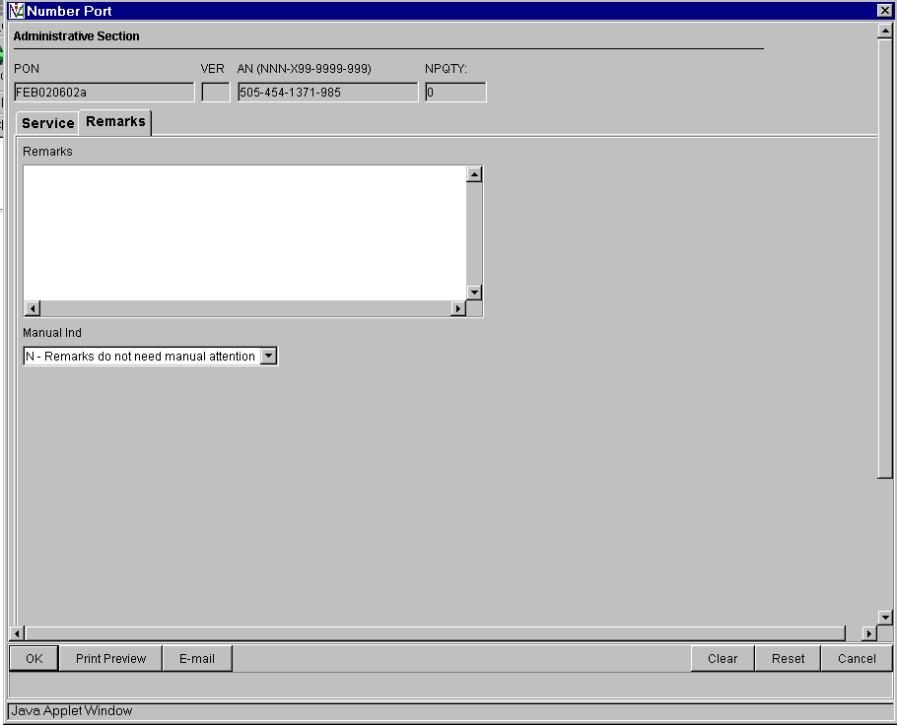

No additional data on this screen
DID Resale Service - Service
(Product Specific)
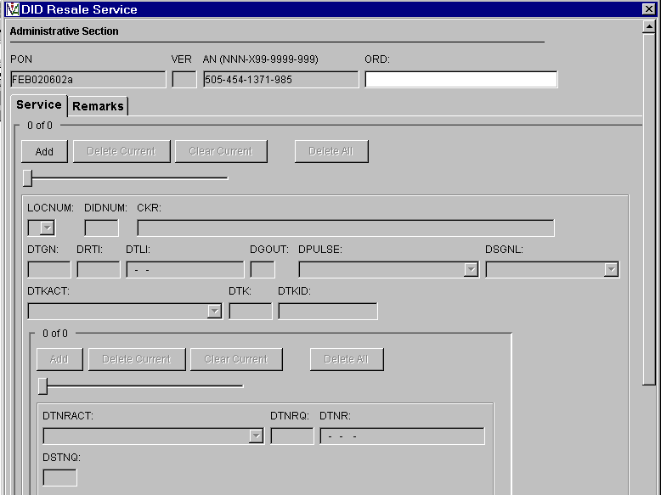
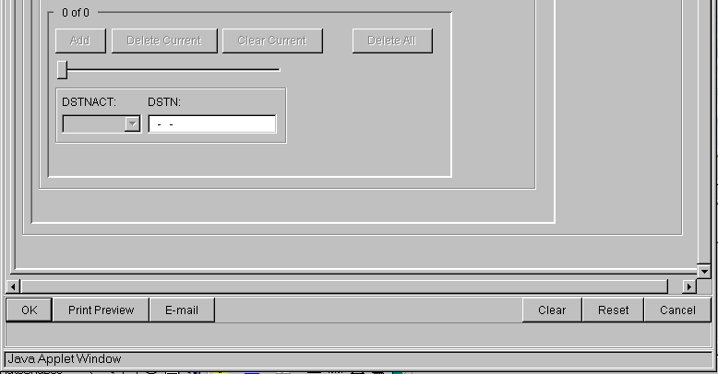

Auto-populated fields:
- PON
- VER
- AN

Note:
- PON / VER – auto-populated from Order Information for New LSR Option Screen
- AN - auto-populated from Pre-order Review CSR Input Screen

DID Resale Service - Remarks
(Product Specific)
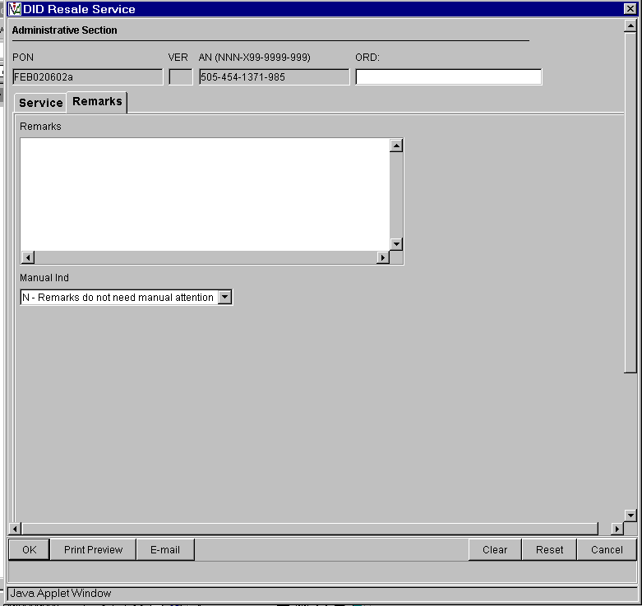
No additional data on this screen
Resale Frame Relay – UNI Circuit
(Product Specific)
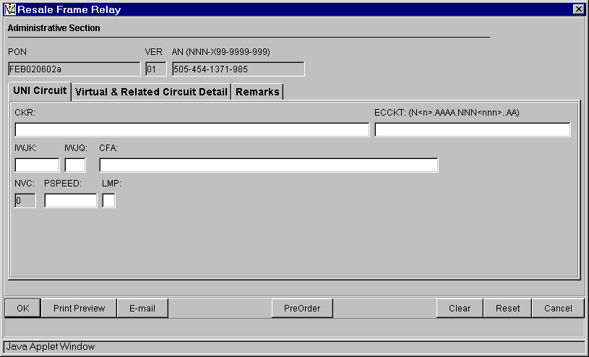

Auto-populated fields:
- PON
- VER
- AN

Note:
- PON / VER – auto-populated from Order Information for New LSR Option Screen
- AN - auto-populated from Pre-order Review CSR Input Screen

Resale Frame Relay – Virtual & Related Circuit Detail
(Product Specific)

Virtual Circuit
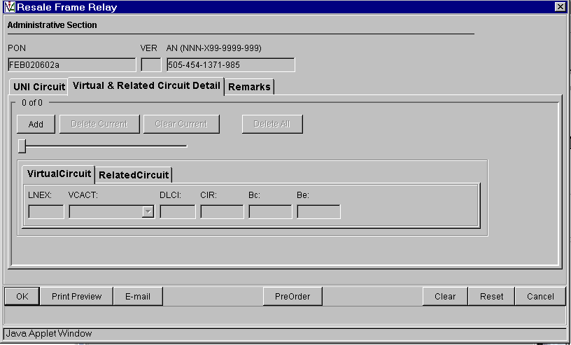

Related Circuit

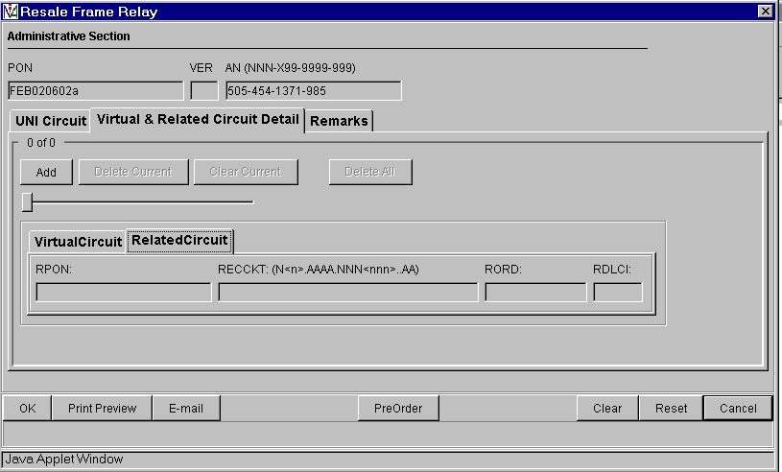

Resale Frame Relay – Remarks
(Product Specific)
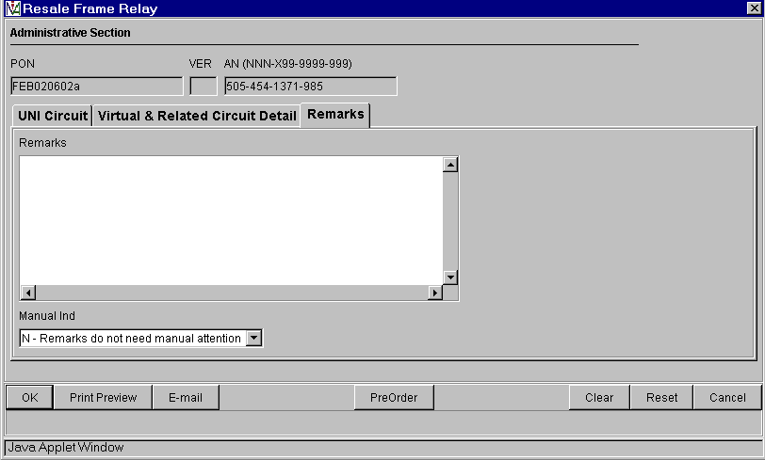

Loop Service with Number Portability - Service
(Product Specific)
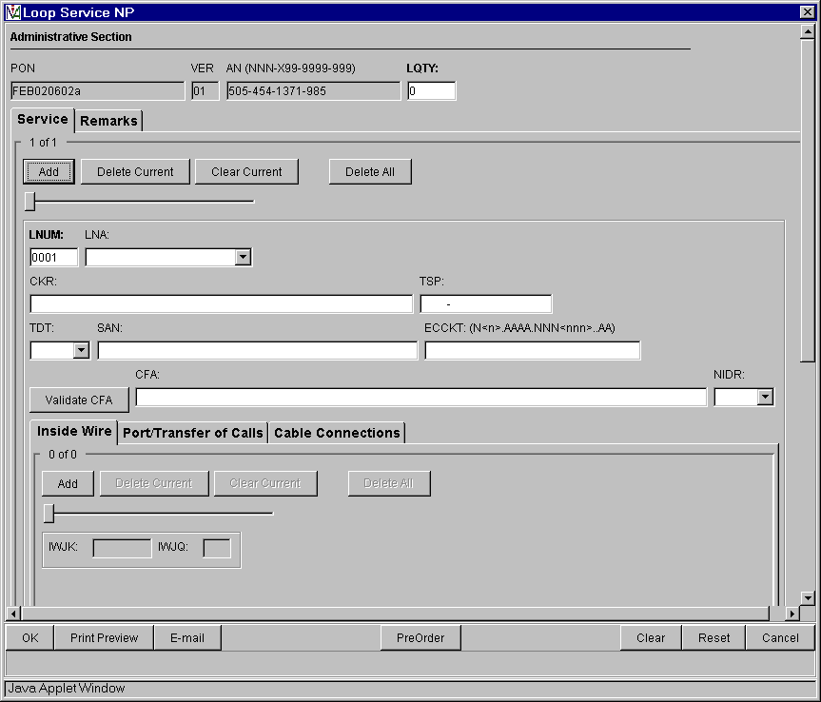

Auto-populated fields:
Inside Wire TAB
- PON
- VER
No additional data on this screen
- AN

Action:
- Click “Add’ button

Pre-populated field:
- Click “Validate CFA” button or “PreOrder” button and execute Pre-Order CF Validation to populate CFA field

Note:
- PON / VER – auto-populated from Order Information for New LSR Option Screen
- AN - auto-populated from Pre-order Review CSR Input Screen
Loop Service with Number Portability – Service: Two Additional TABS
Port/Transfer of Calls

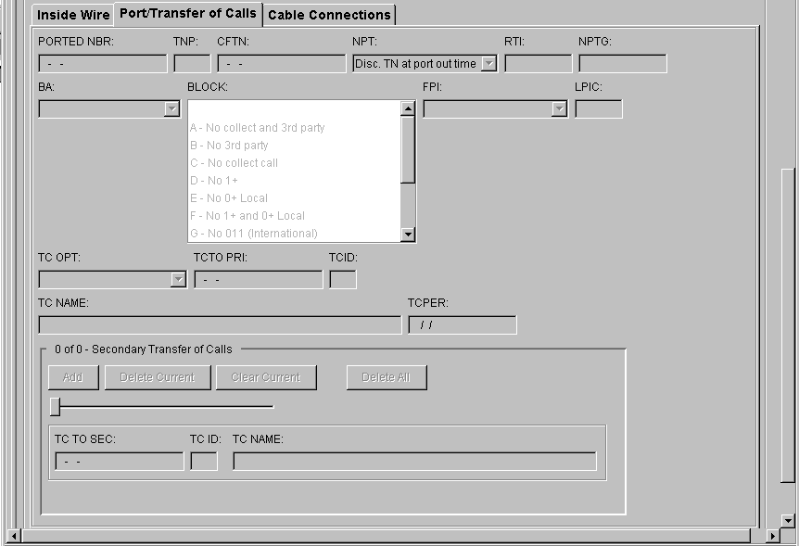

Cable Connection

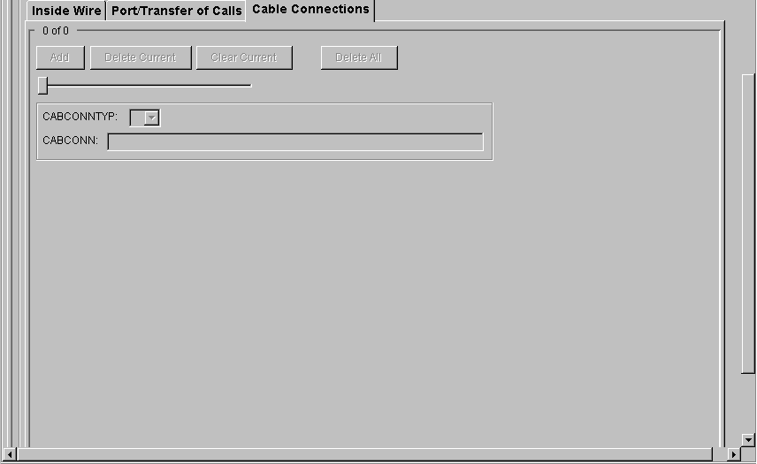

Port Service Form - Service
(Product Specific)
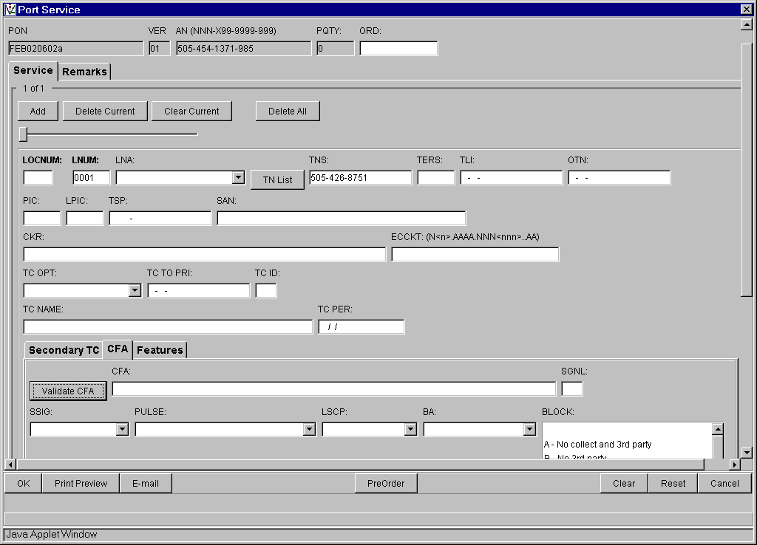
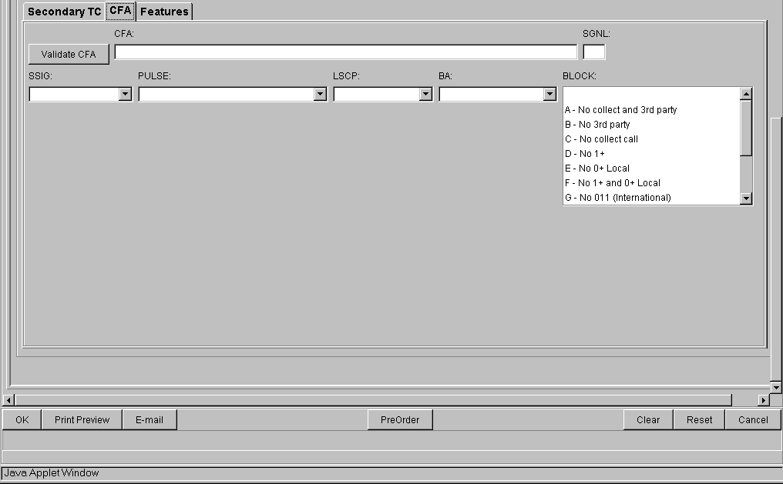
Auto-populated fields:
CFA TAB
- PON
- VER
- AN

Action:
- Click “Add” button
Pre-populated fields:
- Click “TN List” and select telephone number to populate in TNS field
- Select “CFA” tab
- Click “Validate CFA” button or “PreOrder” button and execute Pre-Order CF Validation to populate CFA field

Note:
- PON / VER – auto-populated from Order Information for New LSR Option Screen
- AN - auto-populated from Pre-order Review CSR Input Screens

Port Service Form – Service: The Two Additional TABS
Secondary TC

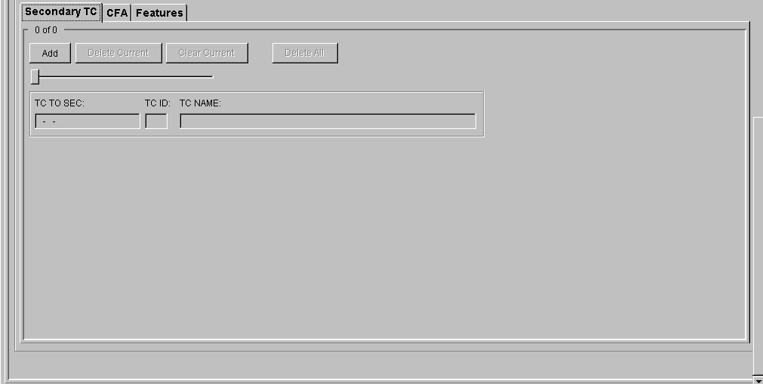

Features:

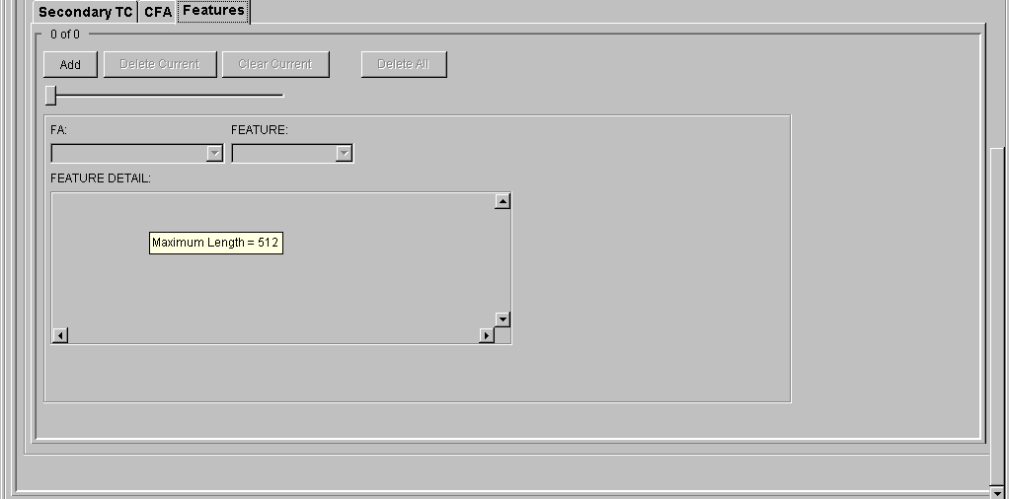

Port Service Form - Remarks
(Product Specific)
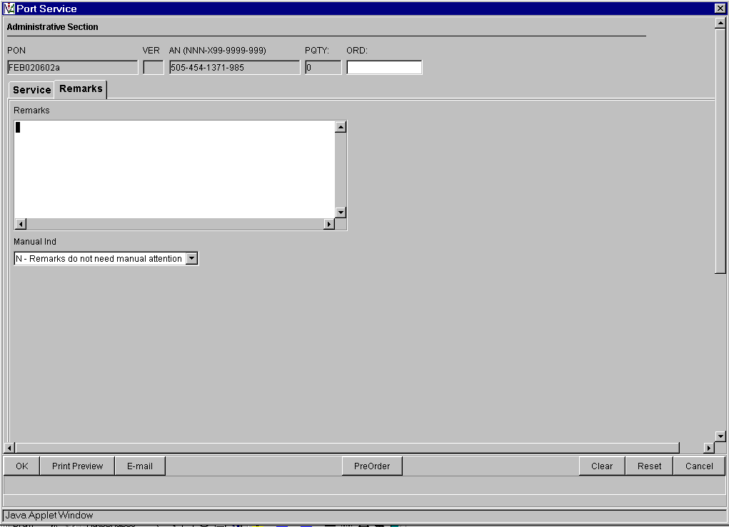
No additional data on this screen

End of the Order Screens

