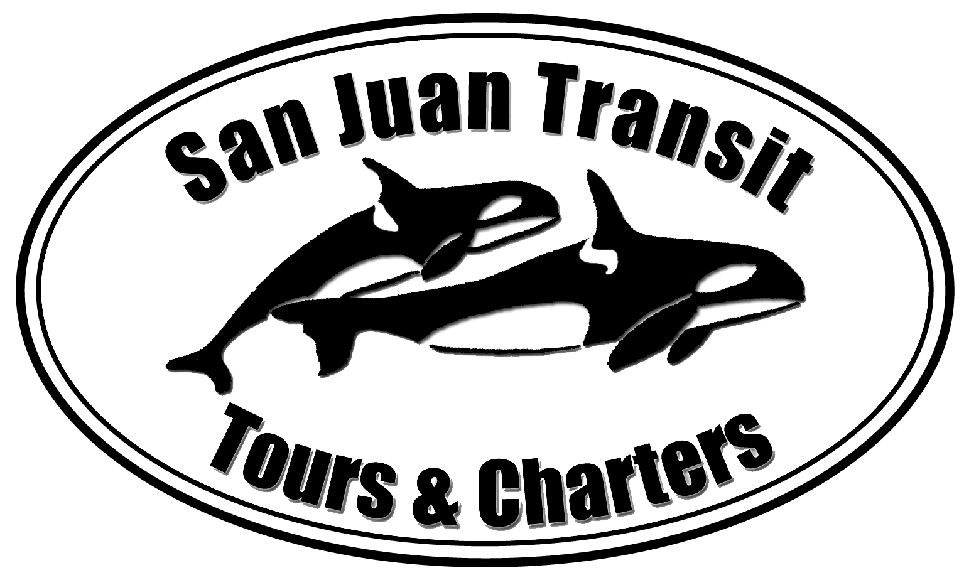

San Juan Transit

Tours and Charters, LLC

Records Center May 7, 2014
Washington Utilities and Transportation Commission
1300 S Evergreen Park Dr. SW
PO Box 47250
Olympia, WA 98504-7250

RE: San Juan Transit Tours and Charters, LLC permit # C-1006
Current Docket number: 140652 Please do not re-docket.

Please accept the following changes to the previously submitted pages for San Juan Island Time Schedule #58:

- Customer Notice
- Title Page (page 1)
- Time Schedule (page 2)
- Time Schedule Routes (pages 3 through 7)

Thank you for your attention, if you need further information, I can be reached at 360-378-8887 or sjtransit@rockisland.com

Sincerely,

Kraig Hansen
San Juan Transit

SERVING THE TRANSPORTATION NEEDS OF THE SAN JUAN ISLANDS
P.O. Box 2809  Friday Harbor, Washington 98250  360-378-8887
Email: sjtransit@rockisland.com Web Site: sanjuantransit.com

