BEFORE THE WASHINGTON UTILITIES AND TRANSPORTATION COMMISSION
In re Application of  SHUTTLE EXPRESS, INC.,  For Extension of Certificate No. C-975,  Shuttle Express, Inc. d/b/a Shuttle Express | Docket No. TC-091931  Permit No. C-975  NOTICE OF APPEARANCE OF SHUTTLE EXPRESS, INC. d/b/a SHUTTLE EXPRESS

TO: David W. Danner, Executive Secretary
AND TO: Parties of Record
  - The undersigned attorney hereby enters his appearance for Shuttle Express, Inc. d/b/a Shuttle Express ("Shuttle"). You are notified that the service of all further pleadings, notices, documents, or other papers herein, exclusive of process, may be had upon Shuttle, by serving the undersigned attorney at the address below stated.
  - The names and address of Shuttle's attorney is:
Brooks E. Harlow
Miller Nash LLP
601 Union Street, Suite 4400
Seattle, Washington 98101-2352
Phone: (206) 622-8484
Facsimile: (206) 622-7485
E-mail: brooks.harlow@millernash.com
DATED this 3rd day of February, 2010.
Miller Nash LLP
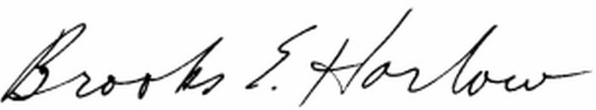
Brooks E. Harlow, P.C.
WSB No. 11843
brooks.harlow@millernash.com
(206) 622-8484

CERTIFICATE OF SERVICE
Docket No. Docket No. TC-091931
I hereby certify that a true and correct copy of the foregoing was forwarded via electronic mail and first class mail, postage fully prepaid, in a sealed envelope, to the following:

John Solin
Mike Lauver
SeaTac Shuttle, LLC
d/b/a Whidbey Seatac Shuttle
P.O. Box 2895
Oak Harbor, WA 98277
E-mail: mike@seatacshuttle.com

John Rowley
General Manager
Shuttle Express, Inc.
800 SW 16th Street
Renton, WA 98055
jrowley@shuttleexpress.net

Dated at Seattle, Washington, this 3rd day of February, 2010.
/s/______________________________
Carol Munnerlyn, Secretary

