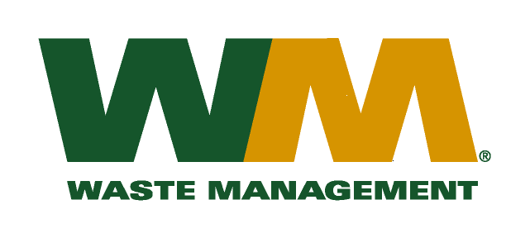

December 28, 2018

Washington Utilities and Transportation Commission
Chandler Plaza Building
1300 S. Evergreen Park Drive SW
P.O. Box 47250
Olympia, WA. 98504-7250

Subject: Replacement tariff pages in dockets TG-180923 and TG-180924
Please find enclosed replacement tariff pages in the above-referenced dockets. These pages are being submitted in accordance with Staff recommendations. Please do not re-docket.

If you have any questions or need additional information, please contact me at:

Address: 720 4th Avenue, Suite 400, Kirkland, WA 98033
Telephone /Fax #: (425) 814-7840 / (425) 814-7866
e-mail: mweinstein@wm.com

Respectfully,

Michael A. Weinstein
Senior Pricing Manager, Pacific Northwest Market Area

