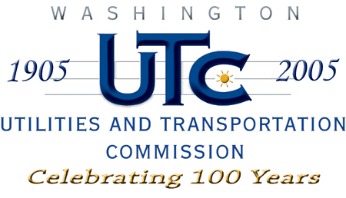

Memorandum
July 2, 2009

To: TR-071945 - File

From: Kathy Hunter, Deputy Assistant Director Transportation Safety

Subject: TR-071945 Washington State Parks and Recreation Commission
Grade Crossing Protective Fund (GCPF) Project - Larrabee State Park on Samish Bay near Bellingham

On December 27, 2007, the Washington Utilities and Transportation Commission (Commission) awarded a GCPF grant totaling $50,000 for design and permitting (to include bridge type, site and location study and detailed geotechnical investigation) of a bridge at Larrabee State Park on Samish Bay near Bellingham in Whatcom county. Total project costs are estimated at $50,000.

On July 2, 2009, the applicant, Washington State Parks and Recreation Commission submitted a request for reimbursement in the amount of $46,307.86 pursuant to commission order. Along with the request for reimbursement Washington State Parks and Recreation Commission submitted a complete set of plans and documentation verifying completion of this phase of the project.

Please close this docket.

