SENT VIA ELECTRONIC MAIL 4/25/2008 TO: records@wutc.wa.gov
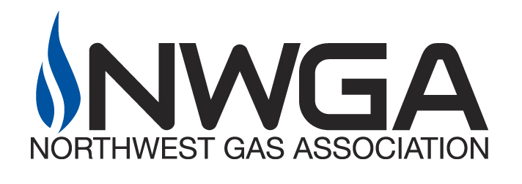
5335 SW Meadows Rd., Suite 220
Lake Oswego, Oregon 97035
Phone: 503-624-2160
Fax: 503-624-2161
www.nwga.org

April 25, 2008

Carole J. Washburn,
Executive Secretary
Washington Utilities & Transportation Commission
1300 South Evergreen Park Drive, S.W.
P.O. Box 47250
Olympia, Washington 98504-7250

Subject: Docket PG-070975: NWGA Comments on Proposed Revisions to 480-93 WAC, Gas Companies – Safety;

Dear Ms. Washburn:
Thank you for the opportunity to comment on PG-070975, revising 480-93 WAC to incorporate statutory changes contained in SSB 5225 (C 142 L 07).
The Northwest Gas Association (NWGA) is a trade organization representing the natural gas industry in the Pacific Northwest. NWGA members that operate in Washington State and that are subject to the regulatory jurisdiction of the Washington Utilities and Transportation Commission include Avista Utilities, Cascade Natural Gas Corp., NW Natural and Puget Sound Energy. The comments that follow characterize the collective view of those members.
First and foremost, we wish to commend staff for a responsive process focused on the objective of implementing the provisions of SSB 5225. For instance, we noted in previous comments that it appeared as though an older version of 480-93 WAC may have been used in a number of places as the basis for creating the initial draft document. This was worrisome to us for a variety of reasons. Staff responded by starting fresh with the latest version of WAC 480-93 as its foundation.
In addition, staff also responded to our specific comments on the initial draft: adopting our suggestions, clarifying the intent of proposed language to our satisfaction or reverting to the original language of the rule where a common interpretation proved difficult to attain. We appreciate staff’s hard work and time. The result is language we can work with given just a few minor comments.
Specifically:
- [Page 1 and 2] 480-93-005 (13) Gas Pipeline Company – last sentence - This definition should be identical to the definition set forth in RCW 81.88.010. Consequently, the word “gas” should be inserted before “pipeline company” in the last sentence. The sentence should read: “…that contract with a gas pipeline company.”
- [Page 2] 480-93-005 (19) Master meters system - Replacing the reference to 49 CFR § 191.3 with static language may compel future rulemakings to ensure consistency, should the federal code be changed. Why make the change?
- [Page 21] 480-93-185 (3) - second sentence, lines 6-7 - This section refers to the responsibility of a gas pipeline company to promptly report certain leaks to a third party owner or operator of the source facility. Therefore, the term “operator” in line 6 should be retained and not replaced with “gas pipeline company”. The resulting language should read: “…must be reported to the owner or operator gas pipeline company of the source facility…”

- [Page 31] 480-93-240 (1) - The term “gas pipeline” is defined in RCW 81.88.010 as pipe. “Gas pipeline company” would be a more appropriate term. Definitions for both terms (identical to those in RCW 81.88.010) are being added to WAC 480-93-005 under this rulemaking so it seems unnecessary to reference the RCW. Also, there is no need to refer to hazardous liquid pipelines in WAC 480-93. Therefore, the paragraph should read “…regulatory fee paid by a gas pipelines pipeline company as that term is defined herein. and hazardous liquid pipelines as that term is defined in RCW 81.88.010. For the purposes of this section, these gas pipelines are a gas pipeline company is called “company” or “companies” and . . .”
In conclusion, our members strive to operate their respective natural gas systems to ensure public safety and in full compliance with applicable state and federal pipeline safety regulations. In that regard, we appreciate the opportunity to participate in the process of writing clear and concise code language.
Sincerely,
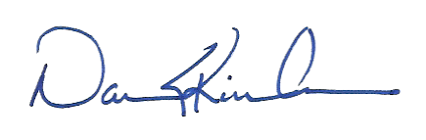
DAN S. KIRSCHNER
Executive Director

