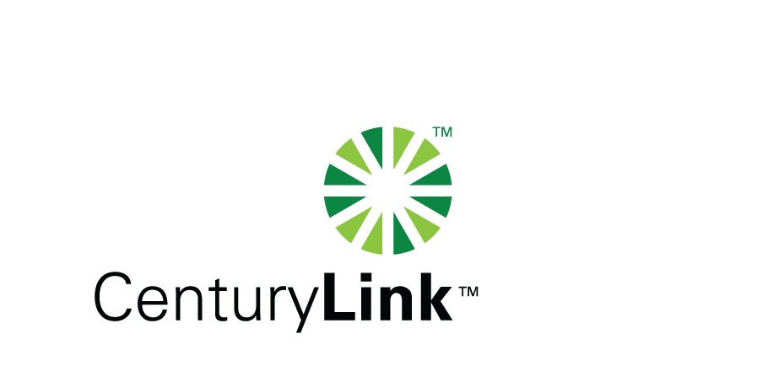

February 27, 2013

David Danner, Executive Director & Secretary
Washington Utilities & Transportation Commission
1300 S Evergreen Park Drive, SW
Olympia, Washington 98504-7250

Re: CenturyTel of Washington, CenturyTel of InterIsland, CenturyTel of Cowiche d/b/a CenturyLink Service Quality Report for January 2013

Dear Mr. Danner:

Attached is the CenturyTel d/b/a CenturyLink Service Quality Report for the month of January 2013 in confidential and redacted versions.

The trouble reports per 100 access lines objective was met for the month of January with the exception of Starbuck at 5.6. With only 89 access lines the exchange has low a volume of activity. However, three tickets were reported due to a central office equipment failure causing the unfavorable result.

Should you have any questions, please contact Mark Reynolds at (206) 345-1568 or by e-mail at mark.reynolds3@centurylink.com.

Sincerely,

Mark Reynolds

Enclosures: Installation/Repair Appointments
Service Activation in 5 Days
Trouble Per 100/Access Lines
Switching – Dial Tone Speed in 3 Seconds
Final Trunk Blockage (EAS and Toll)
Out of Service Trouble Cleared in 48 Hours
Not Out of Service Trouble Cleared in 72 Hours
Service Activation Delay 90-180 Days

