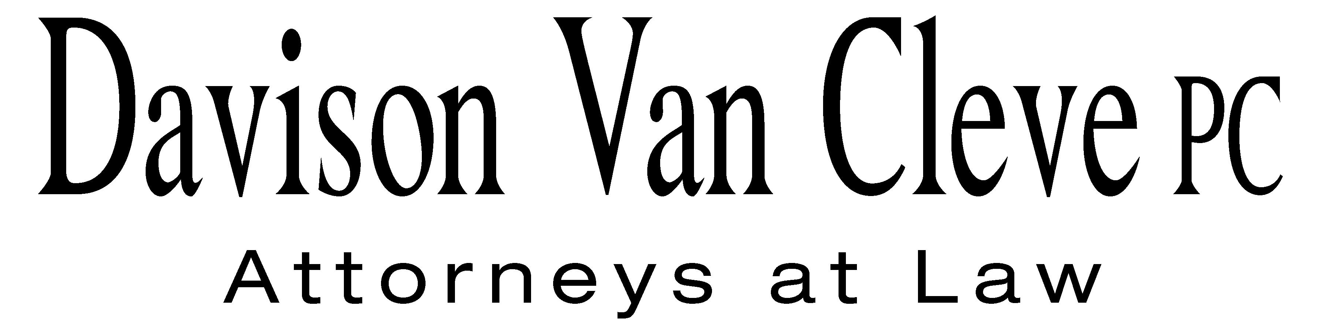
TEL (503) 241-7242 ● FAX (503) 241-8160 ● mail@dvclaw.com
Suite 400
333 SW Taylor
Portland, OR 97204

February 12, 2013

Via Email and Federal Express

UTC Records Center
Washington Utilities and Transportation Commission
PO Box 47250
1300 S Evergreen Park Drive SW
Olympia, WA 98504-7250

Re: In the matter of WUTC v. PacifiCorp.
Docket No. UE-130043

Dear Filing Center:

Enclosed please find an original and twelve (12) copies of the Reply to PacifiCorp Response in Opposition of Columbia Rural Electric Association (“Columbia REA”).

Thank you for your assistance.

Sincerely yours,

/s/ Karen A. Zolka
Karen A. Zolka
Enclosures

cc: Service List

CERTIFICATE OF SERVICE

I hereby certify that I have this day served the foregoing Reply upon all parties of record in this proceeding by mailing a copy thereof in a sealed, first-class postage prepaid envelope to each individual’s last-known address, as listed below.
DATED this 12th day of February, 2013.
Davison Van Cleve, P.C.

/s/ Karen A. Zolka
Karen A. Zolka

WASHINGTON DOCKETS  PACIFICORP  825 NE MULTNOMAH, SUITE 2000  PORTLAND OR 97232  washingtondockets@pacificorp.com | SARAH WALLACE  SENIOR COUNSEL  PACIFICORP  825 NE MULTNOMAH, SUITE 1800  PORTLAND OR 97232  sarah.wallace@pacificorp.com
SHEREE CARSON  PERKINS COIE LLP  10885 NE FOURTH STE 700  BELLEVUE WA 98004  scarson@perkinscoie.com | ROBERT CEDARBAUM  Assistant Attorney General  WUTC  PO Box 40128  Olympia, WA 98504-0128  bcedarba@utc.wa.gov
WILLIAM GRIFFITH  Vice President, Regulation  Pacific Power & Light Company  825 NE Multnomah STE 2000  Portland, OR 97232  Bill.Griffith@pacificorp.com | SIMON FFITCH  LISA GAFKEN  Office of the Attorney General  800 Fifth Avenue STE 2000  Seattle, WA 98104-3188  simonf@atg.wa.gov
MICHAEL C. DEEN  RCS, Inc.  900 Washington St. STE 780  Vancouver, WA 98660  mdeen@r-c-s-inc.com | SCOTT PETERS  Manager of Marketing and Member Services  Columbia Rural Electric Association, Inc.  PO Box 46  Dayton, WA 99328  speters@columbiarea.com
BOISE WHITE PAPER, L.L.C.  Boise White Paper Holdings, L.L.C.  PO Box 50  Boise, ID 83728 | THE ENERGY PROJECT  The Energy Project  3406 Redwood Ave.  Bellingham, WA 98225
BRAD M. PURDY  Attorney at Law  2019 N. 17th St.  Boise, ID 83702  bmpurdy@hotmail.com | COLUMBIA RURAL ELECTRIC ASSOCIATION  Columbia Rural Electric Association, Inc.  PO Box 46  Dayton, WA 99328

