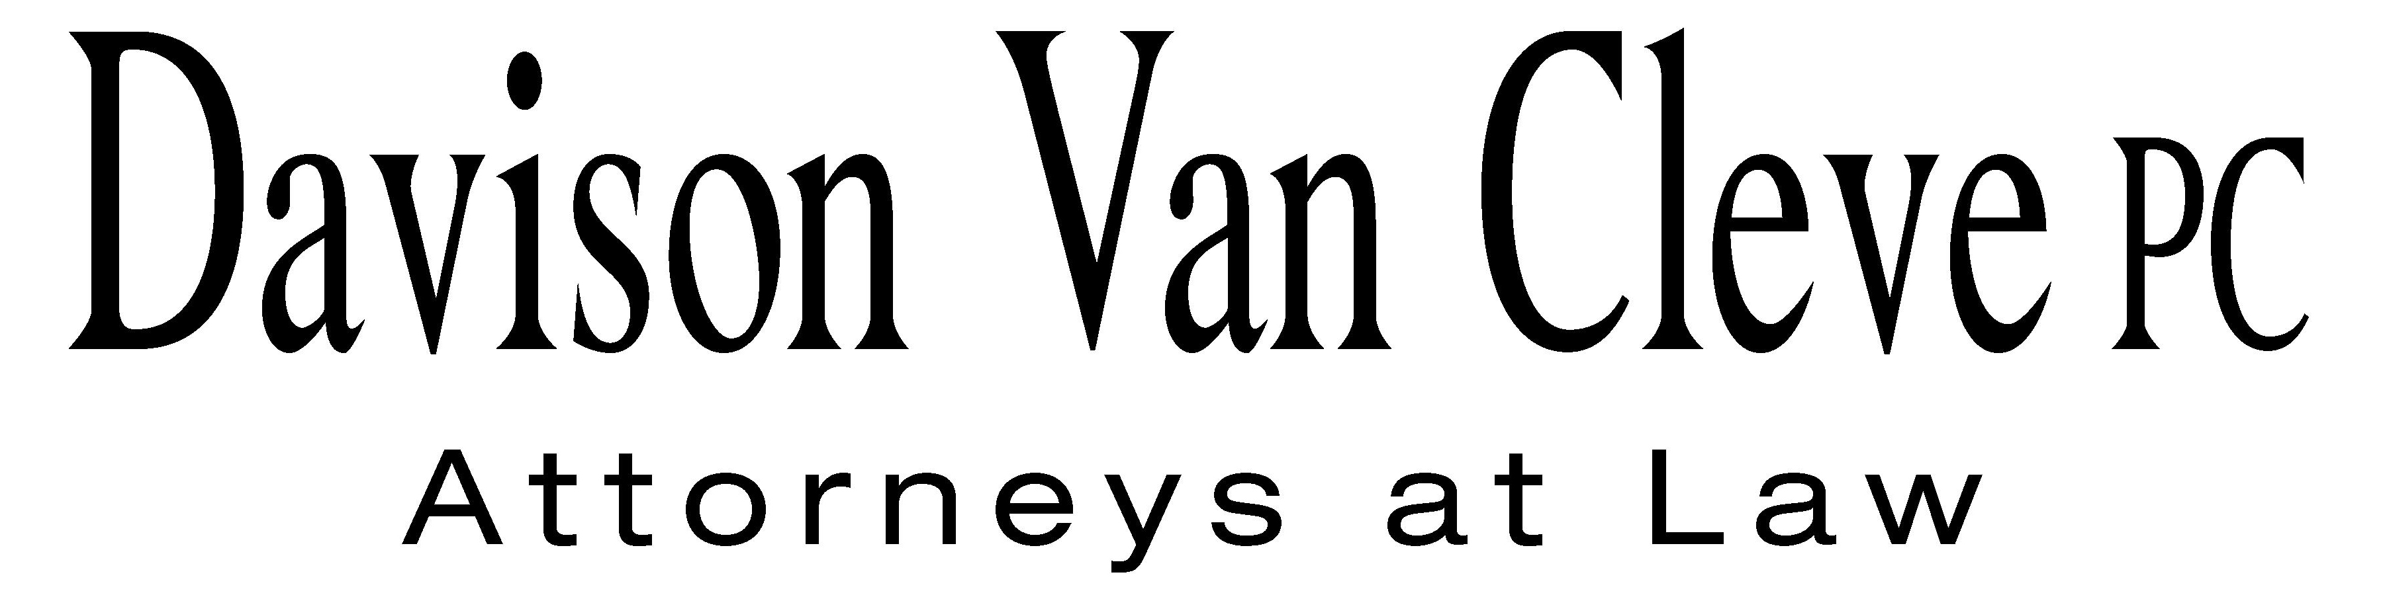
TEL (503) 241-7242 ● FAX (503) 241-8160 ● mail@dvclaw.com
Suite 400
333 S.W. Taylor
Portland, OR 97204

July 27, 2005

Via Email and Federal Express

Carole J. Washburn
Secretary
Washington Utilities and Transportation Commission
PO Box 47250
1300 S Evergreen Park Drive, SW
Olympia WA 98504-7250

Re: In the matter of WUTC v. Puget Sound Energy, Inc.

Docket No. UE 050870

Dear Ms. Washburn:

Enclosed please find the signature page for Raymond D. Bliven on behalf of the Industrial Customers of Northwest Utilities (“ICNU”).

Electronic copies were emailed to the Records Center today, July 27, 2005. Please call me at (503) 241-7242 if you have any questions. Thank you for your assistance.

Sincerely yours,

Sheila R. Ho

Enclosures
cc: Service List

CERTIFICATE OF SERVICE

I hereby certify that I have this day served a copy of the foregoing Signature Page of Raymond D. Bliven on behalf of the Industrial Customers of Northwest Utilities (“ICNU”), upon the parties, shown below, listed on the official service list in Docket Number UE-050870, by causing the same to be mailed, postage-prepaid, through the U.S. Mail.
DATED this 27th day of July, 2005.
Davison Van Cleve, P.C.

_____________________
Sheila R. Ho

Kimberly Harris  VP, Regulatory & Government Affairs  Puget Sound Energy  PO Box 97034  Bellevue, WA 98009 | Karl Karzmar  Regulatory Relations  Puget Sound Energy  PO Box 97034  Bellevue, WA 98009
Kirstin Dodge  Perkins Coie LLP  Representing Puget Sound Energy  10885 NE Fourth Street, Suite 700  Bellevue, WA 98004 | Jason Kuzma  Perkins Coie LLP  Representing Puget Sound Energy  10885 NE Fourth Street, Suite 700  Bellevue, WA 98004
Ken Canon  Executive Director  Industrial Customers of NW Utilities  333 SW Taylor, Suite 400  Portland, OR 97204 | Robert Cedarbaum  Washington State Attorney General's Office  PO Box 40128  Olympia, WA 98504-0128
Simon ffitch
Washington State Attorney General's Office
900 Fourth Avenue, Suite 2000
Seattle, WA 98164-1012

