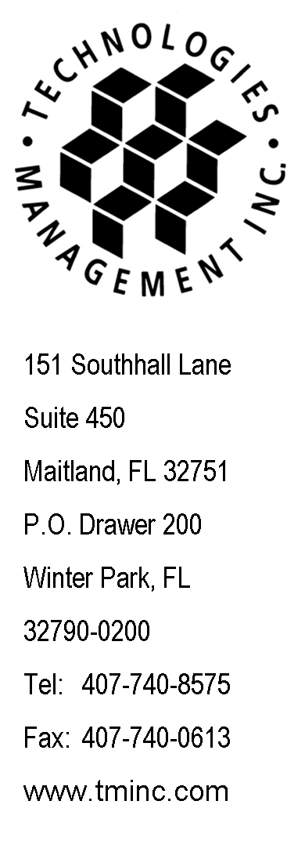
April 26, 2017
Via Email
Records@utc.wa.gov

Records Division (Email)
Washington Utilities &Transportation Comm.
Records@utc.wa.gov,

RE: Budget PrePay, Inc. d/b/a Budget Mobile
WA ETC Quarterly Lifeline Information Report
For the quarter ending March 31, 2017
Docket No: UT-111570

Dear Sir or Madam:

Enclosed please find the WA ETC Quarterly Lifeline Information Report for the quarter ending March 31, 2017, filed on behalf of Budget PrePay, Inc. d/b/a Budget Mobile. No check is enclosed as there are no remittance fees due.

This report has been emailed to Records@utc.wa.gov in PDF and Word format.

Questions regarding this filing should be directed to my attention at 407-740-8575. Thank you for your assistance in this matter.

Sincerely,

Craig Neeld
Compliance Reporting Specialist

cc: Lakisha Taylor - Budget PrePay, Inc. d/b/a Budget Mobile
file: Budget PrePay, Inc. d/b/a Budget Mobile - Reporting - Washington

CN/rh

