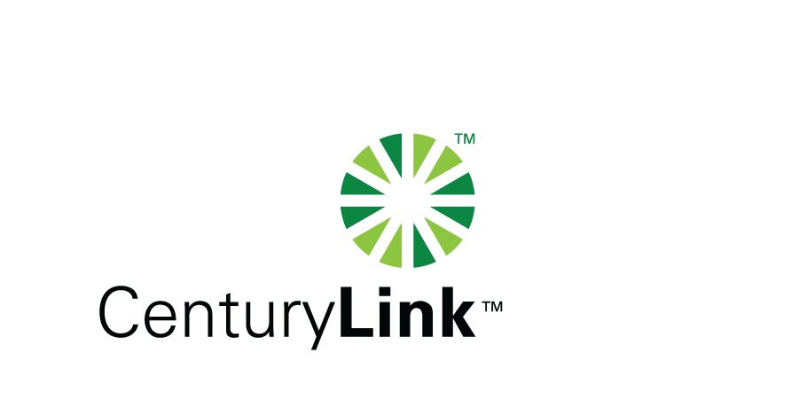

November 16, 2012

David Danner, Executive Director & Secretary
Washington Utilities & Transportation Commission
1300 S Evergreen Park Drive, SW
Olympia, Washington 98504-7250

Re: United Telephone Company of the Northwest d/b/a CenturyLink
July and August 2012 Amended Service Quality Reports

Dear Mr. Danner:

Attached is United Telephone Company of the Northwest d/b/a CenturyLink’s amended July and August Service Quality Reports in confidential and redacted versions.

Should you have any questions, please contact Mark Reynolds at (206) 345-1568 or by e-mail at mark.reynolds3@centurylink.com.

Sincerely,

Mark Reynolds

Enclosures: Installation/Repair Appointments
Service Activation in 5 Days
Trouble Per 100/Access Lines
Switching – Dial Tone Speed in 3 Seconds
Final Trunk Blockage (EAS and Toll)
Out of Service Trouble Cleared in 48 Hours
Not Out of Service Trouble Cleared in 72 Hours
Service Activation Delay 90-180 Days

