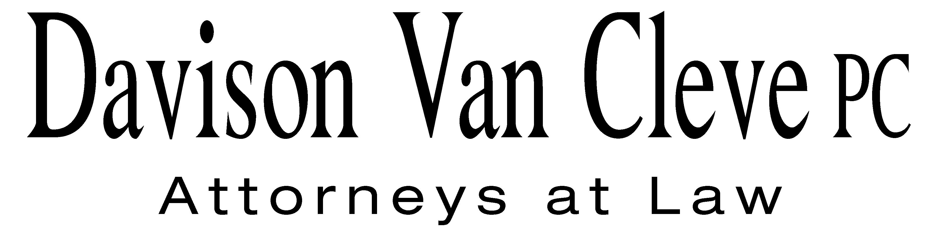
TEL (503) 241-7242 ● FAX (503) 241-8160 ● mail@dvclaw.com
Suite 400
333 SW Taylor
Portland, OR 97204

February 19, 2009

Via Email and Federal Express

Carole J. Washburn
Secretary
Washington Utilities and Transportation Commission
PO Box 47250
1300 S Evergreen Park Drive, SW
Olympia WA 98504-7250

Re: In the matter of WUTC v. PacifiCorp

Docket No. UE-090205

Dear Ms. Washburn:

Enclosed please find an original and twelve (12) copies each of the following documents for filing in the above-captioned matter:

- the Petition to Intervene of the Industrial Customers of Northwest Utilities; and

- the Notice of Appearance of Melinda J. Davison and Irion A. Sanger on behalf of the Industrial Customers of Northwest Utilities.

Thank you for your assistance.

Sincerely yours,

/s/ Brendan E. Levenick
Brendan E. Levenick
Enclosures
cc: Service List

CERTIFICATE OF SERVICE

I hereby certify that I have this day served the foregoing Petition to Intervene and Notice of Appearance of the Industrial Customers of Northwest Utilities upon all parties of record in this proceeding by mailing a copy thereof in a sealed, first-class postage prepaid envelope to each individual’s last-known address, as listed below.
DATED this 19th day of February, 2009.
Davison Van Cleve, P.C.

/s/ Brendan E. Levenick
Brendan E. Levenick

CATHIE ALLEN  PACIFIC POWER  REGULATORY AFFAIRS  825 NE MULTNOMAH STREET, STE 2000  PORTLAND OR 97232  E-mail:cathie.allen@pacificorp.com | KATHERINE MCDOWELL  MCDOWELL & RACKNER P.C.  Representing Pacific Power  520 SW 6TH AVENUE, STE 830  PORTLAND OR 97204  E-mail: katherine@mcd-law.com
MICHELLE MISHOE  LEGAL COUNSEL  PACIFICORP  Representing Pacific Power  825 NE MULTNOMAH STE 1800  PORTLAND OR 97232  E-mail: michele.mishoe@pacificorp.com | DON TROTTER  ASSISTANT ATTORNEY GENERAL  WUTC  ATTORNEY GENERAL SECTION  STATE MAIL STOP 40128  E-mail: dtrotter@utc.wa.gov
SIMON FFITCH
AAG
OFFICE OF THE ATTORNEY GENERAL
PUBLIC COUNSEL
800 FIFTH AVENUE STE 2000
SEATTLE WA 98104-3188
E-mail: simonf@atg.wa.gov

