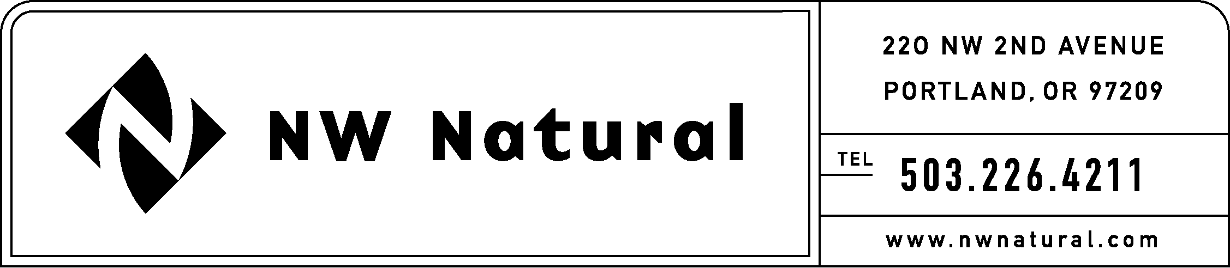
GAIL HAMMER
Rates and Regulatory Affairs
Phone: 503.226.4211 ext. 5865
Fax: 503.721.2516
gail.hammer@nwnatural.com

July 15, 2016

VIA ELECTRONIC FILING AND US MAIL

Steven King, Executive Director and Secretary
Washington Utilities and Transportation Commission
1300 S. Evergreen Park Drive, S.W.
P.O. Box 47250
Olympia, Washington 98504-7250

RE: UG-151776, Chapter 9 of NW Natural’s Draft 2016 Integrated Resource Plan

NW Natural Gas, dba NW Natural (“NW Natural” or the “Company”), herein files Chapter 9 and an updated Table of Contents page for its Draft 2016 Integrated Resource Plan (IRP) in Docket No. UG-151776. Enclosed please find an original and three copies. The Stochastic Risk Analysis was still being completed at the time of the June 28, 2016 Draft 2016 IRP filing.

Please contact me should you have questions or require additional information.

Sincerely,
/s/ Gail Hammer
Gail Hammer
NW Natural

Enclosures

