February 3, 2010

BY Web Portal & Federal Express

David W. Danner
Executive Director and Secretary
Washington Utilities and Transportation Commission
1300 S. Evergreen Park Drive S.W.
Post Office Box 47250
Olympia, Washington 98504-7250
Subject: In re Application of Shuttle Express, Inc., For Extension of Certificate No. C-975, Shuttle Express, Inc. d/b/a Shuttle Express
Docket No. TC-091931
Dear Mr. Danner:
Enclosed, for filing, are the originals and two copies each of the following:
1. Notice Of Appearance
2. Motion To Strike Protest, Cancel Prehearing Conference, And Terminate Adjudicative Proceeding.
3. Declaration of Brooks E. Harlow In Support Of Motion To Strike Protest, Cancel Prehearing Conference, And Terminate Adjudicative Proceeding.
If you have any questions, please do not hesitate to contact the undersigned.
Very truly yours,
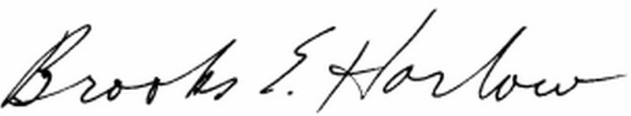
Brooks E. Harlow, P.C.

cc w/encs.: Service List

