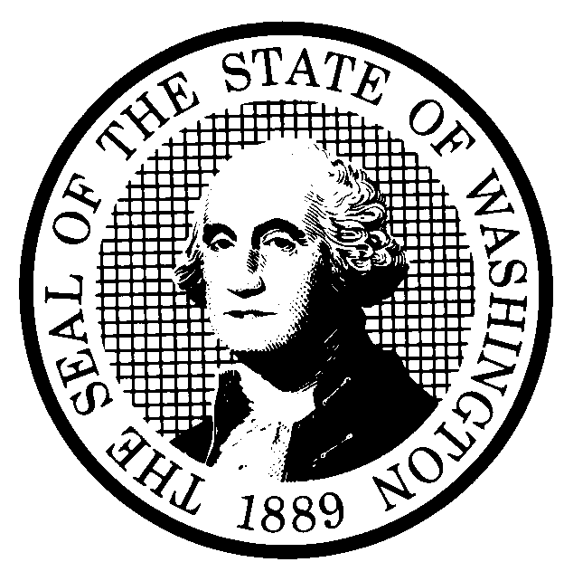 | PROPOSED RULE MAKING |  |  |  |  | CR-102 (June 2004)  (Implements RCW 34.05.320)  Do NOT use for expedited rule making
Agency: WASHINGTON UTILITIES AND TRANSPORTATION COMMISSION
Preproposal Statement of Inquiry was filed as WSR 05-18-087; or  Expedited Rule Making--Proposed notice was filed as WSR ; or  Proposal is exempt under RCW 34.05.310(4). |  |  |  |  |  |  | Original Notice  Supplemental Notice to WSR  Continuance of WSR
Title of rule and other identifying information: WAC 480-140-020, relating to who must file budgets. The rulemaking has been assigned WUTC Docket Nos. UT-051261 and UW-051287.

Hearing location(s):  Commission Hearing Room 206  2nd Floor, Chandler Plaza Building  1300 S. Evergreen Park Dr. SW  Olympia, WA 98504-7250 |  |  |  | Submit written comments to:  Name: Carole J. Washburn, Secretary  Address: P. O. Box 47250, Olympia, WA 98504  e-mail records@wutc.wa.gov Please include  Dockets UT-051261 and UW-051287 in your communication.  fax (360) 586-1150 by (date) November 23, 2005
Date of Hearing: December 6, 2005, at 9:30 a.m. |  |  |  | Assistance for persons with disabilities: Contact  Mary DeYoung by Monday, December 5, 2005  TTY (360) 586-8203 or (360) 664-1133
Date of intended adoption: December 6, 2005
(Note: This is NOT the effective date)
Purpose of the proposal and its anticipated effects, including any changes in existing rules:
WAC 480-140-020(3) and (4) would be deleted to eliminate the requirement that large telecommunications companies and water companies must file annual budgets with the Commission.

Reasons supporting proposal: The amendments to WAC 480-140-020 will eliminate an unnecessary regulatory requirement. The requirement that large telecommunications companies and water companies file budget reports is obsolete. The agency can fulfill its responsibility to ensure fair, just, and reasonable rates without this reporting requirement.
Statutory authority for adoption: RCW 80.01.040(4),  RCW 80.04.160, and RCW 80.04.320. |  |  |  | Statute being implemented: N/A
Is rule necessary because of a:  Federal Law?  Federal Court Decision?  State Court Decision?  If yes, CITATION: |  | Yes  Yes  Yes | No  No  No |  | CODE REVISER USE ONLY  Filed with the Code Reviser’s Office  November 1, 2005, 1:18 p.m.  WSR 05-22-094
DATE
November 1, 2005
NAME (type or print)
Carole J. Washburn
SIGNATURE

TITLE
Executive Secretary
(COMPLETE REVERSE SIDE)
Agency comments or recommendations, if any, as to statutory language, implementation, enforcement, and fiscal matters:
None
Name of proponent: Washington Utilities and Transportation Commission |  |  | Private  Public  Governmental
Name of agency personnel responsible for:
 | Name | Office Location | Phone
Drafting..............Betty Erdahl, Regulatory Analyst |  | 1300 S. Evergreen Park Drive SW, Olympia, WA 98504 | (360) 664-1283
Implementation..Carole J. Washburn, Executive Secretary |  | 1300 S. Evergreen Park Drive SW, Olympia, WA 98504 | (360) 664-1174
Enforcement......Carole J. Washburn, Executive Secretary |  | 1300 S. Evergreen Park Drive SW, Olympia, WA 98504 | (360) 664-1174
Has a small business economic impact statement been prepared under chapter 19.85 RCW?
Yes.

A copy of the statement may be obtained by contacting:
Name:
Address:

phone
fax
No. Explain why no statement was prepared.

The proposed amendments to WAC 480-140-020 will not result in or impose an increase in costs. In fact, the proposed amendments to WAC 480-140-020 will decrease costs due to less reporting by telecommunications and water companies. Because there will not be any increase in costs resulting from the proposed rule changes, an SBEIS is not required under RCW 19.85.030(1).

Is a cost-benefit analysis required under RCW 34.05.328?

Yes A preliminary cost-benefit analysis may be obtained by contacting:
Name:
Address:

phone ( )
fax ( )
e-mail

No: Please explain: The Commission is not an agency to which RCW 34.05.328 applies. The proposed rules are not significant legislative rules of the sort reference in RCW 34.05.328(5).

