July 6, 2015
Steven V. King
Executive Director and Secretary
Washington Utilities and Transportation Commission
1300 S. Evergreen Park Drive, SW
Olympia, WA 98504-7250
Re: T-Mobile West LLC FCC Form 481 – UT-150063
Dear Mr. King:
As requested, enclosed for filing, with this corrected cover letter, are the following:
- T-Mobile West LLC’s Redacted Form 481; and
- T-Mobile West LLC’s Confidential Form 481.
We do not have Word versions of these documents.
The confidential pages contain information that is exempt from public inspection, examination and copying pursuant to WAC 480-07-160(2) and RCW 42.56.270(11), namely proprietary data and trade secrets concerning complaints, outages, and T-Mobile's investment in its network. This competitively sensitive information would harm T-Mobile's business with respect to its competitors if disclosed. That information is redacted in the nonconfidential version of T-Mobile's filing, and T-Mobile has requested confidential treatment for the information from the FCC.
Please feel free to contact me with any questions.
Very truly yours,
Davis Wright Tremaine LLP
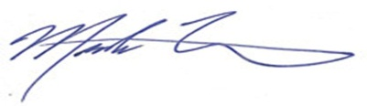
Mark P. Trinchero
Attorneys for T-Mobile West LLC
MPT/jan
Enclosures

