WN U-16  VERIZON NORTHWEST INC.  2nd Revised Sheet 450  Canceling  1st Revised Sheet 450  FACILITIES FOR INTRASTATE ACCESS  5. SPECIAL ACCESS (Cont'd)  5.7 Rates and Charges (Cont'd)  5.7.5 Voiceband Facilities  Nonrecurring Monthly  (A) Standard Arrangements Charges Rate_  Special Transport,  per airline mile* -- $5.56  (1LFSX) (1LF2X, 1LF2XMP) (1LF2X-L)  Special Access Line  Two-Wire 27.30  (EUC2X, 1XC2X, X2W) (EUC2X-L)  Four -Wire -- 36.30  (EUC4X, 1XC4X, X4W) (EUC4X-L)  * Rate also applicable for Intraexchange Interoffice mileage.  Advice No. 3125  Issued: July 23, 2004 Effective: August 22, 2004  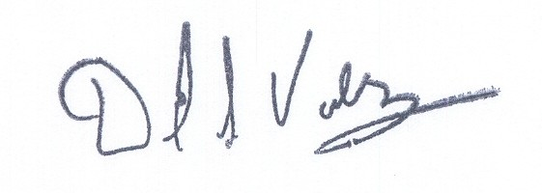  Issued by Verizon Northwest Inc.  By David S. Valdez, Vice President-Public Policy and External Affairs | (I)  (I)  (I)

WN U-16  VERIZON NORTHWEST INC.  3rd Revised Sheet 458  Canceling  2nd Revised Sheet 458  FACILITIES FOR INTRASTATE ACCESS  5. SPECIAL ACCESS (Cont'd)  5.7 Rates and Charges (Cont'd)  5.7.10 High Capacity Digital DS1 (1.544 Mbps) Facilities  Nonrecurring Monthly  (A) Standard Arrangements Charges Rate_  Special Access Line  First System $320.00 $187.50  (EUW, 1XCDX) (NEUW, EUW)  (NEUW-L, EUW-L)  Each Additional System 320.00 178.13  (EU8, 1XCAX, EU4EX, 1CKEX)  (NEU8, EU8) (NEU8-L, EU8-L)  Special Transport Termination -- 75.00  (TRG) (TRGDS1) (TRGDS1-L)  Special Transport, per airline mile¹ -- 11.00  (1LFSX) (1LFDS1, 1LFDS1MP) (1LFDS1-L)  ¹ Rate also applicable for Intraexchange Interoffice mileage.  Advice No. 3125  Issued: July 23, 2004 Effective: August 22, 2004  Issued by Verizon Northwest Inc.  By David S. Valdez, Vice President-Public Policy and External Affairs | (I)  (I)

WN U-16  VERIZON NORTHWEST INC.  3rd Revised Sheet 470  Canceling  2nd Revised Sheet 470  FACILITIES FOR INTRASTATE ACCESS  5. SPECIAL ACCESS (Cont'd)  5.7 Rates and Charges (Cont'd)  5.7.20 Digital Data Service Facilities  Nonrecurring Monthly  Charges Rate_  (A) Standard Arrangements  Special Transport - All Speeds,  per airline mile* -- $5.56  (1LFSX) (1LFDD, 1LFDDMP) (1LFDD-L)  Special Access Line - All Speeds  Month-to-month -- 114.43  (EUCXX, LCH) (EUCXX-L)  (B) Optional Arrangements  Supplemental Features, per Port  DDS Bridging -- 4.70  (BCNDA) (BCNDA-L)  * Rate also applicable for Intraexchange Interoffice mileage.  Advice No. 3125  Issued: July 23, 2004 Effective: August 22, 2004  Issued by Verizon Northwest Inc.  By David S. Valdez, Vice President-Public Policy and External Affairs | (I)  (I)

