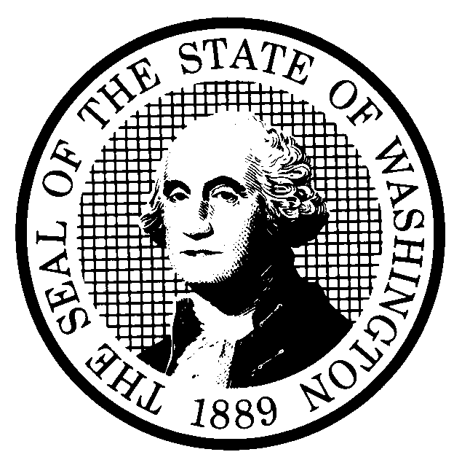 | PREPROPOSAL STATEMENT OF INQUIRY |  | CR-101 (June 2004)  (Implements RCW 34.05.310)  Do NOT use for expedited rule making
Agency: Washington Utilities and Transportation Commission

Subject of possible rule making: Examine the need to reorganize, revise, repeal, and adopt rules governing the conduct of business before the Commission, including rules governing formal proceedings as presently codified in chapter 480-07 WAC – Procedural Rules.

Docket No. A-050802
Statutes authorizing the agency to adopt rules on this subject: RCW 80.01.040(4) and RCW 34.05.020
Reasons why rules on this subject may be needed and what they might accomplish: The Commission repealed and replaced its former procedural rules, chapter 480-09, on January 1, 2004, and adopted new chapter 480-07—Procedural Rules to be effective on that same date. Since the new rules became effective, Commission staff and persons who conduct business before the Commission have identified and suggested discrete changes to certain rules and the possible need for new rules that could ease compliance and promote efficiency in the conduct of business before the Commission.
Identify other federal and state agencies that regulate this subject and the process coordinating the rule with these agencies:

N/A
Process for developing new rule (check all that apply):
Negotiated rule making
Pilot rule making
Agency study
Other (describe) The Commission will schedule one or more workshops with representatives of affected constituencies in a manner designed to develop consensus among affected interests regarding any rule proposal. The Commission will ask for initial written comments by August 26, 2005, and may provide the opportunity for additional comments, if needed.
How interested parties can participate in the decision to adopt the new rule and formulation of the proposed rule before publication:
(List names, addresses, telephone, fax numbers, and e-mail of persons to contact; describe meetings, other exchanges of information, etc.)
Interested persons may contact the Secretary, Washington Utilities and Transportation Commission, P.O. Box 47250,
1300 S. Evergreen Park Drive, S.W., Olympia, Washington, 98504-7250; Telephone (360) 664-1174;
Facsimile (360) 586-1150

For specific information regarding opportunities for written comment, opportunities for participation in workshops, and to ensure receipt of further information concerning this rulemaking, please see the attachment to this form.

DATE  July 15, 2005 |  | CODE REVISER USE ONLY
NAME (TYPE OR PRINT)  Carole J. Washburn |  | Filed with the Code Reviser’s Office  July 15, 2005, 11:31 a.m.  WSR 05-15-091
SIGNATURE
TITLE
Executive Secretary

