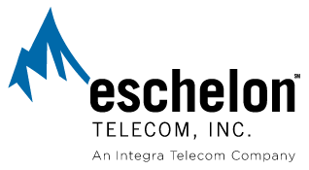
April 25, 2008

Via email and Federal Express Overnight Mail
records@wutc.wa.gov

Ms. Carole J. Washburn
Executive Secretary
Washington Utilities and Transportation Commission
1300 S. Evergreen Park Drive SW
P. O. Box 47250
Olympia, WA 98504-7250

RE: In the Matter of the Petition of Qwest Corporation for Commission Approval of Stipulation Regarding Certain Performance Indicator Definitions and Qwest Performance Assurance Plan Provisions
Docket No. UT-073034

Dear Ms. Washburn:

Enclosed for filing are an original and five copies of the Reply Comments of Eschelon Telecom of Washington, Inc. on Disputed Issues in the above-referenced matter. I have also enclosed a Certificate of Service.

Sincerely,

Tobe L. Goldberg
Legal & Regulatory Administrator
Eschelon Telecom, Inc., an Integra Telecom
Company
612.436.6084 (Direct)
612.436.6816 (Department fax)
tlgoldberg@eschelon.com

cc: See Attached Certificate of Service

