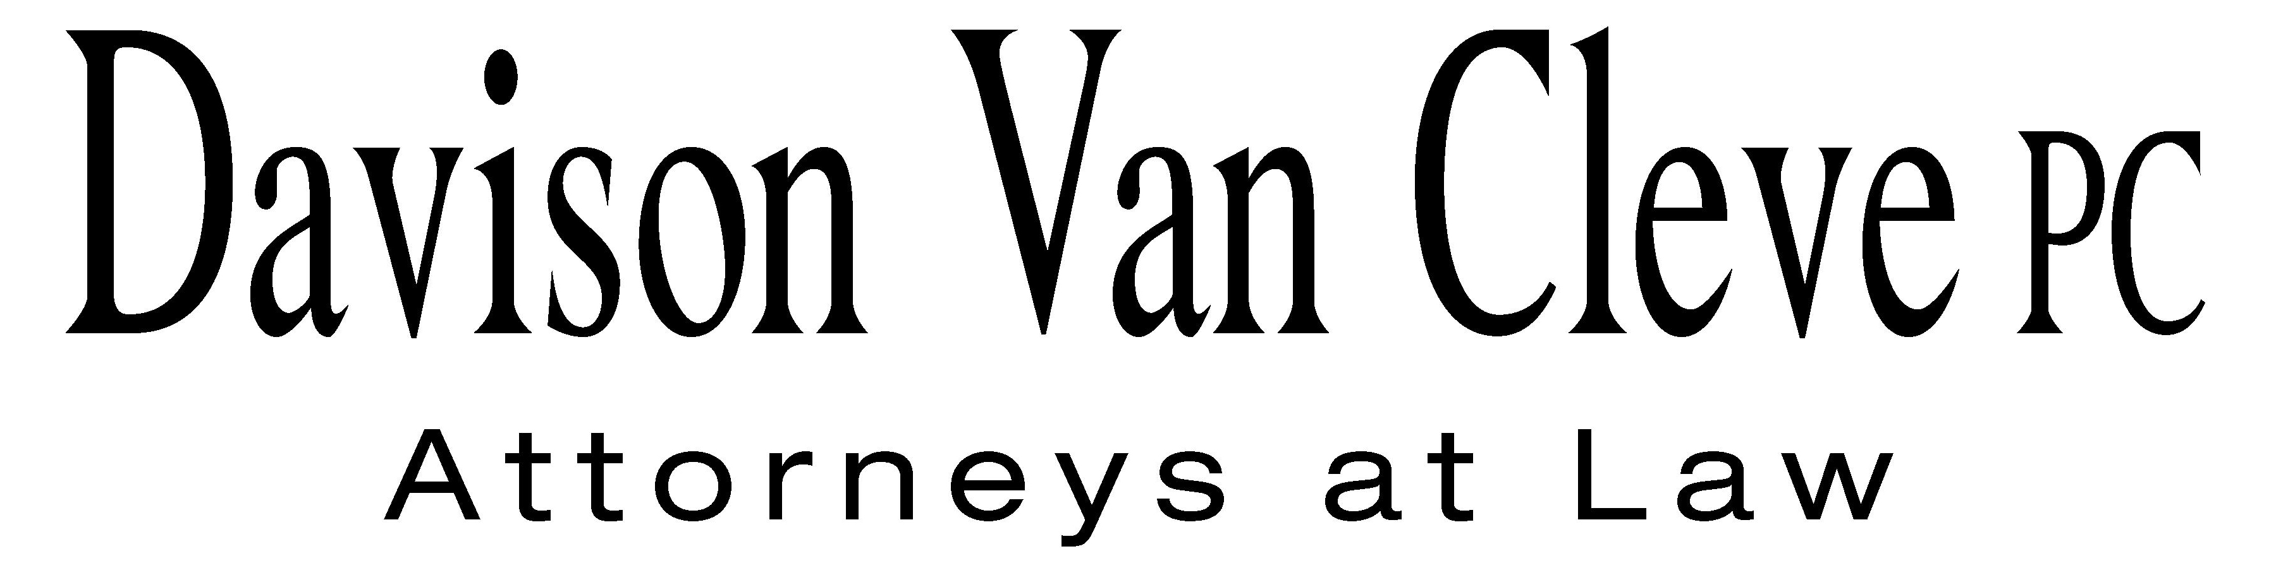
TEL (503) 241-7242 ● FAX (503) 241-8160 ● mail@dvclaw.com
Suite 400
333 SW Taylor
Portland, OR 97204

April 4, 2013

Via Email and Federal Express

Mr. Steven V. King
Acting Executive Director
Washington Utilities & Transportation Commission
1300 S. Evergreen Pk. Dr. S.W.
P. O. Box 47250
Olympia, WA 98504-7250

Re: In the Matter of PUGET SOUND ENERGY, INC. Expedited Rate Filing
WN V-60, Tariff G, Electric Service, Advice No. 2013-01
Docket No. UE-130137/UG-130138

Dear Mr. King:

Enclosed please find an original and sixteen (16) copies of the Response to Public Counsel Objection to Order 02 Schedule of the Industrial Customers of Northwest Utilities.

Thank you for your assistance.

Sincerely yours,

/s/ Jesse Gorsuch
Jesse Gorsuch
Enclosures

cc: Service List

CERTIFICATE OF SERVICE

I hereby certify that I have this day served the foregoing Response to Public Counsel Objection to Order 02 Schedule upon all parties of record in this proceeding by mailing a copy thereof in a sealed, first-class postage prepaid envelope to each individual’s last-known address, as listed below.
DATED this 4th day of April, 2013.
Davison Van Cleve, P.C.

/s/ Jesse Gorsuch
Jesse Gorsuch

PUGET SOUND ENERGY  KEN JOHNSON  PO BOX 97034 PSE-08N  BELLEVUE WA 98009-9734  ken.s.johnson@pse.com | PERKINS COIE  SHEREE CARSON  10885 N.E. FOURTH STREET STE 700 BELLEVUE WA 98004-5579  scarson@perkinscoie.com
SALLY BROWN  Assistant Attorney General  WUTC  PO Box 40128  Olympia, WA 98504-0128 | MICHAEL DEEN  REGULATORY & COGENERATION SERVICES, INC.  900 Washington St. STE 780  Vancouver, WA 98660
SIMON FFITCH  Office of the Attorney General  800 Fifth Avenue STE 2000  Seattle, WA 98104-3188 | Ronald L Roseman  Attorney At Law  2011 - 14th Avenue East  Seattle, WA 98112
Chad M Stokes  Attorney  Cable Huston Benedick Haagensen & Lloyd, LLP  1001 SW 5th Avenue STE 2000  Portland, OR 97204 | Nucor Steel Seattle, Inc.  Nucor Steel  2424 SW Andover  Seattle, WA 98106-1100
Damon E Xenopoulos,  Brickfield, Burchette, Ritts & Stone, P.C.  1025 Thomas Jefferson Street NW; Eighth Floor-West Tower  Washington, DC 20007 | John Carr  Industrial Customers of Northwest Utilities  818 SW 3rd Avenue # 266  Portland, OR 97204
Ed Finklea  Executive Director  NORTHWEST INDUSTRIAL GAS USERS  326 Fifth Street  Lake Oswego, OR 97034 | Norman Furuta  Associate Counsel  Department of the Navy  1455 Market Street STE 1744  San Francisco, CA 94103-1399
Charles M Eberdt
Manager
The Energy Project
3406 Redwood Ave
Bellingham, WA 98225

