BEFORE THE WASHINGTON STATE
UTILITIES AND TRANSPORTATION COMMISSION

In the Matter of the Joint Application of  QWEST COMMUNICATIONS INTERNATIONAL INC. AND CENTURYTEL, INC.  For Approval of Indirect Transfer of Control of Qwest Corporation, Qwest Communications Company LLC, and Qwest LD Corp.  . . . . . . . . . . . . . . . . . . . . . . . . . . . . . . . . | )  )  )  )  )  )  )  )  )  ) | DOCKET UT-100820  JOINT APPLICANTS’ OBJECTION TO, AND REQUEST FOR REVIEW OF, THE SCHEDULE ESTABLISHED IN PREHEARING CONFERENCE ORDER 02

- On May 13, 2010, Qwest Communications International Inc. (QCII) and CenturyTel, Inc. (CenturyLink) (collectively, “Joint Applicants”) filed a joint application for expedited approval with the Washington Utilities and Transportation Commission (Commission) of the indirect transfer of control of QCII’s operating subsidiaries, Qwest Corporation (Qwest Corp.), Qwest LD Corp. (QLDC) and Qwest Communications Company LLC (QCC) (collectively “Qwest”) to CenturyLink.
- The Commission convened a prehearing conference in this proceeding at Olympia, Washington on June 1, 2010. Thereafter, the Administrative Law Judge entered Order 02, establishing the procedural schedule. Pursuant to the statement in that Order, a party who objects to any portion of the Order must file a written objection within ten (10) calendar days after the service date of the Order, pursuant to WAC 480-07-430 and WAC 480-07-810. The service date of the Order was June 10, 2010, and this objection is therefore timely filed on June 21, 2010, as the tenth calendar day fell on a weekend.
- Order 02 determined that the procedural schedule proposed by the Joint Applicants was too compressed for the level of complexity involved in this matter. Likewise, Order 02 stated that the longer timeframe requested by Staff and other parties was unreasonable. Thus, in an effort to balance the needs of the parties to conduct discovery and formulate arguments and the need to efficiently resolve this docket, Order 02 adopted a procedural schedule slightly shorter than that requested by Staff, but considerably expanded from that proposed by Joint Applicants.
- Joint Applicants respectfully ask the Commission to review Order 02, and revise the procedural schedule in order to allow the docket to conclude this year. Absent Commission review, Joint Applicants will be prejudiced by a procedural schedule that is far too lengthy, and such prejudice cannot be cured by post-hearing review. As such, Joint Applicants state a basis for interlocutory review under WAC 480-07-810. Further, WAC 480-07-430 allows a request for review as a matter of right. In support of this request, Joint Applicants present the following information and argument.
- First, four other states have established schedules that allow the case to wrap up this year, including Minnesota, Oregon, Utah, and Pennsylvania. Indeed, the transaction has already cleared the regulatory review process in California and Hawaii.
- Second, the schedule established in this case is not consistent with schedules established in either CenturyTel/Embarq (UT-082119), or in Verizon/Frontier (UT-090842). A comparison of Joint Applicants’ originally requested schedule with the intervals in the two prior merger cases was filed on June 1, 2010, prior to the prehearing conference. That comparison shows that the schedule adopted in Order 02 is far more extended than in either of the other two cases, with no showing that the issues in this case are more complex or time-consuming to address. Once the schedule is established in any case, there is always the possibility that it can be extended for cause, but in no case does the schedule become more compressed than originally set. Thus, Joint Applicants have no way to accelerate the proceeding under the current schedule.
- Third, Joint Applicants have a revised proposal that they believe will not prejudice other parties, and that would allow a more expeditious hearing. Joint Applicants propose that the Commission modify the date on which Joint Applicants file their rebuttal testimony, and move that date from November 1, 2010 under the current schedule to October 15, 2010. Joint Applicants further propose that the hearings be moved from January 5-7, 2011 to November 10-12, 2010. This proposal preserves the stated desire of the other parties to have time for discovery and preparation, as no change is proposed to their September 27, 2010 testimony deadline.
- For these reasons, Joint Applicants ask the Commission to reevaluate and revise the schedule as set forth herein.

Respectfully submitted this 21st day of June, 2010
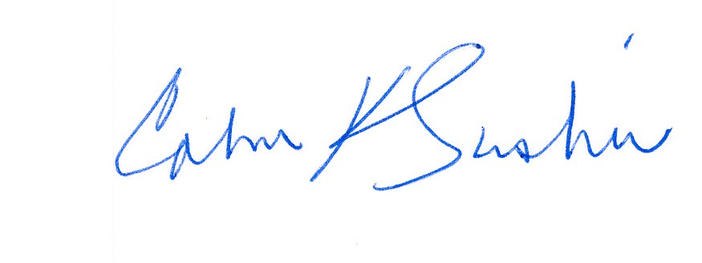
________________________ _________________________
Calvin K. Simshaw Lisa A. Anderl (WSBA# 13236)
CenturyLink Qwest Law Department
805 Broadway 1600 – 7th Ave., room 1506
Vancouver, WA 98660 Seattle, WA 98191
calvin.simshaw@centurylink.com lisa.anderl@qwest.com

