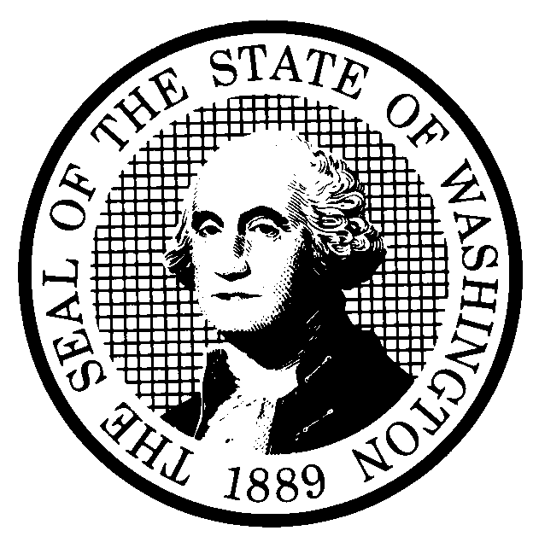 | PROPOSED RULE MAKING |  |  |  |  | CR-102 (June 2004)  (Implements RCW 34.05.320)  Do NOT use for expedited rule making
Agency: Washington Utilities and Transportation Commission
X Preproposal Statement of Inquiry was filed as WSR 01-17-048 ; or  Expedited Rule Making--Proposed notice was filed as WSR ; or  Proposal is exempt under RCW 34.05.310(4). |  |  |  |  |  |  | Original Notice  X Supplemental Notice to WSR 04-15-141  Continuance of WSR
Title of rule and other identifying information: Chapter 480-93 WAC, Gas Companies-Safety, WUTC Docket No. UG-011073

Hearing location(s):  Commission Hearing Room 206  2nd Floor, Chandler Plaza Building  1300 So. Evergreen Park Dr. SW  Olympia, WA 98504-7250 |  |  |  | Submit written comments to:  Name: Carole J. Washburn, Executive Secretary  Address: P.O. Box 47250, Olympia, WA 98504-7250 or  e-mail records@wutc.wa.gov  fax (360) 586-1150 by (date) January 28, 2005  Please include Docket No. UG-011073 in your communication.
Date of Hearing: March 16, 2005 at 9:30 a.m. |  |  |  | Assistance for persons with disabilities:  Contact Mary DeYoung  by Tuesday, March 15, 2005  TDD (360) 586-8203 or (360) 664-1133
Date of intended adoption: March 16, 2005 Time: 9:30 a.m.
(Note: This is NOT the effective date)
Purpose of the proposal and its anticipated effects, including any changes in existing rules:

The primary purpose of the Supplemental CR-102 is to clarify the intent of the proposed effective dates in WAC 480-93-100(5) and WAC 480-93-188(3) and to change the definition of “Business District.” Comments received from stakeholders after the proposed rules were published on June 30, 2004, indicate that language concerning the effective dates of these two rules was not clear. In addition, the Supplemental CR-102 provides minor clarifying changes to various rules in chapter 480-93 WAC. A more detailed description of the substantive changes to the proposed rules is set forth in Attachment A to this form.

Reasons supporting proposal: The proposed rules are necessary and reasonable to ensure the safety of gas pipeline operations and to promote safety for the citizens of Washington state from the hazards of gas pipeline operations. In addition, a review of the existing rules and the Commission’s experience in inspecting pipeline facilities in the state has shown a need for clarification of rules, consistency in practices among companies, and definition of terms used in federal and state rules. Some of the proposed rules apply more stringent requirements than existing federal rules to address concerns the Commission has identified in its experience in inspecting pipeline facilities.

Statutory authority for adoption: RCW 80.01.040, RCW 80.04.160, and RCW 80.28.210. |  |  |  | Statute being implemented: N/A
Is rule necessary because of a:  Federal Law?  Federal Court Decision?  State Court Decision?  If yes, CITATION: |  | Yes  Yes  Yes | X No  X No  X No  X No |  | CODE REVISER USE ONLY  Filed with the Code Reviser’s Office  January 5, 2005, 11:08 a.m.  WSR 05-02-096
DATE
January 5, 2005
NAME (type or print)
Carole J. Washburn
SIGNATURE

TITLE
Executive Secretary
(COMPLETE REVERSE SIDE)
Agency comments or recommendations, if any, as to statutory language, implementation, enforcement, and fiscal matters:
None

Name of proponent: Washington Utilities and Transportation Commission |  |  | Private  Public  X Governmental
Name of agency personnel responsible for:
 | Name | Office Location | Phone
Drafting..............Sondra Walsh, Senior Policy Strategist |  | 1300 S. Evergreen Park Drive SW, Olympia, WA 98504 | (360) 664-1286
Implementation..Carole J. Washburn, Executive Secretary, |  | 1300 S. Evergreen Park Drive SW, Olympia, WA 98504 | (360) 664-1174
Enforcement......Carole J. Washburn, Executive Secretary, |  | 1300 S. Evergreen Park Drive SW, Olympia, WA 98504 | (360) 664-1174
Has a small business economic impact statement been prepared under chapter 19.85 RCW?
X Yes. A copy of the SBEIS was attached as Attachment B to the CR-102 filed as WSR # 04-15-141. No changes contained in the proposal in this Supplemental CR-102 would alter the result of the earlier SBEIS.

A copy of the statement may be obtained by contacting:
Name: Washington Utilities and Transportation Commission
Address: Records Center, Docket No. UG-011073
1300 S. Evergreen Park Dr. S.W.
P.O. Box 47250
Olympia, WA 98504-7250
phone (360) 664-1286
fax (360) 664-1150
e-mail swalsh@wutc.wa.gov
No. Explain why no statement was prepared.

Is a cost-benefit analysis required under RCW 34.05.328?

Yes A preliminary cost-benefit analysis may be obtained by contacting:
Name:
Address:

phone ( )
fax ( )
e-mail

X No: Please explain: The Commission is not any agency to which RCW 34.05.328 applies.

ATTACHMENT A TO SUPPLEMENTAL CR-102
WUTC Rulemaking Docket No. UG-011073

NOTE: This attachment summarizes, by rule, the substantive changes now being proposed to the proposed rules in chapter 480-93 WAC that were published at WSR # 04-15-141:

WAC 480-93-005: The supplemental proposal would modify the proposed rule by changing the definition of the term “Business District” and changes the term “Building of Public Assembly” to “High Occupancy Structure or Area.”
WAC 480-93-015: Clarifies the language pertaining to calibration of instruments used for leak surveying.
WAC 480-93-020: Section (1)(a)(ii) and section (1)(b)(ii) are redrafted to reflect the change in definition from “Building of Public Assembly” to “High Occupancy Structure or Area” and rewritten for clarity.
WAC 480-93-080: Section (2)(c) is redrafted to clarify the tracking of production fuses.
WAC 480-93-100: Section (5) is modified to clarify the intent to require compliance with the rule after a one-year phase-in period.
WAC 480-93-110: Section (1) of the original proposal is duplicative of requirements in CFR 49 Part 192, and has been deleted. The Commission has determined that the provisions of Section (7) of the original proposal are no longer necessary and the section has also been deleted.
WAC 480-93-160: Clarifies that certain reports must be filed with the Commission.
WAC 480-93-188: Section (7) is modified to clarify the intent to require compliance with the rule after a two-year phase-in period.

