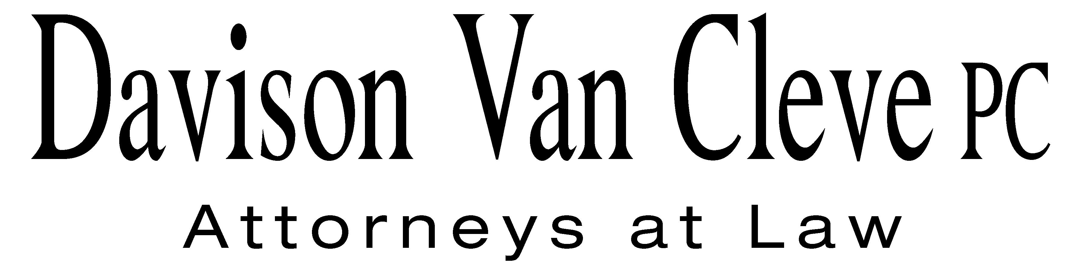
TEL (503) 241-7242 ● FAX (503) 241-8160 ● mail@dvclaw.com
Suite 400
333 S.W. Taylor
Portland, OR 97204

February 16, 2006

Via Federal Express and Electronic Mail

Carole J. Washburn
Secretary
Washington Utilities & Transportation Commission
1300 S. Evergreen Park Drive S.W.
Olympia, WA 98504

Re: In the Matter of WUTC v. Avista Corp.

Consolidated Docket Nos. UE-060181

Dear Ms. Washburn:

Enclosed please find the original Petition to Intervene on behalf of the Industrial Customers of Northwest Utilities in the above-referenced matter.
Electronic copies were emailed to the Records Center today, February 16, 2006. Please call me at (503) 241-7242 if you have any questions. Please return one file-stamped copy of each document in the self-addressed, stamped envelope provided. Thank you for your assistance.
Sincerely yours,

/s/ Anna E. Studenny
Anna E. Studenny

Enclosures
cc: Service List
CERTIFICATE OF SERVICE

I hereby certify that I have this day served a copy of the foregoing Petition to Intervene on behalf of the Industrial Customers of Northwest Utilities upon the parties, shown below, listed on the official service lists in docket No. UE-060181, by causing the same to be mailed, postage-prepaid, through the U.S. Mail.
DATED at Portland, Oregon, this 16th day of February, 2006.
Davison Van Cleve, P.C.

/s/ Anna E. Studenny
Anna E. Studenny

Kelly Norwood  David Meyer  Avista Corporation  PO Box 3727  Spokane, WA 99220 | Simon ffitch  Office of the Attorney General  Public Counsel Section  900 4th Avenue, Suite 2000  Seattle, WA 98164
Greg J. Trautman  Washington Utilities & Trans. Comm'n  1400 S. Evergreen Park Drive S.W.  PO Box 40128  Olympia, WA 98504 | Alan Buckley  Washington Utilities & Trans. Comm'n  1400 S. Evergreen Park Drive S.W.  PO Box 40250  Olympia, WA 98504
Mike Parvinen
Washington Utilities & Trans. Comm'n
1400 S. Evergreen Park Drive S.W.
Olympia, WA 98504

