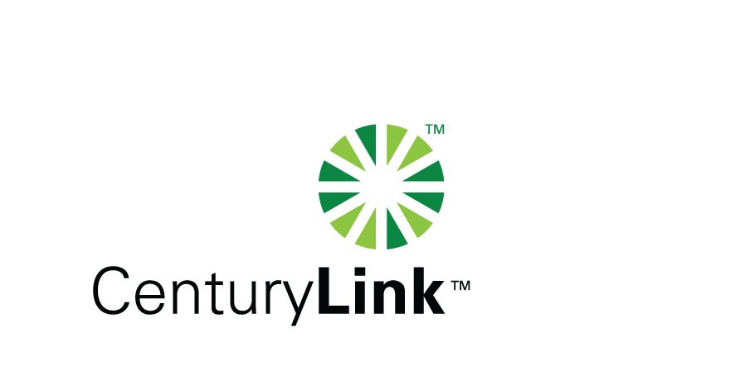

September 20, 2012

David Danner, Executive Director & Secretary
Washington Utilities & Transportation Commission
1300 S Evergreen Park Drive, SW
Olympia, Washington 98504-7250

Re: CenturyTel d/b/a CenturyLink’s August 2012 Service Quality report

Dear Mr. Danner:

Attached is the August 2012 Service Quality Report for CenturyTel d/b/a CenturyLink, in confidential and redacted versions.

The trouble reports per 100 access lines objective was met for the month of August in all exchanges.

Should you have any questions, please contact Mark Reynolds at (206) 345-1568 or by e-mail at mark.reynolds3@centurylink.com.

Sincerely,

Mark Reynolds

Enclosures: Installation/Repair Appointments
Service Activation in 5 Days
Trouble Per 100/Access Lines
Switching – Dial Tone Speed in 3 Seconds
Final Trunk Blockage (EAS and Toll)
Out of Service Trouble Cleared in 48 Hours
Not Out of Service Trouble Cleared in 72 Hours
Service Activation Delay 90-180 Days

