EXHIBIT NO. ___(MLJ-4)
DOCKET NO. UE-09___/UG-09___
2009 PSE GENERAL RATE CASE
WITNESS: MICHAEL L. JONES

BEFORE THE
WASHINGTON UTILITIES AND TRANSPORTATION COMMISSION

WASHINGTON UTILITIES AND  TRANSPORTATION COMMISSION,  Complainant,  v.  PUGET SOUND ENERGY, INC.,  Respondent. |  | Docket No. UE-09____  Docket No. UG-09____

THIRD EXHIBIT (NONCONFIDENTIAL) TO THE
PREFILED DIRECT TESTIMONY OF
MICHAEL L. JONES
ON BEHALF OF PUGET SOUND ENERGY, INC.

MAY 8, 2009

BACKGROUND OF SETTLEMENT OF CLAIMS

DUANE and CAROL ANKNEY et al. v. PPL MONTANA LLC et al.

I. INTRODUCTION

A. The Colstrip Steam Electrical Station
The Colstrip Steam Electrical Station (CSES), a photograph of which is attached as Exhibit A, is located in Colstrip, Montana (pop. 2,346), approximately 124 miles east of Billings, Montana. It consists of 4 plant units, with related facilities: Units 1 & 2, rated at 307 net megawatts each; and Units 3 & 4, rated at 740 net megawatts each. Units 1 & 2 were constructed in the 1970's by Montana Power Corporation (MPC) and Puget Sound Power & Light, n/k/a Puget Sound Energy (PSE). Approximately 4 years later, MPC, PSE, The Washington Water Power Company, n/k/a Avista Corporation (Avista), PacifiCorp and Portland General Electric (PGE) applied to the State of Montana to build Units 3 & 4. PSE is an owner of 50% of Colstrip Units 1 & 2, which were placed into service in 1975 and 1976 respectively servicing the needs of its electric customers. PSE's share of the net capacity of these two electric generating projects is 307 MW. PSE is an owner of 25% of Colstrip Units 3 & 4, which were placed into service in 1984 and 1986 respectively. PSE's share of the net capacity of these two electric generating projects is 370 MW. Together, this important source of low cost energy supplied approximately 22% of the electric energy used by PSE's electric customers in calendar year 2007. PSE's most recent power cost only rate case supported a per kWh cost of $.02907 for Colstrip Units 1, 2, 3 & 4.
The CSES is maintained and operated pursuant to two Ownership and Operation Agreements, the first governing Units 1 & 2 and the second governing Units 3 & 4. Under both Agreements, the owners of the Units are entitled to receive generated electricity, and are responsible for associated operation and maintenance costs, in proportion to their respective ownership interests. With respect to day-to-day operations, the CSES is maintained and operated by a single owner, originally MPC. The non-operating owners are provided reports and hold periodic meetings concerning the facility, but do not play a role in day-to-day operations.
In 1999, MPC's interests in Units 1, 2 & 3 were sold to a subsidiary of Pennsylvania Power & Light, now known as PPL Montana, LLC (PPL). At that time, PPL assumed the role of operating owner.

B. The Geography of the CSES
The site of the CSES, including Units 1 & 2 and Units 3 & 4, is located to the immediate southeast of the original Colstrip town site. Also southeast of the town, and to the southwest of the principal site of the CSES, are two fly ash ponds, generally referred to as Ponds A & B.
To the northwest of the Colstrip town site is Castle Rock Lake, otherwise referred to as the Surge Pond. The lake is man-made, and is maintained as part of the CSES. It also provides the primary source of the city's drinking water.
To the north of Castle Rock Lake are the Stage I and Stage II fly ash ponds. These ponds contain fly ash slurry from scrubbers on Units 1 & 2 and, under extenuating circumstances, from Units 3 & 4. The slurry is transferred from the Units to the ponds via a pipeline. Upon arrival, the slurry moves through several pond cells, where the ash settles out of the water. The clean water then moves to the clear well of the pond, where it is pumped back to the plant and reused.
A satellite view of Colstrip, including references to pertinent CSES facilities and areas involved in the Ankney Litigation, is attached as Exhibit B.

II. NATURE OF THE LAWSUIT
There are three types of claims at issue in the Ankney litigation: differential settlement claims, contamination claims, and emotional distress claims.

A. Differential Settlement Claims
The majority of the Plaintiffs (37 of the 55) allege cosmetic and/or structural damage to their homes and buildings due to seepage from Castle Rock Lake. These Plaintiffs contend that fresh water, originating from the Yellowstone River and stored in Castle Rock Lake, has caused the soil to settle under their homes and commercial structures. Plaintiffs also allege that this soil settlement is not uniform (which would result in limited damage to a building or structure), but rather is differential, or uneven, through the footprint of their respective structures. Although the damage from differential settlement is typically cosmetic, it can impair the structural integrity of a home or building. In addition, some Plaintiffs claim to have mold damage related to differential settlement, although none claim to have suffered adverse health affects.
Differential settlement claims have a long history in Colstrip. Since 1976, numerous claims of differential settlement stemming from Castle Rock Lake and the CSES have been made by Colstrip residents. In some instances, the Plaintiffs in the Ankney litigation have presented second generation differential settlement claims, seeking damages for new or additional damage to structures for which claims were previously asserted and resolved.

B. Contamination Claims
The second type of claim is for trespass and/or potential well contamination due to water seeping from the process ponds, principally the Stage I & II fly ash ponds. These claims are principally focused in the B&R and Seward subdivisions, located north of the original township site and approximately 1400 feet to the east of the Stage II pond, although some claims pertaining to the A & B ponds and other Unit 3 & 4 process ponds have also been asserted. Plaintiffs allege that the Stage I and II ponds, as well as the A & B ponds and other Unit 3 & 4 ponds, were negligently built, allowing contaminated water to seep into the groundwater and impact Plaintiffs' wells and property. Plaintiffs seek emotional distress damages for the fear that their wells could have been contaminated, but they do not claim to have been exposed to contamination or otherwise suffered physical harm. Rather, the Plaintiffs seek damages for contamination of the groundwater, and point to the fact that (a) the Stage I pond was unlined; and (b) alternative designs were available with respect to the Stage II pond that would not have involved the storage of fly ash slurry in ponds. Plaintiffs further allege that Defendants were aware of seepage from the ponds and of the potential impact to Plaintiffs' property, but did not act to correct the problem or protect the Plaintiffs' property from damage. Plaintiffs also alleged that Defendants failed to adequately notify them that seepage had gotten on to Plaintiffs’ property and threatened Plaintiffs wells.

C. Emotional Distress Claims
The final type of claim, which is secondary to the first two claim types, is for emotional distress damages due to fear of contamination of the City of Colstrip's drinking water. Under this theory, Plaintiffs allege that seepage from the Stage I fly ash pond has contaminated and will continue to contaminate Castle Rock Lake, which supplies the City's drinking water, and that rumors of such contamination caused residents to suffer emotional distress damages.

III. POTENTIAL EXPOSURE
Plaintiffs sought a wide range of damages, both compensatory and punitive in nature. With respect to claims of groundwater contamination, Plaintiffs sought remediation damages (abatement) of between $43 and $90 million, together with $4 million to remediate the Surge Pond, a/k/a Castle Rock Lake, and $12 million for costs associated with remediation of the CSES plant site. In addition, Plaintiffs sought unjust enrichment damages, measured by the cost savings to Defendants of using storage ponds for disposal of fly ash in lieu of alternative dry ash disposal methods, in the range of approximately $95 million. Finally, Plaintiffs sought unspecified damages for trespass, unlawful occupation of land, and emotional distress due to the fear of contamination, as well as between $15,000 and $37,500 per parcel of property for the diminution in value of Plaintiffs' lands for a total up to $4 million. Taken together, Plaintiffs damage claims related to groundwater contamination are estimated to be in excess of $205 million.
With respect to differential settlement claims, Plaintiffs sought damages for the cost of repairing cosmetic and structural damages to their home in excess of $2.8 million. In addition, Plaintiffs sought unspecified emotional distress damages. Taken together, Plaintiffs sought differential settlement claims estimated to be in excess of $3 million.
Finally, Plaintiffs sought punitive damages somewhere in the range of $5 million per Defendant, or $25-30 million total, and possibly more.
Given these claims, Plaintiffs total claim for compensatory damages is estimated to be in excess of $208 million. Assuming that PSE would be found jointly and severally liable for compensatory damages in an amount reflective of its proportionate ownership share, PSE's potential exposure for such damages is estimated to be in excess of $116 million. In addition, assuming that PSE would also be found liable for punitive damages of at least $5 million, its total potential exposure in the Litigation is estimated to be well in excess of $121 million.
IV. LITIGATION SUMMARY
Defendants have presented a joint defense to Plaintiffs' claims, and are, with the exception of PGE, mutually represented by the Billings, Montana law firm of Crowley, Haughey, Hanson Toole & Dietrich, PLLP. The lawsuit was originally filed in May of 2003 in Silverbow County, but was subsequently moved to the Montana Sixteenth Judicial District Court, Rosebud County, where it has been presided over by Judge Joe L. Hegel. Trial of the case was scheduled to begin in June of 2008.
In defense of the case, between 2006 and October 2007, Defendants filed several Motions seeking summary judgment and other relief on various issues. These included motions to:
(1) Dismiss Plaintiffs' claims for remediation costs in light of the Montana Supreme Court's decision in Sunburst School Dist. No. 2 v. Texaco, 338 Mont. 259, 165 P.3d 1079 (2007);

(2) Dismiss Plaintiffs' assertion of tort-based claims based on Article II, Section III of the Montana Constitution, which provides that all persons have a "right to a clean and healthful environment," in light of the Montana Supreme Court's decision in Sunburst;

(3) Allow evidence of negotiations between the Defendants and the Montana Department of Environmental Quality (DEQ) regarding remediation of the site;

(4) Preclude Plaintiffs from seeking attorneys' fees based on the private attorney general doctrine;

(5) Bifurcate trial proceedings between differential settlement and groundwater contamination claims;

(6) Dismiss any claims for abatement on the grounds that DEQ has exclusive jurisdiction over such issues;

(7) Preclude claims of differential settlement to the extent that the damage claimed occurred more than three years prior to commencement of the lawsuit and is, therefore, barred by the statute of limitations;

(8) Dismiss the claims of groundwater contamination of Plaintiffs who previously settled their claims with the Defendants;

(9) Dismiss Plaintiffs' claims for emotional distress damages;

(10) Dismiss Plaintiffs' claim that they are entitled, on a theory of unjust enrichment, to all money allegedly saved by the Defendants by using the Stage II pond for slurry storage rather than the alternative of dry ash disposal; and

(11) Dismiss the claims of differential settlement claimants who have previously entered into settlements and releases with the Defendants.

In addition, on February 15, 2008, Plaintiffs submitted supplemental expert disclosures which, among other things, supported new remediation claims raising the total abatement amount sought by Plaintiffs from $12 million to $106 million and named new expert witnesses. In response Defendants filed a motion to strike these disclosures.

With trial approaching, the court issued orders on some, but not all, of these outstanding motions. On February 22, 2008, the court determined that Plaintiffs could maintain claims for abatement, despite DEQ's jurisdiction to address and resolve such issues. Likewise, on April 11, 2008, the court denied Defendants' request to dismiss Plaintiffs' claims for unjust enrichment, and determined that Plaintiffs would be allowed to seek damages measured by, among other things, the cost savings to Defendants of using fly ash ponds rather than alternative dry ash disposal systems. Although other motions remained pending before the court, the cumulative effect of these and other rulings, and the trend evidenced thereby, is that Plaintiffs would be allowed to argue most, if not all, of the theories they had advanced for recovery, and to seek the full extent of damages claimed, including claims for unjust enrichment, abatement, remediation costs and punitive damages. As such, the impact of these decisions on Defendants' potential exposure in the litigation was significant, and was a material factor leading to Defendants' decision to settle Plaintiffs' claims prior to trial.

V. TERMS OF SETTLEMENT
On April 25, 2008, the Defendants jointly offered to settle all claims in the Ankney litigation under the terms and conditions outlined below. This offer was subsequently accepted by all Plaintiffs, and the parties reduced the settlement terms into a formal settlement agreement June 2008.

1. Compensation of Plaintiffs and Allocation among Defendants
For purposes of settlement, Avista, PSE, PPL, PacifiCorp, and PGE have agreed to pay the Plaintiffs the total sum of $25 million, which will be divided among the Plaintiffs or placed in trust for other purposes as the Plaintiffs deem appropriate. This amount reflected the bottom-line settlement figure that Plaintiffs were willing to accept to resolve their claims prior to trial.
As among the respective Defendants, this payment is broken down as follows:
Defendant | Payment Amount | Payment, Net of Potential Insurance
PSE | $10,707,986 | $8,624,396
PPL | $8,507,570 | $7,157,552
PGE | $2,500,000 | $1,540,072
Avista | $2,084,443 | $1,350,408
PacifiCorp | $1,200,000 | $691,857
Total | $25,000,000

The Defendants are in the process of seeking recovery of a portion of these amounts from applicable insurance carriers. The outcome of that endeavor is, at this point, unknown. In the event that PSE is able to fully recover from said carriers, it will recover approximately $2,083,590 of its $10,707,986 settlement payment, reducing its final out-of-pocket expense of settlement to $8,624,396.

2. Release and Dismissal
Plaintiffs agreed to execute a broad, general release, releasing to the fullest extent possible, all past and future claims they have, may have or ever can have against the Defendants, their successors and assigns. Likewise, the litigation was dismissed with prejudice, and without costs to any party.

3. Rights of First Refusal Regarding Plaintiffs' Properties
Plaintiffs have agreed to execute a right of first refusal, in favor of Defendants or their designees, with respect to their properties in Colstrip. Further, in an effort to minimize the potential for recurrent differential settlement claims by the same Plaintiffs, Defendants have been granted the right to document the existing state of all alleged damage to Plaintiffs' properties, including photo and video documentation and detailed elevation measurements.

4. Facilitation of Remediation Efforts
The final aspect of the settlement pertains to Defendants' ongoing efforts to reach and enter an Administrative Order on Consent (AOC) with the Montana Department of Environmental Quality, or DEQ, regarding remediation efforts at the CSES. At the present time, the AOC, as amended, is under consideration with the DEQ, but has not been formally approved. In order to facilitate DEQ's approval of the same, Plaintiffs, without impairing their right to take part in the public participation process as work on remediation moves forward, have agreed not to oppose Defendants' efforts to obtain DEQ approval of the AOC. This will help facilitate Defendants' discussions with DEQ, and help ensure that Defendants' remediation efforts are not unduly hindered going forward.

VI. FAVORABLE ASPECTS OF SETTLEMENT
The negotiated terms of the parties' settlement presents a favorable resolution to PSE of contested matters, particularly taking into account the following:
1) The settlement presents a full and final resolution of the claims of 55 Plaintiffs relating to the current and historical operation of the CSES. As such, the settlement resolves disputed issues covering more than three decades of operation of the CSES, and brings finality to more than five years of litigation proceedings;
2) The settlement reflects a substantial reduction of the Plaintiffs' litigation position, significantly limits PSE's potential exposure for excessive compensatory and punitive damages totaling well in excess of $121 million, and provides increased certainty to PSE and its customers;
3) The settlement facilitates PSE and the other Defendants' ongoing efforts to implement appropriate remediation efforts with DEQ;
4) The settlement helps limit future claims of differential settlement by providing Defendants with valuable rights of first refusal with respect to Plaintiffs' properties. Likewise, it will enable Defendants to document existing damage to Plaintiffs' properties, helping to minimize both the recurrence and extent of future claims of property damage resulting from the operation of the CSES;
The settlement does not give any party all the outcomes that might be obtained or desired under various scenarios, including the possibility of successful litigation in Montana State Court, or successful appeals therefrom. However, this must be weighed against the possibility of unfavorable outcomes at the trial court and appellate levels, the likelihood that formal litigation could continue for decades, and the risk that PSE could be subjected to excessive compensatory and punitive damages. Therefore, considering the risks of litigation, together with the potential exposure and other considerations involved, the settlement reflects a reasonable compromise, and a fair accommodation, to the interests of PSE and its customers.

Exhibit A

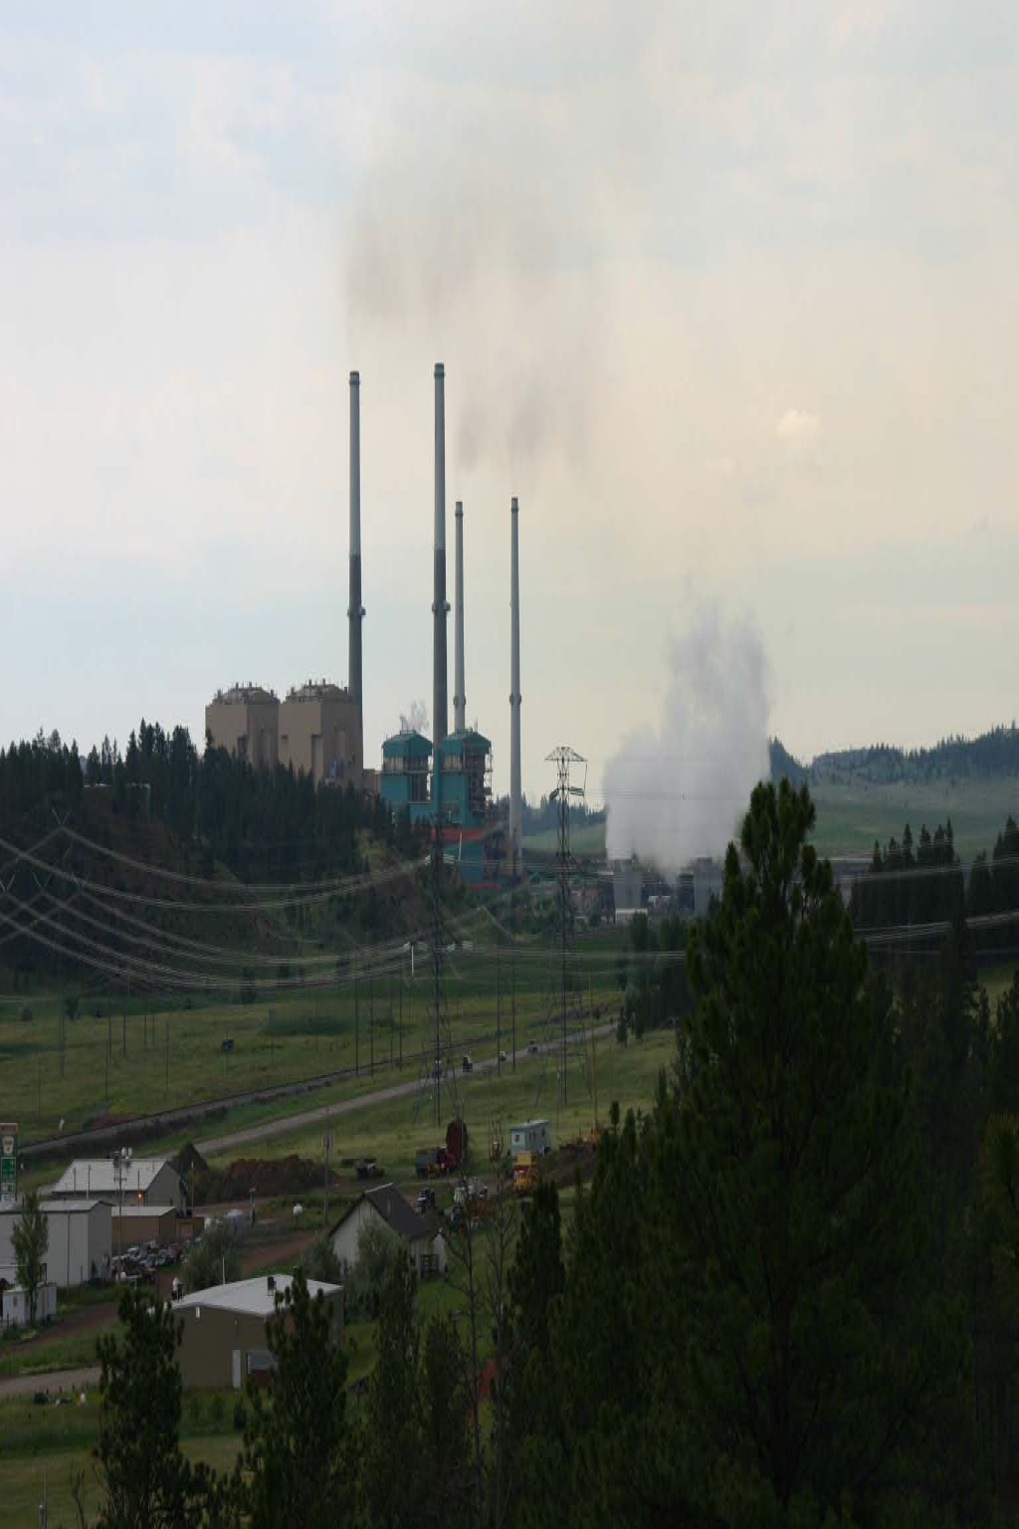

MPC's interest in Unit 4 was sold to Northwestern Energy, LLC. Northwestern Energy was a named Defendant in the Ankney Litigation but, in light of its subsequent declaration of bankruptcy, Northwestern Energy was later dismissed.
Through a separate cause of action, Kelly and Karson Kluver and Douglas and Kim McRae, owners of ranch property in the Colstrip area, have asserted claims similar to those at issue in the Ankney litigation. These claims, which pertain to slurry ponds utilized by Units 3 & 4, are not part of the settlement in the Ankney litigation. The Kluver litigation is currently in the discovery phase of proceedings and, as a consequence, the value of the claims is not yet known.
Plaintiffs were not restricted in the amount they could seek as punitive damages and, as such, this figure may be overly conservative. It was possible that, at trial, Plaintiffs would seek punitive damages in excess of $90 million.
PGE has retained independent counsel, Shane Coleman of the law firm Holland and Hart, LLP, to represent its interests in the litigation.
During settlement discussions, Plaintiffs indicated that they would not accept less than $25 million in full and final settlement of their claims. Thereafter, on or about April 21, 2008, the Court issued an adverse ruling that included sanctions against certain Defendants regarding various discovery issues. Defendants immediately filed a Motion for Reconsideration of the Order, bringing evidence to the Court's attention that it had not previously considered. The Order, although favorable to Plaintiffs, did not affect their bottom-line settlement position.

