July 7, 2003

Carole J. Washburn, Secretary
Washington Utilities and Transportation Commission
1300 South Evergreen Park Drive S.W.
P.O. Box 47250
Olympia, WA 98504-7250

Sent VIA e-mail: records@wutc.wa.gov

Re: TR-021465

Dear Ms. Washburn,

The Brotherhood of Locomotive Engineers (BLE) represents over 600 working locomotive engineers in railroad operations in Washington State. On behalf of our membership, the Washington State Legislative Board of the BLE wishes to voice our strong support for WUTC-Staff proposed regulations of remote control operations in Washington (TR-021465).

The WSLB-BLE recognizes that the recommendations do not go as far as the BLE requested in our February 2003 submission to the WUTC, a submission designed to insure railroad safety in Washington. However, if adopted, the WUTC staff recommendations would be taking a progressive approach to regulating a serious safety hazard to Washington citizens. We believe the Commission staff has carefully researched the preemption issue and formulated regulations that fall within Commission authority under Federal and State law. We also believe that the specific proposals will enhance rail safety efforts in Washington State.

For example, there were 14 pedestrian fatalities in railroad operations in 2002. In the first 6 months of 2003, 11 Washington citizens have died while walking across railroad tracks. At this pace, pedestrian fatalities will increase by 50%, year over year, in Washington State. The proposed regulations support an overall safety effort in Washington to address these troubling statistics.

Since WUTC-Staff have seriously researched the law, the hazard to Washington citizens and the conflicting experiences of railroad interests in an open and reasoned process, the BLE is supporting the WUTC staff proposal without amendment in order to establish regulation of remote control operations in Washington State. This is the first regulation of Locomotive Remote Control operation in the nation. These proposals will provide important protection for the public in Washington State. At the same time these proposals will only minimally, if at all, impact railroad operations inside Washington State. None of the proposals exceed the authority of the State of Washington. The BLE is strongly urging all friends of railroad safety to join us in supporting the work of the Commission with these proposed remote control regulations.

Respectfully,
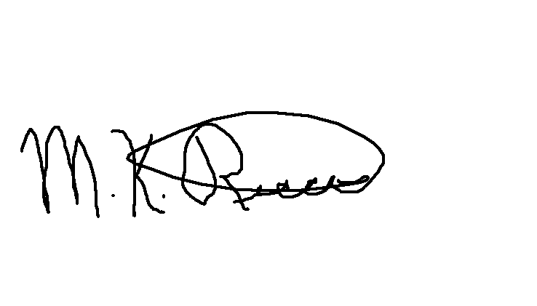
Mark K. Ricci, Ph.D., Chairman
WSLB-BLE

