August 17, 2006

To: Bob Shirley, Telecommunications Policy Analyst

From: Steve Otto, USF Program Manager
Rural Cellular Corp. (RCC)

Re: Response to Request for Supplemental Filing of ETC Certifications and Reports
Docket UT-063052

Attached is RCC’s supplemental filing as requested by commission staff in order to meet the requirements of WAC 480-123-020 through 080.

Please contact me by e-mail at stevebo@unicel.com or by calling (320) 808-2479 if you have questions. Thank you.

Attachment: ETC Certification and Report Request with RCC responses
Declaration Certifying Use on Universal Service Funds
Declaration Certifying Ability to Function in Emergency Situations
Complaints per 1,000 Handsets report

ATTACHMENT

Rural Cellular Corp. (RCC) ETC Certification and Report Request

WAC 480-123-060(1)

RCC needs to provide the certification in the manner required by RCW 9A.72.085.

An officer of the company submitted the certification request, but did not use the required language from RCW 9A.72.085. The certification or declaration may be in substantially the following form:
"I certify (or declare) under penalty of perjury under the laws of the State of Washington that the foregoing is true and correct":
(Date and Place) (Signature)

RCC is providing a revised certification containing the required language.

WAC 480-123-070(2)

RCC needs to provide information that responds to all requirements of the subsection or seek a waiver if it did not track this information during the calendar year before the rule went into effect.

RCC provided information about service affected by the outages, but does not state whether a public safety answering point was affected. The rule requires that the report include “particular services affected, including whether a public safety answering point (PSAP) was affected.”

PSAPs were not affected by any outages reported in RCC’s Local Service Outage Report.

WAC 480-123-070(4)

RCC needs to provide the number of complaints to the FCC and, separately, to the Washington Attorney General (AG). The number may be zero.

RCC provided a number of complaints per 1,000 handsets, but did not say whether it is for the FCC or AG. The rule requires companies to state “the number of complaints that the ETC’s customers made to the federal communications commission, or the consumer protection division of the office of the attorney general of Washington.”

RCC is providing a revised Complaints per 1,000 handsets report providing the information for the FCC or AG specifically.

WAC 480-123-070(6)

RCC needs to provide a certification consistent with WAC 480-123-070(6).

The certification provided is in the present tense. The rule requires certification that RCC “had the ability to function in emergency situations based on continued adherence to the standards found in WAC 480-123-030(1)(g).”

RCC is providing a revised certification containing the required language.
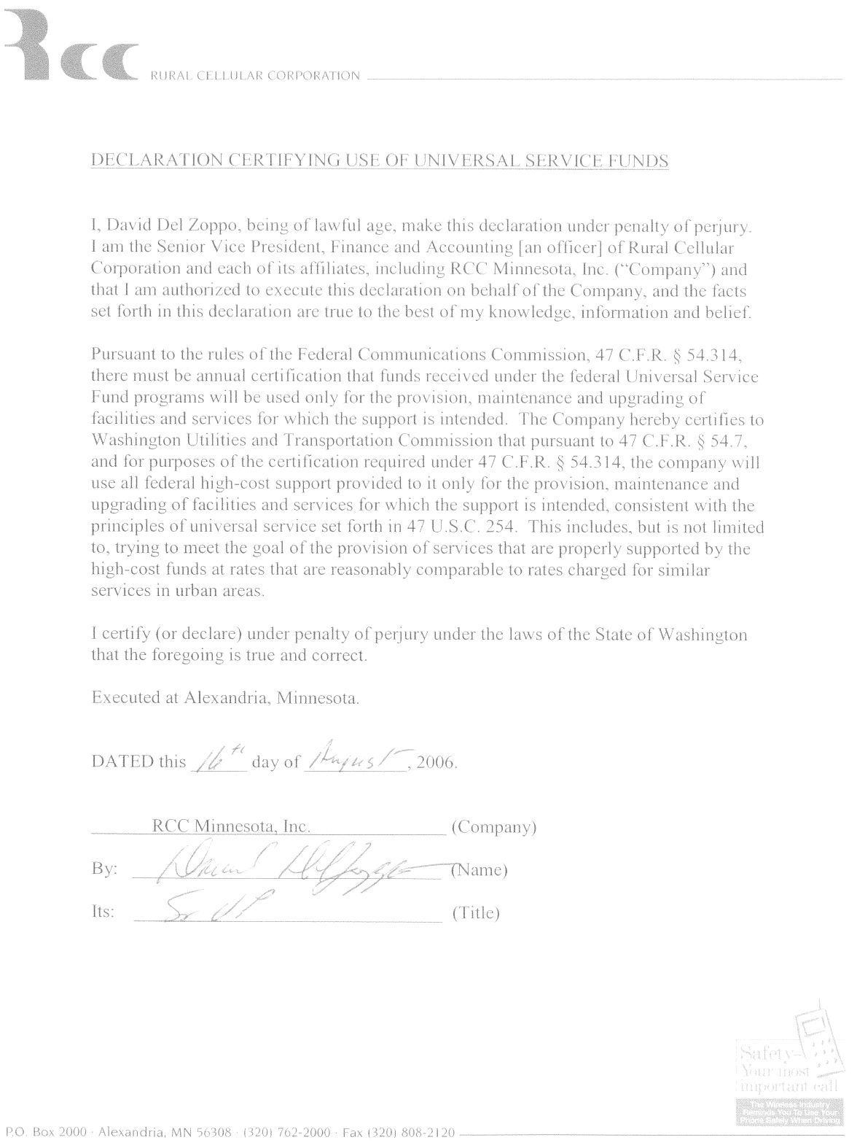
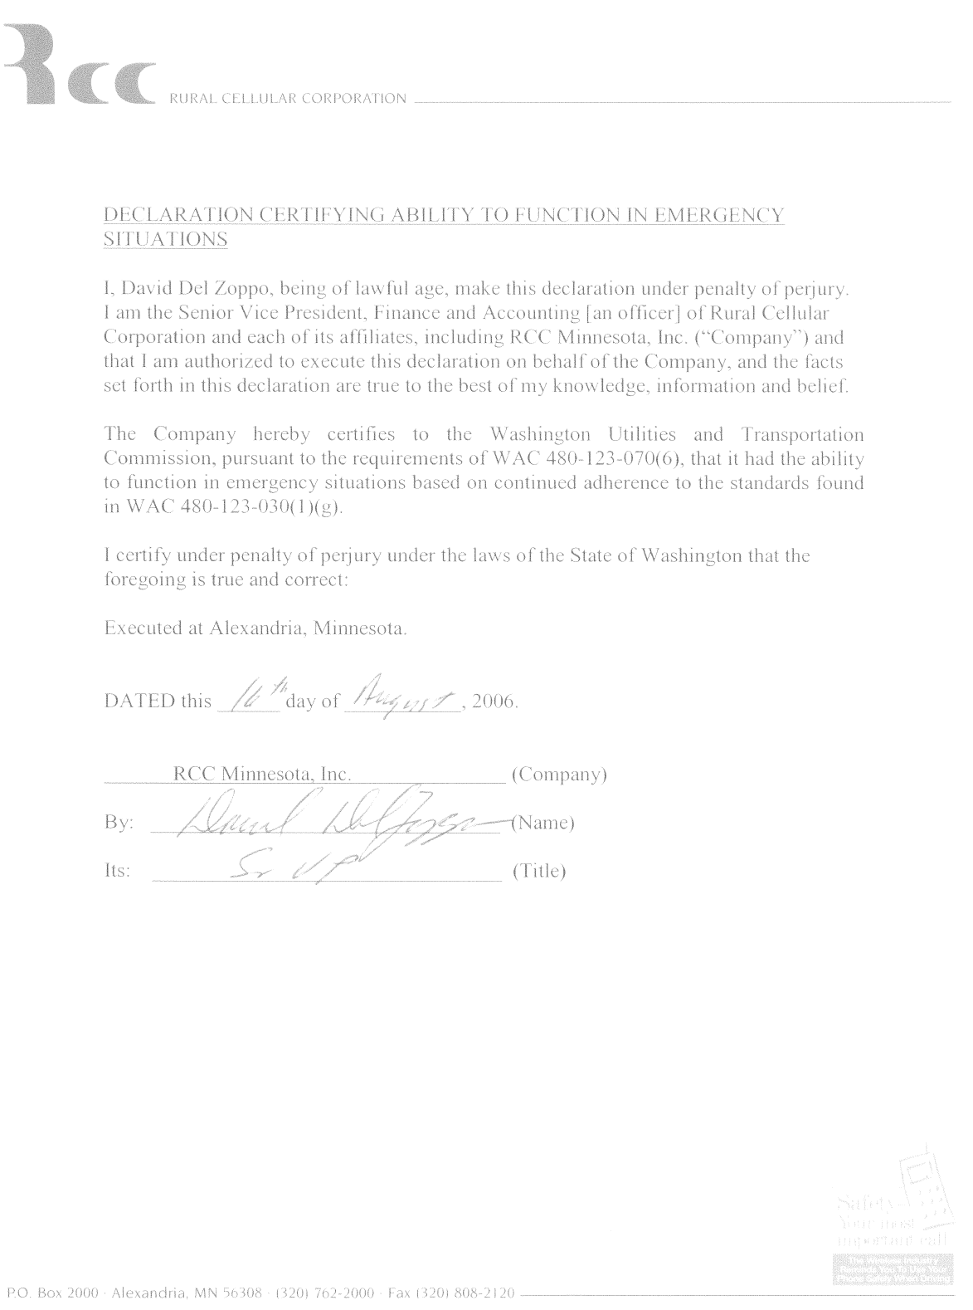

Complaints Per One Thousand Handsets
Washington Attorney General (AG) Complaints
# Complaints per 1,000 | Complaint Type | Carrier Resolution
0.0536 | Contractual - 30 Day Cancellation Policy | Provided credits to customers for remaining balance.
0.0536 | Service/Equipment issues | Allowed to terminate service without an early termination fee; Provided new handsets at discounted prices.
FCC Complaints
# Complaints per 1,000 | Complaint Type | Carrier Resolution
0 | No complaints to report | N/A

