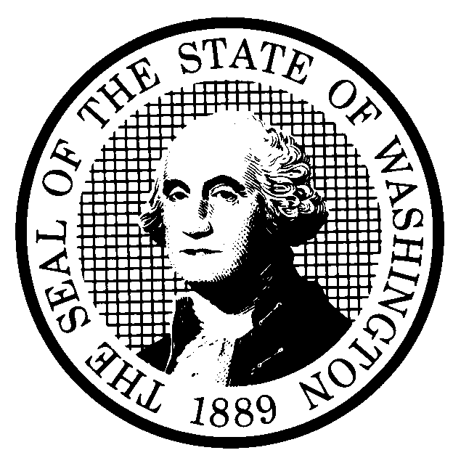 | PROPOSED RULE MAKING |  |  |  |  | CR-102 (June 2004)  (Implements RCW 34.05.320)  Do NOT use for expedited rule making
Agency: Washington Utilities and Transportation Commission
Preproposal Statement of Inquiry was filed as WSR 01-17-048; or  Expedited Rule Making--Proposed notice was filed as WSR or  Proposal is exempt under RCW 34.05.310(4). |  |  |  |  |  |  | Original Notice  Supplemental Notice to WSR  Continuance of WSR 04-15-141
Title of rule and other identifying information:

Chapter 480-93 WAC, Gas Companies - Safety. WUTC Docket No. UG-011073.
Hearing location(s):  Commission Hearing Room 206  Second Floor, Chandler Plaza Building  1300 S. Evergreen Park Drive S.W.  Olympia, WA 98504 |  |  |  | Submit written comments to:  Name: Carole J. Washburn, Secretary  Address: P.O. Box 47250, Olympia, WA 98504-7250  e-mail records@wutc.wa.gov  fax (360) 586-1150 by December 22, 2004  Please include Docket No. UG-011073 in your communication.
February 9, 2005, 9:30 a.m. |  |  |  | Assistance for persons with disabilities: Contact  Mary DeYoung by February 7, 2005  TTY (360)-586-8203 or (360) 664-1133
Date of intended adoption: February 9, 2005
(Note: This is NOT the effective date)
Purpose of the proposal and its anticipated effects, including any changes in existing rules:

The proposed rules are intended to ensure the safety of gas pipeline operations and to promote safety for the citizens of Washington state from the hazards of gas pipeline operations. The proposed rules are intended to implement the requirements of Executive Order 97-02, requiring agencies to review significant rules for need; effectiveness and efficiency; clarity; intent and statutory authority; cost and fairness. The proposal repeals some of the existing rules that are no longer necessary, adds rules to clarify existing federal rules which the Commission adopts by reference, and includes new rules that are more stringent than federal rules, such as adding “new construction” as an activity included as a covered task. The proposed rules include new rules for defining “timeframes” used throughout the chapter, and addressing protection of exposed plastic pipe.

The purpose of this continuance of WSR# 04-15-141 is to provide notice of a change in the adoption and hearing dates for this rulemaking from October 27, 2004, to December 10, 2004. In addition, the continuance is necessary to allow sufficient time for the Commission to file a supplemental CR-102, Notice of Proposed Rulemaking, with the Code Reviser by mid-November, and allow sufficient time for interested persons to file comments concerning any changes to the proposed rule published in WSR# 04-15-141.

Reasons supporting proposal:
Statutory authority for adoption: |  |  |  | Statute being implemented:
Is rule necessary because of a:  Federal Law?  Federal Court Decision?  State Court Decision?  If yes, CITATION: |  | Yes  Yes  Yes | No  No  No |  | CODE REVISER USE ONLY  Filed with the Code Reviser’s Office  October 18, 2004, 8:38 a.m.  WSR 04-21-048
DATE
OCTOBER 18, 2004
NAME
CAROLE J. WASHBURN
SIGNATURE

TITLE
EXECUTIVE SECRETARY
(COMPLETE REVERSE SIDE)
Agency comments or recommendations, if any, as to statutory language, implementation, enforcement, and fiscal matters:

Name of proponent: Washington Utilities and Transportation Commission |  |  | Private  Public  Governmental
Name of agency personnel responsible for:
 | Name | Office Location | Phone
Drafting.......... Mike Rowswell, Rail Safety Manager |  | 1300 S. Evergreen Park Drive S.W., Olympia WA 98504 | (360) 664-1265
Implementation....Carole J. Washburn, Executive Secretary |  | 1300 S. Evergreen Park Drive S.W., Olympia WA 98504 | (360) 664-1174
Enforcement........Carole J. Washburn, Executive Secretary |  | 1300 S. Evergreen Park Drive S.W., Olympia WA 98504 | (360) 664-1174
Has a small business economic impact statement been prepared under chapter 19.85 RCW?
Yes. Attach copy of small business economic impact statement.

A copy of the statement may be obtained by contacting:
Name:
Address:

phone ( )
fax ( )
e-mail
No. Explain why no statement was prepared.

Is a cost-benefit analysis required under RCW 34.05.328?

Yes A preliminary cost-benefit analysis may be obtained by contacting:
Name:
Address:

phone ( )
fax ( )
e-mail

No: Please explain:

