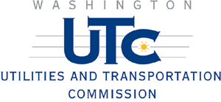

Memo

To: Bob Wallis, Director
Administrative Law Division

From: Alan Rathbun, Director
Pipeline Safety Section

Date: July 14, 2006

Subject: Puget Sound Energy Wrapped Steel Assessment Program

Attached is a progress report on Puget Sound Energy’s (PSE) Wrapped Steel Assessment Program. In Order No. 7 of Docket PG-041624, the commission accepted a settlement agreement between PSE, pipeline safety staff and the City of Bellevue regarding an investigation into a fatal natural gas incident.

This package includes a report by PSE and by staff on the action items included in the settlement agreement and ordered by the commission.

Attachments (2)
- WUTC staff risk assessment report
- PSE May 2006 status report

